Burr
Bulletin
2014-2015
IMPORTANT INFORMATION
____________________________________________________
PRINCIPAL Jason Bluestein

LOCATION 1960 Burr Street
Fairfield, Connecticut 06824

TELEPHONE (203) 255-7385
FAX (203) 255-8244

WEB SITE http://fairfieldschools.org/schools/burr/

HOURS OF OPERATION 8:55 AM TO 3:30 PM

ABSENTEE NUMBER 255-7387
GUIDANCE & NURSE 255-7388
EARLY CLOSING HOTLINE 255-TALK (8255)
TRANSPORTATION 255-8385
STUDENT POPULATION 452
____________________________________________________

SCHOOL HOURS

Grades K-5 8:55 AM to 3:30 PM

Pre-Kindergarten 8:45-11:30 AM/12:45-3:30 PM

Early Dismissal FOR ALL GRADES
(Including Kindergarten) 8:55 AM to 1:40 PM

Weather Delayed Opening 10:55 AM

SCHOOL OFFICE

Secretary Carol Rossomando
Clerical Assistant Laurie Whiteley
Clerical Assistant Laura Keller
Hours Monday-Friday 8:30 AM to 4:30 PM

REACHING STAFF BY E-MAIL

Use firstinitiallastname, followed by: @fairfieldschools.org
Example: jbluestein@fairfieldschools.org

Burr Elementary School
Staffing 2014-2015

Principal Jason Bluestein

Pre-Kindergarten Susan Totilo Smith

Kindergarten Lori Thompson
Stacie Vigeant
Kate Schallau

Grade 1 Karen Musante Marilee Root

Julie Sherwood

Kristen Kurimai

Grade 2 Susan Cinquegrana
Mei-Ling Uliasz
Sharon Miles

Grade 3 Lauren Noonan

Brian Jasgur
Alison Taylor

Grade 4 Kelly Sadick
Nicole Passero

Nancy de Regt

Grade 5 Linda Chandler

Sabrina Phillips
Karis Beno

Instructional Improvement/Gifted Bret Henkel
Math/Science Teacher Analisa Sherman

Library Media Specialist Carolyn Shea

Language Arts Specialist Gail Felberbaum
Language Arts Specialist Lisa Henkel

Psychologist Eileen Montgomery

Social Worker Laura Craighead 0.4 M am, T pm, Th am, F pm

Art Teacher Roni Yessenow 0.9
Physical Education Teacher Marc Hilinski
Physical Education Teacher Bret Connors 0.1
Music Teacher Carole Maravich

Spanish Teacher Suzanne Sugrue 0.3
Special Education Teacher Jody Harkins

Special Education Teacher Susan Shea

Special Education Teacher Elizabeth Raucci
Special Education Teacher Fran Torrani

Speech and Language Joy Lawrence 0.7 M-W, Th am

Speech and Language Kathy Gardner 0.3 M am, Th am, F am

Teacher of Visually Impaired Dana Uhrynowski
Occupational Therapist Deirdre McCann M, T & W
Physical Therapist Michele Farrelly T & Th am
Strings Teacher Cynthia Eckhardt 0.6
Band Teacher Patti Buchta 0.2
ELL Teacher Bonnie O’Neill 0.4
Computer Technician Diana Beeton

Library Media Center Assistant Cathy Sondheim 0.6 M, T, Th

Library Media Center Assistant Kate McGuinness 0.4 W, F
Paraprofessional Judy Weiss
Paraprofessional Cathy Farrell
Preschool Paraprofessional Lori Aufiero

Paraprofessional Michelle Allen
Paraprofessional Darlene Chatlos

Paraprofessional Ashly Anziano
Paraprofessional Diana Maver
Paraprofessional Pam Rottkamp
Intern Bianca Boudreau
School Substitute Lauren DaLan
Secretary Carol Rossomando
Clerical Assistant Laurie Whiteley
Clerical Assistant Laura Keller
Nurse Joan Miller
Head Custodian Ken Thompson

Custodian Christopher Chappa
Custodian TBD

Cafeteria Manager Donna Achille
Kitchen Staff Carolyn Moran
Kitchen Staff Evette Rodriguez
Cafeteria Aide Pam Bader
Cafeteria Aide Janet Connors
Cafeteria Aide Chris Nightingale
After School Program- ECC

PROFESSIONAL DEVELOPMENT

Professional development is a program of planned activities that provides for the professional improvement of all staff members. All professional staff members in the system participate in this program.

For the 2014-2015 school year, there are two full days for professional development and two early-release days for teachers (please mark your calendars!):

Tuesday, October 7 Early-dismissal day for ALL students (1:40)
Tuesday, November 4 Full Day (school not in session)
Thursday, February 12 Early Dismissal day for ALL students (1:40)
Friday, February 13 Full Day (school not in session)

OPEN HOUSE

Open House is a way to be informed about the school and your child’s classroom. There is a brief informational presentation given at 7 PM in the Gymnasium, followed by visits to the classrooms for teacher presentations. The date of the 2014-2015 Open House is

September 17, 2014 K-5 7 PM
Pre-K 6 PM
Open House Schedule
7:00 – 7:15 Opening/Welcome/Introductions of Staff in Gym
7:15 – 7:30 Passing
7:30 – 8:10 Session 1
8:10 – 8:20 Passing
8:20 – 9:00 Session 2

PARENT/TEACHER CONFERENCES:
(Please mark your calendars!)

Parent/Teacher Conferences: October 23, October 29 and October 30
Parent Teacher Conferences: March 25, March 26 and April 1

All conference days are “early-dismissal.”
Dismissal for ALL students is at 1:40 PM

ABSENCES/EXCUSES

If a child is to be absent or tardy, parents must report the absence or tardiness using the Absentee Call-in line at 255-7387. Students entering school after 8:55 AM should proceed to their classrooms and will be marked tardy by their homeroom teachers. Students arriving after 9:00 AM should sign in (that is, signed in by an adult), at the main office. Students may not be dropped off at the curb, sent, or taken directly to the classroom. Upon the child’s return to school following an absence of any kind, parents are required to send a note to the classroom teacher regarding the nature of the child’s absence.

DISMISSALS

Please avoid picking up your child early for non-medical/-emergency reasons. Students who must be dismissed early for medical or dental appointments must present a written note in advance. If you need to pick up your child early, please do so before 3 o’clock. Parents are encouraged to make these appointments outside of school hours. Parents must meet their child in the school office.

PARKING

To ensure the safety of EVERY Burr family and staff, please take note of the NO PARKING zones in the diagram on the other side.
We do realize that parking is limited; however, we must be sure that everyone is safe at Burr.

There have been several incidents that prompted safety concerns. Please share this diagram with whoever may be picking up your child(ren). Many times there are available spaces in the front parking lots, or please patiently wait for a space to open up instead of parking illegally (your children are safe inside with staff for a few minutes more). School buses and emergency vehicles must be able to enter and leave the school at all times. Buses have been delayed because of people parking illegally.

Locking of school doors
For the safety of our students, ALL school doors are locked throughout the day. However, between 8:45-9:00 a.m., the front doors will be open for students who are being dropped off. At 3:25 the doors to the cafeteria are opened for dismissal. After 9:00 a.m., please ring the bell located at the front of the building to gain access.

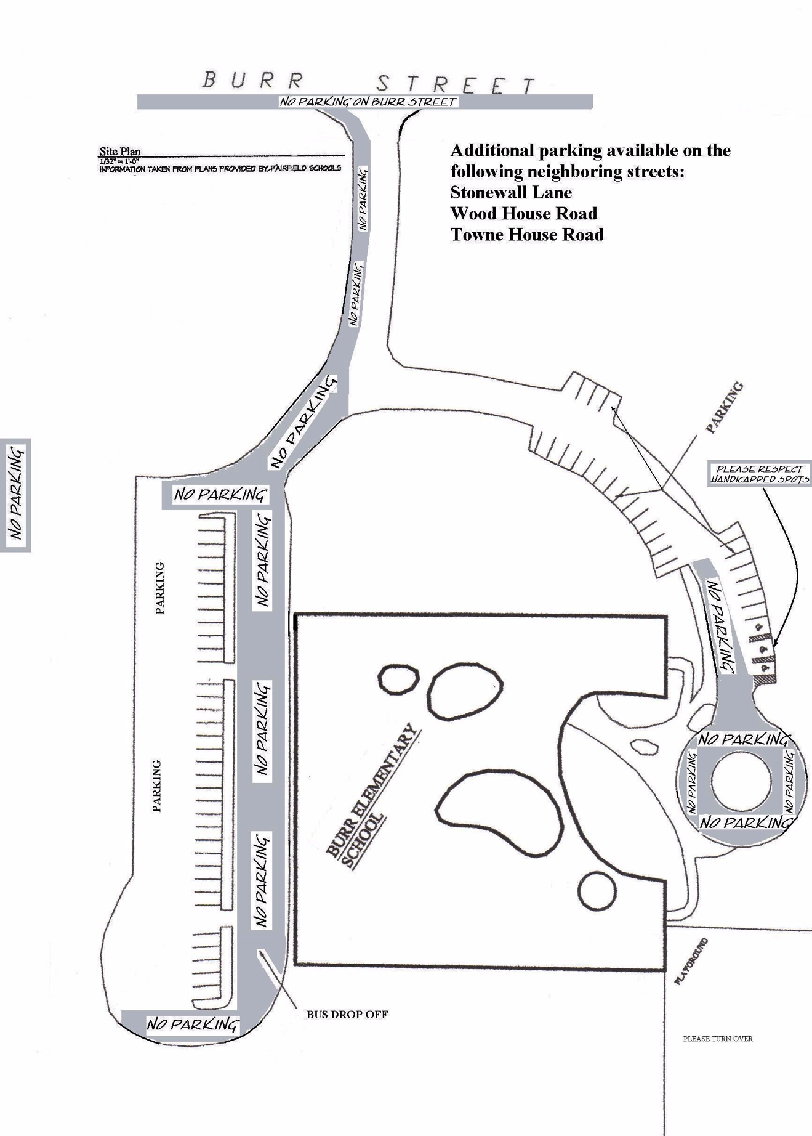

PARKING, DROP-OFFS, PICK-UPS

- Dropping off children before 8:45 AM is prohibited under the Fairfield Public Schools’ district-wide policy.
- When dropping off your children, please use the front drop-off circle and pull your car up as far as possible. Do not leave your car. If your child needs assistance, ask the attending teacher(s) to help. Have your children exit from the passenger side of the car only. Please do not drop off at the back doors, as there are no staff members supervising that area.
- If you are dropping off your students after 9:00, then you must sign your child in at the main office and receive a tardy slip from our school secretary.
- Park only in the areas designated with white lines.
- Parents who are picking children up after school must park and meet them in the Cafeteria. When picking your child up after school, please arrive before 3:15 PM so you will allow enough time to park your car and walk into the school. Do not park in the drop-off loop. This area must be left clear so that traffic can pass as needed.
- Under no circumstances should you instruct your child to meet you at your car! This is against school policy and is a serious safety concern. The children have been advised that if they have a note that they are being picked up, they may not meet their parents anywhere other than the Cafeteria.
- If you are picking up your children early or in the middle of the day for any reason, please ask our school secretary, Mrs. Carol Rossomando, or the office staff to call them to the office. Please wait in the lobby area for your children. Remember to sign them out and, if they return during the day, sign them back in. If your children are at recess, they will be called in for dismissal, or you may go to the playground area, identify yourself to the recess monitor, and follow the checkout procedure inside.
- It is imperative that caution be used at all times when driving near school grounds and in driveways. Please drive slowly. Also, avoid parking in the handicapped spaces unless you have a permit. Please be a positive role model for driving, parking, and walking safely. Please know that our students’ safety is our primary concern. Your caution and cooperation are most appreciated.

STUDENTS NOT TAKING THE BUS

All students will be dismissed from their classrooms. Students cannot be allowed to leave the building at dismissal time unless they are going home on a bus, being met by a group leader in the Cafeteria (After the Bell, Brownies, Scouts, soccer, etc.), or are being met by a parent in the designated pick-up area in the Cafeteria, with the appropriate note to the teacher. Please note that the Cafeteria will have designated areas for each grade level, and staff will be on hand to supervise and collect written notices.

DISMISSAL NOTES

Whenever you must make changes in your child’s schedule at school (e.g., picking your child up early or after school, staying for an after-school activity, or making arrangements for an after-school play date with another child), please inform your child’s teacher in writing. Your child will present their note to a designated staff member upon leaving school. To avoid anxiety in your children, please be sure they know where the note has been placed in their backpacks. This will avoid anxious phone calls home. Failure to send in a note will result in your children being put on the bus. Large numbers of phone calls coming in around dismissal time create problems and make phone lines unavailable for an emergency. If a last-minute phone call is absolutely necessary, it must come from a parent, guardian, or a designated baby sitter or nanny. The names of such designated sitters or nannies must be on file in the office, with the classroom teacher, and listed on all emergency cards. E-mail is not a preferred method of making such arrangements. Very often teachers are busy working with students and are unable to check e-mail. If your child is to be picked up every day, please inform your child’s teacher at the start of the school year. Your child will be assigned a permanent pass, thus preventing the need for a handwritten note each day.

Please be reminded that the policy of the Fairfield Public Schools prohibits students from riding on any bus other than the one to which they have been assigned. However, if your child is going home with another child on the same bus (the one taken every day), he or she may get off at a different stop, provided there is a note from his/her parent or guardian.

ITEMS NOT PERMITTED IN SCHOOL

In order to ensure the student safety and the protection of personal property, parents are encouraged to closely monitor those items that are brought or worn to school by students. The school is not responsible for lost, stolen, or broken prohibited items. The following items are specifically prohibited on school grounds and will be confiscated by school staff:
- Weapons (real or toy) such as guns, pocket knives, razor blades, or sharp objects
- Matches, caps, and fireworks
- Skateboards, roller blades, roller skates, heeleys
- Cell phones, iPods, radios, CD players, Game Boys, and MP3 players
- Sports equipment (equipment for recess will be provided by the school)
- Toys, stuffed animals, dolls, and trading or playing cards
- Make-up, glitter, scented lip gloss, perfume or cologne

*Please note: e-readers are permitted in school at the discretion of the teacher. However, students are NOT permitted to download content while at school. For multi-purpose e-readers like iPads and Kindle Fires, students are not permitted to access games, movies, music, or Web content while at school.
DRESS CODE POLICY

At Burr Elementary School we know that our students’ dress reflects pride in the school and in themselves. At no time should clothing be a distraction to the students, nor should their attire be a danger to their personal safety in the classroom or on the playground. Below are some guidelines for appropriate dress:
- Appropriate, closed footwear must be worn (no flip-flops, clogs, or open-toed sandals). Sneakers must be worn on Physical Education days.
- Bandanas or hats may not be worn inside the school (these items may be worn at recess and placed in cubbies during school hours).
- Appropriate outerwear must be worn to outside recess in the winter months. Please dress your child accordingly.
- Short shorts, bare-midriff style shirts, and halter tops are inappropriate school attire
- Tank tops are allowed as long as the strap is greater than one inch wide
- T-shirts that display alcohol- or drug-related logos, or inappropriate messages are prohibited
- Jewelry that is inappropriate or considered a danger will not be allowed (dangling earrings, chains, or bracelets).

TELEPHONE

Plans for the afternoon should be made at home prior to coming to school. In an emergency, the office phone may be used with a teacher’s permission. Only emergency phone messages for children and/or teachers will be delivered during the school day. Each classroom teacher will review the telephone policy with your children in school.

FIELD TRIPS

Each grade level has several field trips throughout the year that provide for increased learning in specific curriculum areas. Permission slips are sent home in advance along with requests for fees, if necessary. Travel is generally by school bus, although coach/luxury buses are hired for longer trips. Parents are often needed as chaperones and can volunteer by contacting their child’s teacher or Classroom Coordinator (depending on the arrangement). Note: Field trip costs are subsidized by the Burr Elementary School PTA, and scholarships are available.

RECESS/ LUNCH SCHEDULE 2014-2015:

Please note recess will occur before lunch.
Grade | Recess | Lunch
Kindergarten | 11:45-12:05 | 12:05-12:25
3 | 11:55-12:15 | 12:15-12:35
2 | 12:05-12:25 | 12:25-12:45
5 | 12:15-12:35 | 12:35-12:55
1 | 12:25-12:45 | 12:45-1:05
4 | 12:35-12:55 | 12:55-1:15

PUPIL SERVICES PROGRAMS

The Special Education Department is comprised of a team of professionals dedicated to ensuring that all children learn. The members, comprised of three Special Education Teachers, a Speech and Language Pathologist, Social Worker, Occupational Therapist, Physical Therapist, and School Psychologist, are specially educated and trained to address the specific learning needs of the children at Burr. Together, the department addresses the learning, behavioral, emotional, and social needs of the students. The Special Education Team, under the leadership of School Psychologist Eileen Montgomery, meets regularly throughout the year with Mr. Bluestein, classroom teachers, specialists, and parents to address academic and social issues of concern. During this Planning and Placement Team meeting, they design individual student programs, brainstorm behavioral and academic strategies, and determine the best way to enhance student learning.

PSYCHOLOGICAL/COUNSELING SERVICES

Our school has a full-time School Psychologist available to every child, parent, and staff member. Our School Psychologist, Mrs. Eileen Montgomery, has specialized training in both education and in psychology, and uses her skills as a professional to assist students in their educational, personal, and social development. Mrs. Montgomery works with the entire school community toward the goal of helping all students reach their full potential. As students face different challenges, these services can provide solutions for tomorrow’s problems through thoughtful and positive actions today. Among those services are
- Peer mediation groups
- Interest groups
- Peer leadership groups
- Groups to help children learn how to study
- Groups to help children enrich their social and friendship skills
- Classroom lessons to help children learn how to get along with others

SOCIAL WORKER SERVICES

The Burr Elementary School Social Worker, Mrs. Laura Craighead, provides support for students through a variety of modalities. These include

- Individual counseling
- Dyad or group work focusing on enhancing social skill development or to provide children experiencing difficulties (such as divorce, bereavement) with a peer support network
- Classroom lessons on character development (including topics such as bullying, gossip, good sportsmanship, diversity, tolerance, kindness) focused on creating a supportive learning environment
- A school-wide program on diversity and tolerance
- Support to Burr faculty in the form of resources and consultation
- Family support in the form of resource referral, counseling, consultation and limited home visits.
Mrs. Craighead is currently at Burr 14 hours per week, which she spreads over four days.

SPEECH AND LANGUAGE SERVICES

Speech and language services are available for students whose difficulties in articulation, fluency, voice and/or language have an adverse effect on educational performance. The Speech and Language Pathologist, in collaboration with the classroom teacher, special educator, and School Psychologist, designs instruction to address educationally related communication needs. Students are selected for the program on the basis of staff or parent referrals and diagnostic evaluation. Mrs. Joy Lawrence and Mrs. Kathy Gardner are our Speech and Language pathologists.

BURR LIBRARY MEDIA CENTER

Burr Elementary School’s library media program is co-planned and co-taught by the classroom teacher and the Library Media Specialist, Mrs. Carolyn Shea. Flexible scheduling allows us to incorporate information literacy and technology skills in the curriculum-based K-5 research projects so all students have the opportunity to become independent, responsible users of information. We are committed to providing access to all our resources. Circulation is unlimited, with no restrictions on the number of books students may take out or fines for overdue books. An important aspect of our program is the presentation of these projects to our learning community.

BURR CLASSROOM WEB SITES

Burr’s new school website is available at: http://fairfieldschools.org/schools/burr/

INFINITE CAMPUS (PARENT COMMUNICATION)
Infinite Campus is the tool by which the school and district communicates with families throughout the school year. As such, an Infinite Campus account is very important. Below is a link to a manual that offers suggestions on how to set up your account. We would recommend that you include e-mail and text as contact preferences. Links (such as school letters or newsletters) are only accessible through e-mail.

http://fairfieldschools.org/parent_resources_infinite_campus.htm

Please be aware that you need an activation code in order to create a user name and password. Burr’s main office can provide you with an activation code if you have not yet set up an Infinite Campus account.
To access the Parent Portal through Infinite Campus, follow the link below:
https://campus.fairfieldschools.org/campus/portal/fairfield.jsp

SCHOOL VISITATION

Parents and other visitors are both welcome and encouraged to visit the school, attend assemblies, participate in special events, and volunteer. All visitors must report to the office immediately upon entering the building. Classroom instruction should not be interrupted. Below are some important reminders to help maximize the learning environment for your children and decrease classroom disruptions:

- When visiting the school, please make sure you sign your name in the book in the Main Office.
- Please make an appointment with your child’s teacher to address any concerns.
- If it is necessary to drop off your child’s lunch or a forgotten item from home, please leave it on the “oops” cart located outside the main entrance. Office secretaries will check the cart multiple times throughout the day.
- Please refrain from unannounced visits to your child’s classroom.

Thank you in advance for your partnership and cooperation with these guidelines. They will greatly help us to maintain consistency in your child’s daily school routine. This also will allow your child to have a positive school experience that will foster his/her independence.

GUIDELINES AND EXPECTATIONS FOR PARENT VOLUNTEERS IN SCHOOL:

Thank you for offering to lend a hand as a parent volunteer at Burr Elementary School.
Our teachers are outstanding, yet it’s a real challenge to meet the academic, social, and emotional needs of each child within the classroom setting. As a staff, we firmly believe that there is a direct correlation between the quality of education that can be achieved in a school and the visible presence of caring parent volunteers. In order to keep all minds and bodies appropriately focused and “on task” during instructional sessions, additional adult eyes and hands can dramatically improve the efficiency and productivity of the children’s participation in a lesson or activity. Below is a list of ethical standards for parents who serve as volunteers at Burr. The school reserves the right to “dis-invite” a parent volunteer who is not able to adhere to these standards.
1. Please be aware that secretaries will ask any visitor to Burr a few basic questions to ascertain why they are visiting our school. Please be patient with them. This is a safety procedure implemented at all of Fairfield’s schools and is not meant to prevent parents from accessing Burr.
2. Volunteers must aspire to “professional standards” of ethical conduct while serving in the school and while communicating about school activities outside of the school. Please respect confidential matters and the special “trust” that is formed between the school and the parent volunteer. There should be no judgmental or comparative anecdotal conversations in school or within the school community regarding the following:
- Perceived strengths, weaknesses, or “styles” of individual children or teachers
- Children who display developmental delays or a need for special education or social services (School Psychologist, Social Worker, Speech and Language Pathologist, etc.)
- Children’s social, economic, academic, or emotional challenges or advantages
3. Volunteers must try to adhere to the schedules they have worked out with their cooperating teachers. If you are not able to keep to your scheduled arrangement, please notify the classroom teacher as soon as possible in advance.
4. Volunteers with questions about the methods or practices of a teacher should make arrangements to seek clarification from the teacher.
5. Volunteers may be asked to work with children directly or handle management tasks (laminating, copying, etc.) as determined by the teacher.
Your role as a parent volunteer is important to our overall success and to the quality of learning we are able to provide the Burr Elementary School children. We want and need your involvement as a volunteer.

FAIRFIELD PUBLIC SCHOOLS FAMILY GUIDE

The Family guide contains additional general information about the Fairfield Public Schools. This online publication is a convenient reference tool that can be used to stay informed about your child’s education.

http://fairfieldschools.org/parent_resources_family_guide.htm

BURR PARENT-TEACHER ASSOCIATION (PTA)
The Burr PTA is a dynamic, caring group of parents, teachers and staff whose mission parallels that of the CT PTA Mission:
- Support and speak on behalf of children and youth in the schools, in the community, and before governmental bodies and other organizations that make decisions affecting children;
- Assist parents in developing the skills they need to raise and protect their children; and
- Encourage parent and public involvement in the public schools of the nation.

HELP YOUR CHILD SUCCEED – BECOME INVOLVED! Research has proven children perform better when their parents are actively involved both at home and at school. Grades and test scores climb; self-esteem grows; and schools improve. The PTA helps parents, students, school staff and the community work together to build programs and activities that benefit our children. Your time, talents and financial contributions are so important to the success of our family here at Burr.

PLEASE JOIN: The Burr PTA aims to create a sense of community and school spirit, while providing support to the school as a whole. We can’t achieve this goal without you, the PTA volunteer! Please consider volunteering for one or more of our committees. With over 50 working committees, there is truly something for everyone. There are committees that enrich our children’s education; others are fundraisers or administrative in nature; and some are just plain FUN!
Our #1 goal is to help Burr be the best it can be! Funding from the PTA supports programs and materials that directly benefit our children, including curriculum enrichment programs, books, classroom materials, field trip subsidies, teacher grants, scholarships* ... just to name a few.
You can sign up anytime by contacting our Volunteer Coordinators, by contacting a committee chair directly (listed on the Burr PTA website), or by speaking with us directly at our Welcome Back celebration “Tears and Cheers” at 9:15am in the cafeteria on the first day of school!
Volunteer Coordinator Contacts:

Holly Calmus hollycalmus@hotmail.com

Lynda Oshinskie Laoshin65@hotmail.com

Ria Rassias: Ria_rassias@hotmail.com

SHARE YOUR VOICE: General PTA meetings are held throughout the year to update you on happenings at Burr. These meetings are key to staying in touch with your child’s educational life – they provide a forum for you to share your thoughts and ideas about issues that affect Burr and your student. They are also fun and a great way to get to know the staff and other Burr families!

STAY IN TOUCH: Our website has just about everything you need to know about upcoming PTA events, volunteer opportunities, lunch menus, school calendar, forms and procedures, community links and MUCH MORE! Check it out: http://www.burrpta.org. Every week “The Buzz Buzz”, our electronic weekly newsletter, will be emailed to you, to keep you informed of the upcoming weeks’ happenings and Burr activities.
We look forward to working with you for a successful and fun year!

Sharon Jacobs  President  jacobs.sharon@gmail.com | Patty Donohue  President-Elect  brendanandpatty@gmail.com

*Please note:
Any student or parent participating in a PTA or school-sponsored activity or program may be eligible for financial assistance. Inquiries are confidential and should be made directly to Mr. Bluestein.

PARENT OBSERVATION REQUEST FORM FOR CLASSROOM OR PLAYGROUND OBSERVATIONS

Please complete the Classroom or Playground Parent Observation Request Form in support of your request to observe your child in the school environment in the classroom or on the playground at Burr Elementary School. We appreciate one week’s notice to accommodate a request for an observation; however, we will do our best to schedule your observation as soon as possible. An administrator or other designee must accompany parents during observations. While we welcome your input as a parent and encourage active involvement in your child’s education, please respect our need to limit observations to a 30-minute time period once every two months in order to minimize interruptions to the student learning environment. Please understand that the teacher cannot meet with you at this time, nor may you engage any student in a private conversation. Thank you for your cooperation. (A copy of the form is included)

Burr Elementary School
Classroom or Playground
Parent Observation Request Form

Please complete the following in support of your request to observe your child in the school environment in the classroom or on the playground at Burr Elementary School. We appreciate one week’s notice to accommodate a request for an observation; however, we will do our best to schedule your observation as soon as possible. An administrator or other designee must accompany parents during observations. While we welcome your input as a parent and encourage active involvement in your child’s education, please respect our need to limit observations to a 30-minute time period once every two months in order to minimize interruptions to the student learning environment. Please understand that the teacher cannot meet with you at this time nor may you engage any student in a private conversation. Thank you for your cooperation.

Name of Student: __________________ Date Submitted: ____________

Classroom Teacher: _______________________

(If Applicable: Case Manager: ________________)

Individual Observing: _______________________

Class you wish to observe: _____________________________________

Options for dates & times requested:______________________________

Reason for observation:

_______________________________________________________

_______________________________________________________

Staff complete:

Date & Time Approved: ______________________________________________

Approved by: ______________________________________________

Designee Attending Observation______________________________________________

Burr Elementary School
1960 Burr Street
Fairfield, Connecticut 06824

Jason Bluestein, Principal 203- 255-7385 fax 203-255-8244

August 5, 2014

Dear Parents,

You play an integral role in your child’s education, and we welcome the many contributions you can make with your time before, during, and after school at Burr. In continued efforts to provide for a safe and secure learning environment for all students, Fairfield Public Schools is implementing a new administrative regulation (#1212AR) regarding Volunteers/Resource Persons. This regulation requires all Volunteers/Resource Persons in our schools to complete a registration form. Any Volunteer/Resource Person working before, during or after school in a school- or PTA- sponsored activity is required to complete this form.

Attached you will find the Volunteer Registration Form and Waiver of Liability. Please complete this form and return it to the office prior to the start of any volunteer work. If you have any questions, please feel free to contact me.

Sincerely,

Jason Bluestein

Jason Bluestein

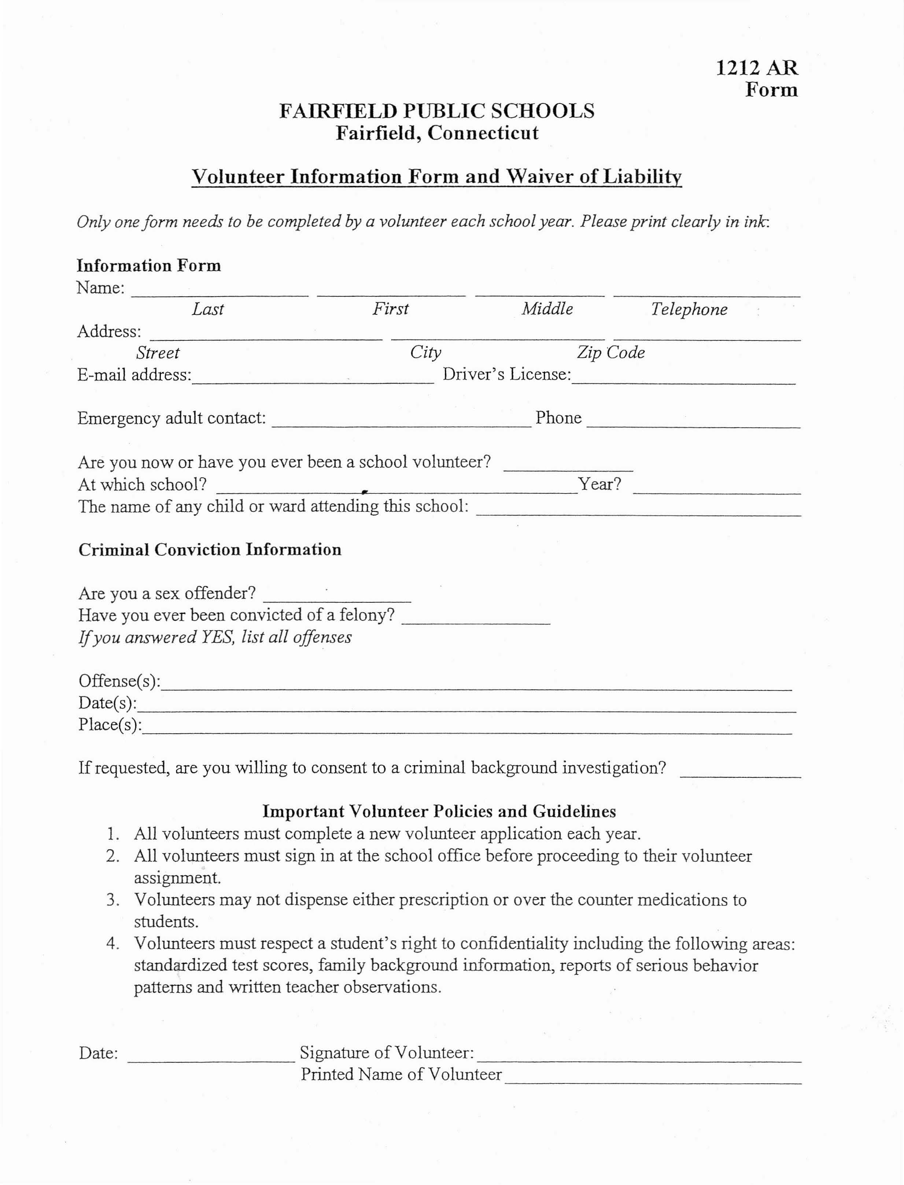

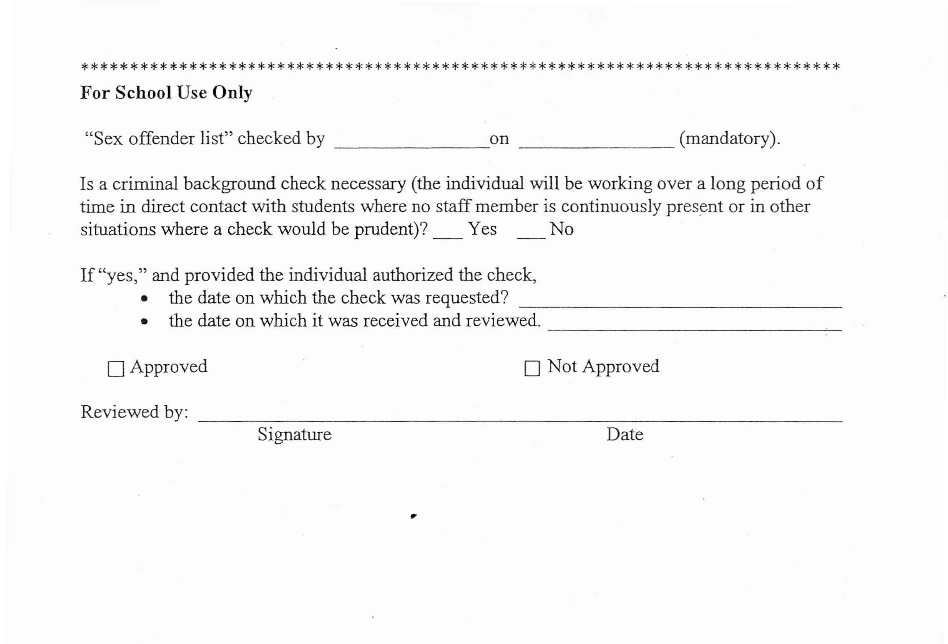
Burr Elementary School

