Join us for
BURR PTA’s ANNUAL ICE CREAM SOCIAL

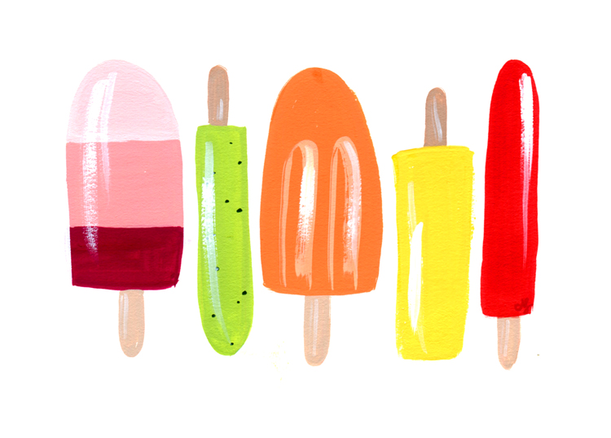
See your old friends and make some new ones!

When: Thursday, September 10th
Where: Courtyard in front of Burr
What time: 4:00 PM
Rain date: Thursday, September 17th
Price: $3.00 per ice cream

We will be welcoming the Fireman’s Ice Cream Truck.
Nut Free and Dairy Free options will be available.

We need volunteers to make this a success!

Please note that this is not a drop off event. Parents are asked to stay
for the duration of the social. Thank you in advance for your cooperation.

Contact Meghan Tetro at mmtetro@gmail.com or
Terra Tortorello at tpjtort@yaoo.com
_____________________________________________________________________________
Detach and send in to the PTA mailbox labeled Ice Cream Social. Checks should be made payable to the “BURR PTA”.
Name and contact Information ________________________________________________________
# of children and adults ______x $3.00 per ice cream
Volunteer? Yes________ No_________ Total Enclosed $___________
**Sponsored by the Burr PTA. Scholarships are available for this event. Please contact Mr. Bluestein.

