1P Week at a Glance
Week of March 3/17 – 3/21

- Word Work:
      - New word wall words: after, look, going, there, who
- Word Focus: Handwriting

- Reader’s Workshop: Poetry
Focuses Include:
- Using poems to practice fluent reading.
- Working on visualizing (what do we see in our heads while reading)
- Making connections through our poems.

- Writer’s Workshop: Non-Fiction Wrap Up
Focuses Include:
- Creating a celebration piece
- Includes table of content, different chapters of a topic, cover page.
- About the author pages

- Math Workshop: Unit Four: Organizing and Collecting

- We will be talking about adding and subtracting packs of 10.
- Showing a number by drawing it using 10’S and 1’s
- Showing a three digit number pictorially
- “Neighbor numbers” showing what numbers are above/below/side to side
- Example: if your number is 43, above 33, below 55, sides 42 and 44

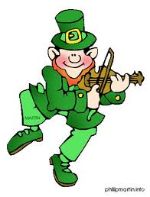

Dates/Times to Remember:
- 3/17 – 11:30-12pm – LMC – Spelling City
- 3/21 – 11:30-12pm – LMC - Sumdog

