1P Week at a Glance
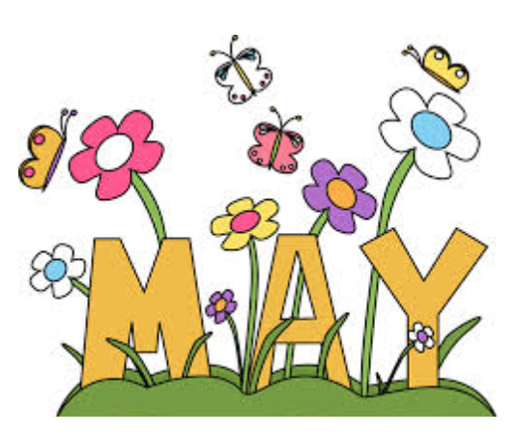
Week of May 12-16

- Word Work:
      - New word wall words: brother, favorite, girl, give, good
- Word Focus: handwriting

- Reader’s Workshop: Character Study
- Essential question: How does studying characters help the reader to better understand a story?
Focuses Include:
- Making personal connections to our characters
- Picking a favorite character and explaining traits that we like about them

- Writer’s Workshop: Intro into Writing Reviews (Lucy Caulkins)
Focuses Include:
- Students will talk about collections
- Students will “judge” the collections with opinions as to why they like or dislike collections.
- Math Workshop: Unit Five -Time

- Drawing hands on a clock
- Reading and writing hands on a clock
- Telling time to the minute
- Estimating “about” what time it is

Dates/Times to Remember:
- 5/13 – Orchestra Concert – 10-11am
- 5/15 – S.P. @ Math meeting – 8:45-9:45
- 5/15 – First Grade CPT 1:30-2:15

