Dear 1L Families,
2/10/14

Over the last month your scientist has been learning all about the Emperor Penguin. We have studied their habitat, their diet, how they survive in the freezing Antarctic temperatures and much more!

As a culmination of this very special unit, the students will be creating an adventure-filled Penguin Expedition! During this time, your scientists will be showing you all that they have learned about the Emperor Penguin and will take you on an interactive journey into the life of an Emperor Penguin!

Please join us on Friday, March 7th at 1:45 pm to share in this very special experience!
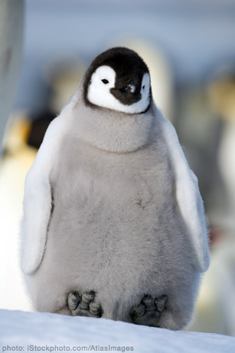

--------------------------------------------------------------------------------
Child’s Name ____________________

______ Yes, I will be able to attend this event.

______ No, I won’t be able to attend this event.

