1P Word Wall Words
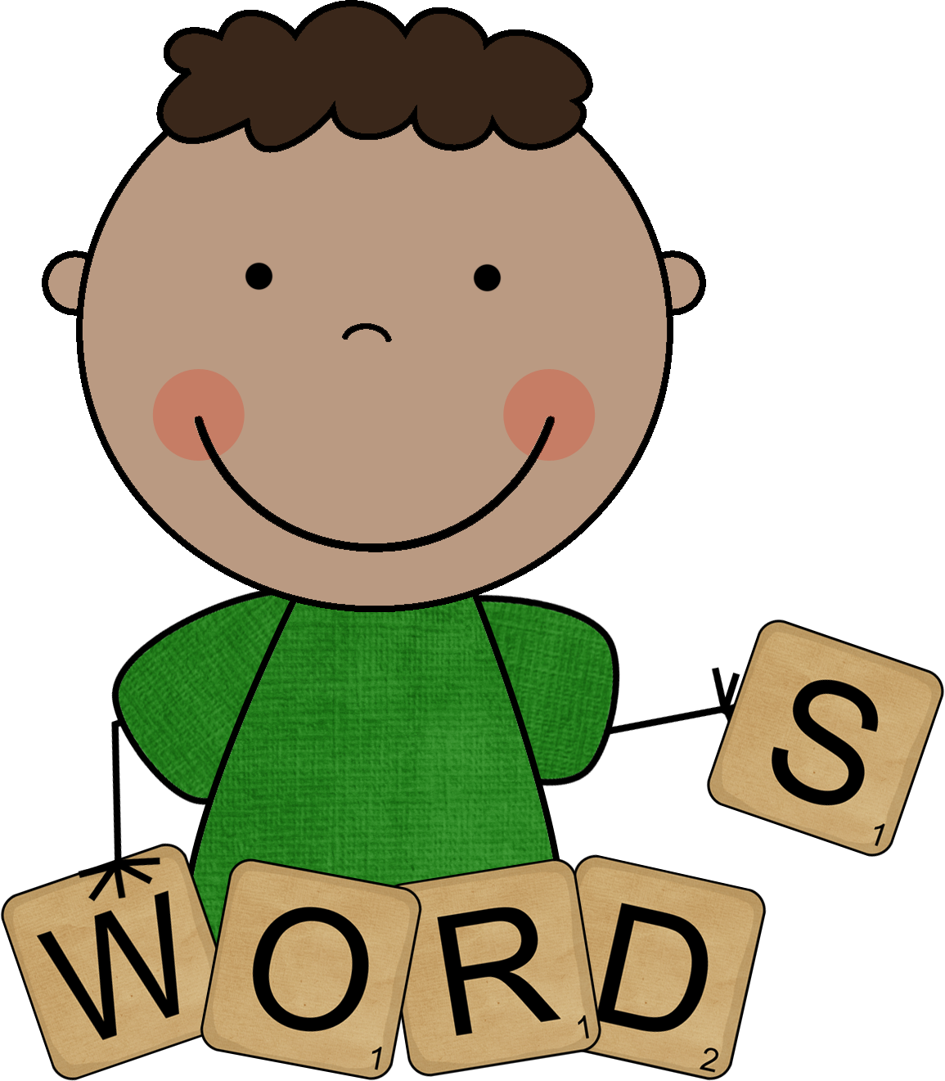
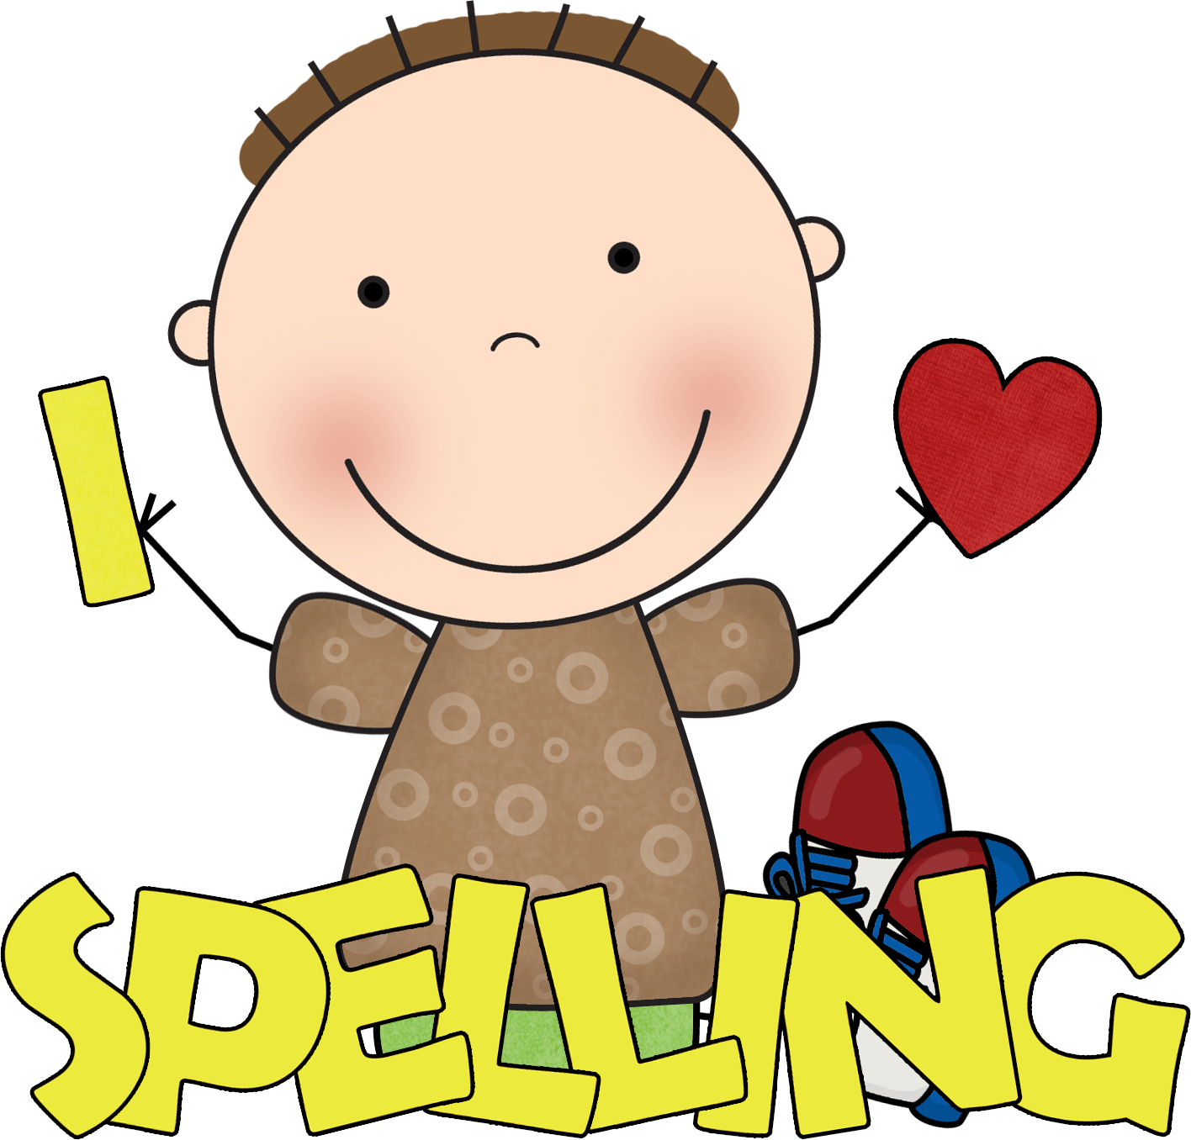
Week of October 10th
all, an, day, see, so

a
and
at
can
I
it
is
in
my
on
the
to
up
we
you
go
he

like
me
no

