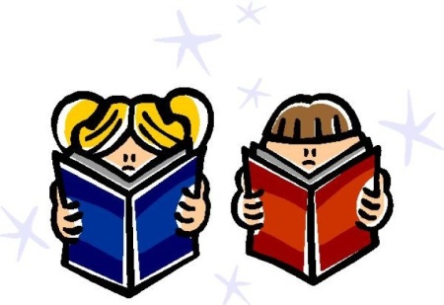
Dear KR Families,

Reading is one of my personal favorite things to do. One of the most important goals I have for your children this year is to instill a love of books and reading. There are many ways to develop this. The most important is to read, read, read at home to your child! At school, your children have been very enthusiastic borrowing books from the Dwight library. The public libraries are also a wonderful resource. In a few months your child will start bringing home a “Just Right Book Bag” with books from the KR library that are “Just Right” for him/her to read with you.
One strategy to develop a love of books is to allow them to choose and own their own. Doing this will develop their creativity, vocabularies, and confidence and help them see themselves as readers. So, this year I have decided to offer the Scholastic Reading Club to KR. Scholastic offers a wide variety of high-quality books to help our child find something that he or she will feel excited to read.
I will send home a flyer approximately once a month. If you want to purchase any books, you have a choice of doing it online or sending the form back in to me.
For online ordering, go to Scholastic.com/readingclub and enter our Class Activation Code: HP2HD.
Thank you for supporting your child’s reading at home.

Fondly,
Mrs. Rafsky

