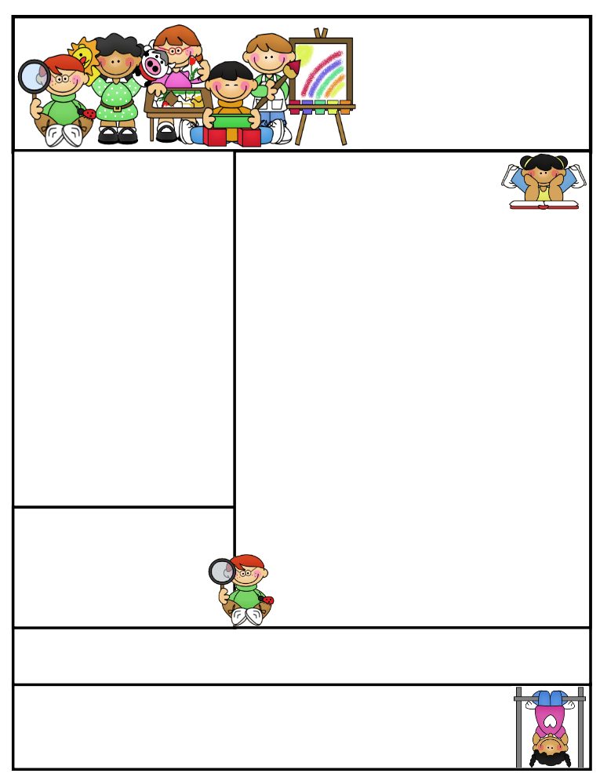
Mrs. Kalamaras’ Class ClaClassCWeek of: March 4-8th
Look at Mrs. Kalamaras’ class
Week of: October 6th

Grad

In class:

This week in class we worked on the letters R,B,P. Having them work on correctly forming the letters, holding the pencils correctly and using the writing man as a guide.
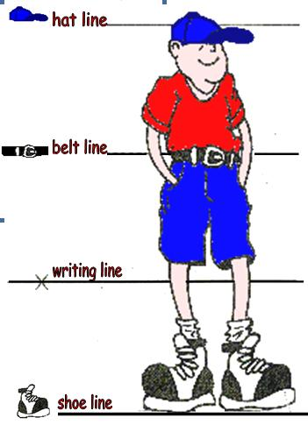
Math we worked on one-to-one correspondence, subitizing and hierarchical inclusion using unifex cubes, colored tiles and white boards.
We went on a fall walk looking for leaves after reading Leaf Man by Lois Ehlert. We then got our creative hats on and made our very own leaf men/women using our leaves we found on the playground. It was a great experiment and they turned out great!
Our apple unit is still going strong…we painted 3 kinds of apples, were able to identify, and we were able to label the apple parts. We ended the week with an apple graph.
Reading Workshop is still learning how to book shop in our own library, readers respect and the different way to “read” a book.

Special Happenings:
Fireman Waiksnis came in this week to talk to the kindergarten classes about Fire Safety. They were able to see, touch and feel a fireman in his uniform and ask questions about fire safety.
Our V.I.P. this week was Steven. He was so excited to share with the class his very special items he brought in and the great pictures. KK gives a very special thank you to his sister and mom who came in to the class to read. The kids LOVED it!
Our Mystery Reader for this week did a fantastic job! Thank you Mrs. Mahfouz for coming in and giving us 3 wonderful clues.

Take a LOOK!
Next week our student of the week is Sophia. Hip, Hip Hooray!
Next Friday is our Field Trip to Blue Jay 9-12pm.
Conferences are coming!!!... starting October 20th. Looking forward to seeing all of you!

Dates to Remember:

