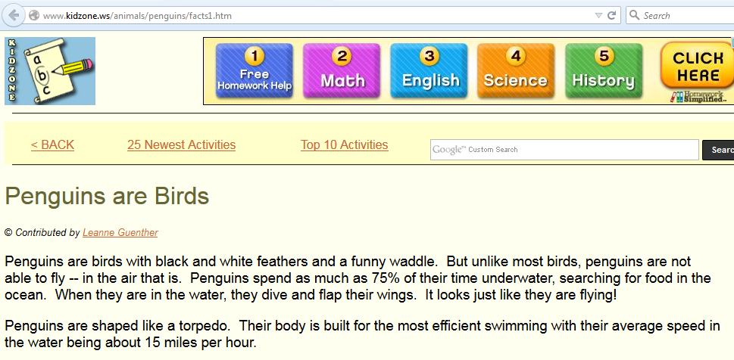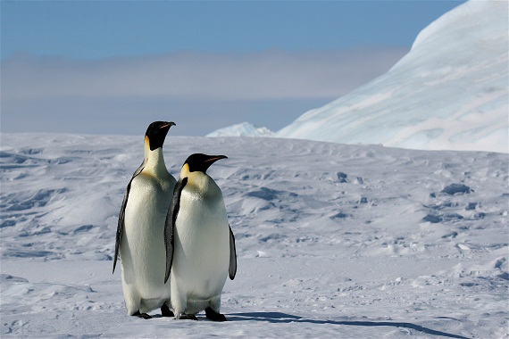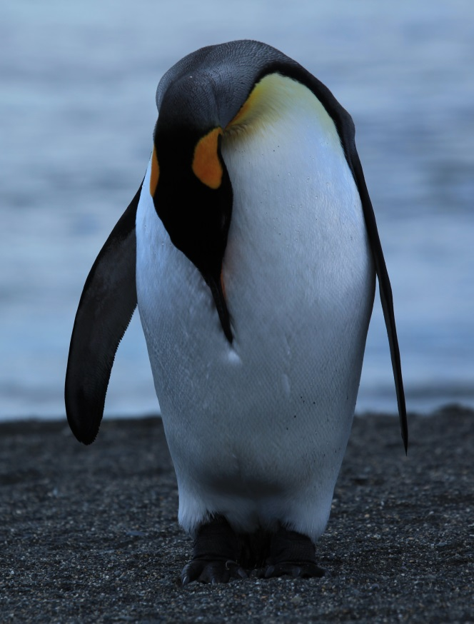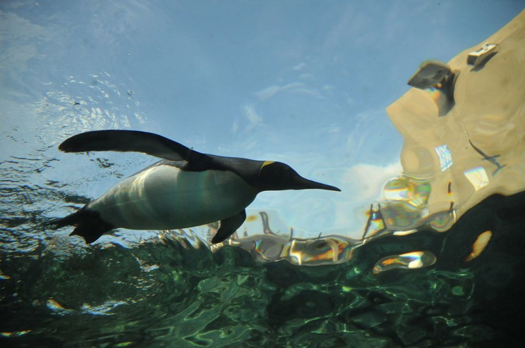

Double click on box to listen!



Creative Commons Image

Liam Quinn Creative Commons

Photo by saname777. **Creative** **Commons** License. via Wikimedia **Commons**