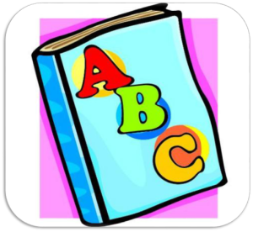
1K Word Wall Words
Week of October 5th, 2015
me he go no like
a
and
I
the
to
in
is
it
on
you
can
my
we
up
at

