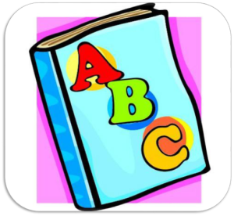
1K Word Wall Words
Week of January 25th, 2015
best came make of said
not
on
one
or
out
play
see
she
so
that
the
they
this
to
up
want
was

a
all
am
an
and
as
at
back
be
because
big
by
can
day
do
from
get

we
went
what
when
where
who
will
with
you
go
had
has
he
her
him
his
how
I
if
in
is
it
like
me
my
no

