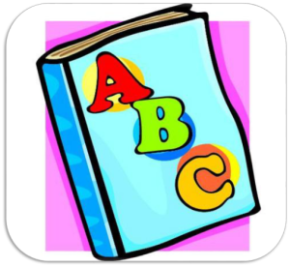
1K Word Wall Words
Week of March 14th, 2016
after been before saw there
want
was
we
went
what
when
where
who
will
with
you
your

or
out
our
play
put
said
see
she
so
that
the
they
this
to
up
us
very

I
if
in
into
is
it
like
little
make
me
my
no
not
now
of
on
one

can
day
did
do
for
from
get
go
had
has
have
he
her
here
him
his
how

a
all
am
an
and
are
as
at
away
back
be
because
best
big
but
by
came

