All graphs below are transformations on the graphs of the sine and cosine functions and are of the form:



Unless otherwise stated, all windows for the x-axis were set as:



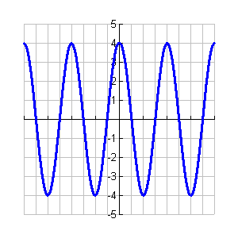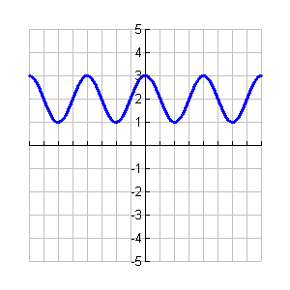1) *vertical shift only…*  2) *amplitude only…*

Y = _____ Y = ________

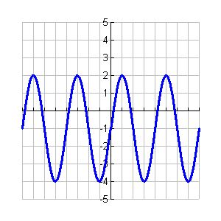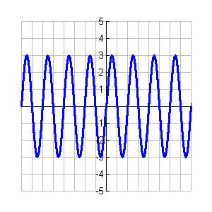

3) *transformation on a sine function…* 4)

Y = $3\sin\left(x\right)-1$_________ Y = $3\sin\left(2x\right)$

_______

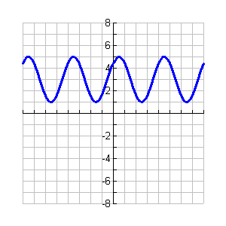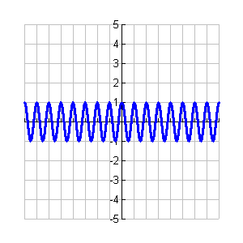5) *cosine…* 6) *sine… amplitude/phase shift…*

Y = $\cos\left(4x\right)$_________ Y = $2\sin\left(x+\frac{π}{4}\right)-3$

__________

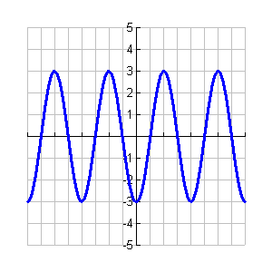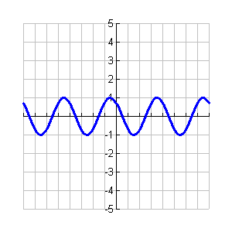7) *cosine… phase shift…* 8) cosine…

9) *sine… amplitude/phase shift…* 10) *cosine…*

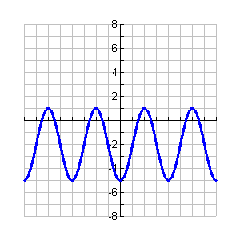

Items 11-15: Complete the blanks based on the given equation.

11)  Amplitude: __5_______

Equation of Midline: _y=0_____

Period: _π_____

Phase Shift: ___ π/8______

12)  Amplitude: ___3______

Equation of Midline: _y=2_____

Period: __ π/2_____

Phase Shift: __0_______

13)  Amplitude: __2_______

Equation of Midline: __y=-3____

Period: ___2____

Phase Shift: __0_______

14)  Amplitude: ___1______

Equation of Midline: _y=1_____

Period: _ 2π/3____

Phase Shift: __ -π/6_______