Brain Area Functions
The Cerebral Hemispheres

Frontal Lobes:
- Decision-making
- Ability to recognize future consequences resulting from current actions, to choose between good and bad actions, to override and suppress unacceptable social responses and behavior, and to determine similarities and differences between things or events.
- Stores long-term memories which are not task-based. This is important for decision-making and social behavior.
- Our frontal lobes reach full maturity around age 25, which marks the cognitive maturity associated with adulthood.

Primary Motor Area (Pre-Central Gyri):
- Allows us to consciously move our skeletal muscles.
- The entire body is represented on the gyrus. Body parts with fine motor control have a larger area of the gyrus devoted to them. [See diagram below.]
- The nerve pathways cross just below the brainstem. In other words, the right-side of the brain controls the left-side of the body and vice versa.
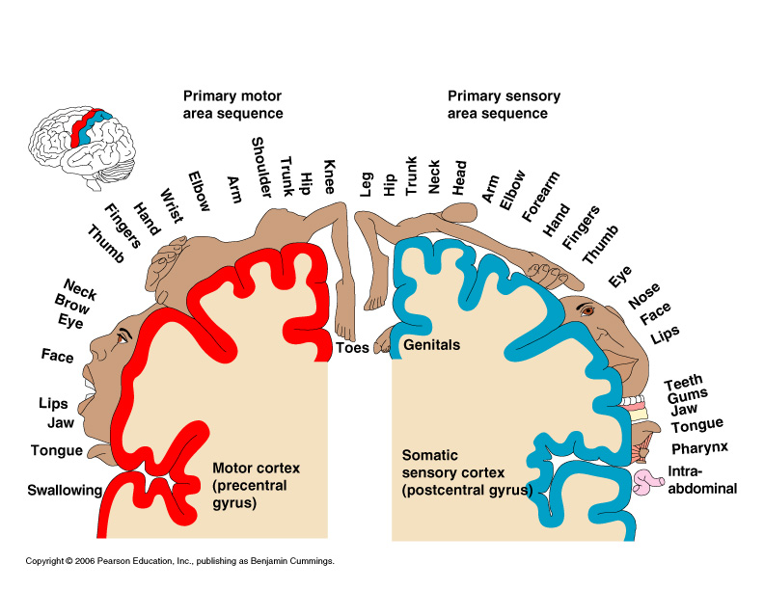

Primary Sensory Area (Post-Central Gyri):
- Nerve signals traveling from the body’s sensory receptors for pain, temperature, and touch (does not include the special senses) are localized and interpreted in this area of the brain.
- The entire body is represented on the gyrus. Body parts that are particularly sensitive have a larger area of the gyrus devoted to them. [See diagram above.]
- The sensory nerve pathways are also crossed. In other words, the right-side of the brain sense stimuli on the left-side of the body and vice versa.

Parietal Lobes:
- Visual-spatial processing area of the brain.
- Integrates sensory information (sight, body position, hearing, and balance) to determine where objects are in relation to the body.
- Professional athletes have incredibly high-functioning parietal lobes.

Occipital Lobes:
- The primary visual processing area of the brain.
- Shape, color, depth perception, and movement of objects in our visual field.
- The visual pathway = Retina → Optic Nerves → Optic Chiasm → Optic Tracts → Thalamus → Optic Radiations → Occipital Cortex
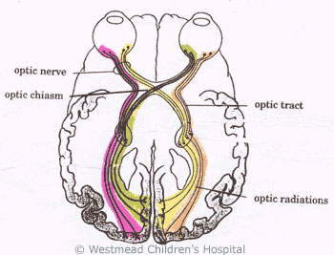

Temporal Lobes:
- Hearing, smell, memory, and emotions.
- Hearing = Wernicke’s area. Auditory processing and language comprehension.
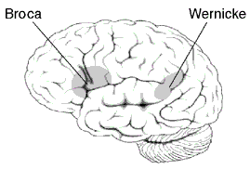
- Smell = Olfactory cortex of the temporal lobe.
- Memory = Hippocampus. A special structure located within the temporal lobe. The hippocampus is vital to storing short-term memories and then processing particular memories into long-term storage.
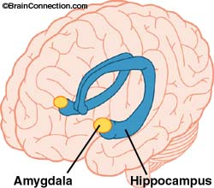
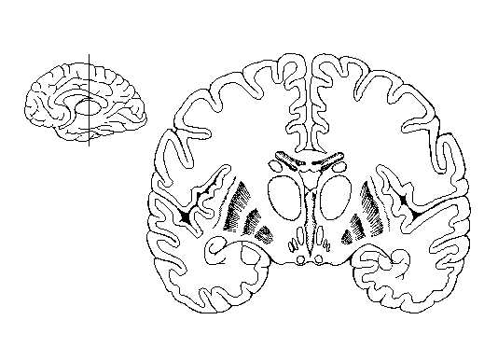
- Emotions = Amygdala. A special structure within the temporal lobe that plays a significant role in processing emotions. [See figure above.]
- Note: The brain structures involved in processing smell, emotions, and memory are all closely related and connected to each other. Our most vivid memories often have a strong emotional component to them. Aromatherapy deals with a smell’s ability to alter our emotional state. And smells often conjure up memories.

Cerebellum:
- Fine motor control and balance.
- The cerebellum quickly integrates sensory information on body position with motor output from the precentral gyrus to create very smooth and controlled body movements.
- Damage to the cerebellum causes disorders in fine-motor movements, coordination, balance, and posture. This is called ataxia.

