Name Period

AP Biology

WALRUSES AND WHALES AND SEALS, OH MY!

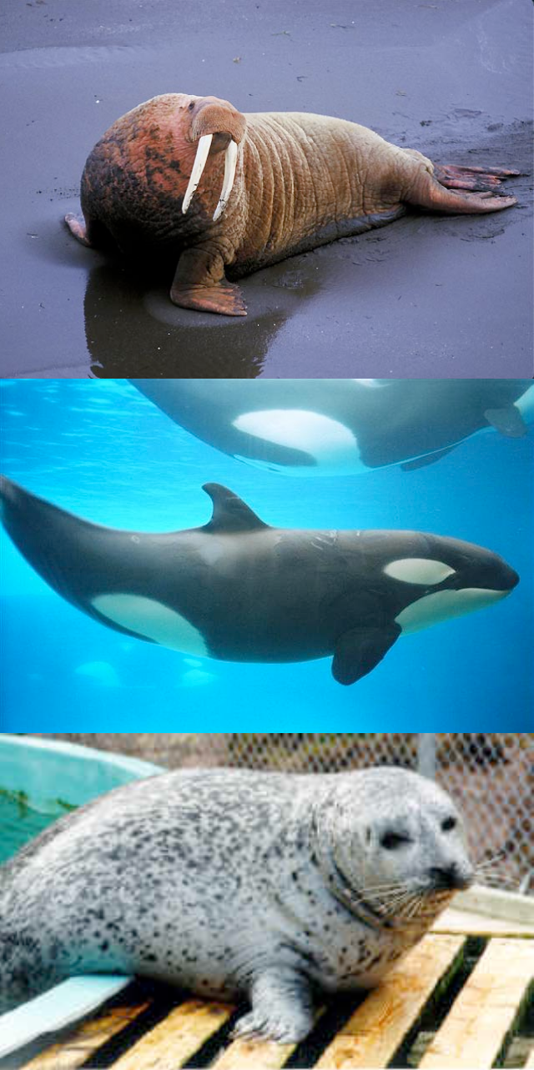
Walruses and whales are both marine mammals. So are dolphins, seals, and manatee. They all have streamlined bodies, legs reduced to flippers, blubber under the skin and other adaptations for survival in the water. Although mammals evolved on land, these species have returned to the sea. Did they evolve from a single ancestor who returned to the ocean, or were there different return events and parallel evolution? We can’t go back in time to observe what happened, but DNA sequences contain evidence about the relationships of living creatures. From these relationships, we can learn about the evolutionary history of marine mammals.

In this lab, we will use sequence information in GenBank (the public repository of all known DNA sequences from many species) and bioinformatics software to test hypotheses about the relationship between aquatic mammals (seals, whales, dolphins, walruses, manatees, and sea otters) and their potential ancestral relationship to land mammals.

We will use a protein that all mammals share: the hemoglobin beta protein. Hemoglobin is a good test molecule since it shows both conservation across species (since it performs the essential function of carrying oxygen in the blood), and variation between species. Species with unique challenges such as holding their breath for long underwater dives, may have evolved changes in their hemoglobin which improved
their supply of oxygen. In addition, hemoglobin has been studied by many evolutionary biologists, so sequences are available in GenBank from many different organisms.

In this lab, we will be testing hypotheses about the evolutionary ancestry of different marine mammals. To repeat, we are trying to answer the question: Did marine mammals evolve from a single ancestor who returned to the ocean, or were there distinct return events from separate ancestors? As a starting point let’s hypothesize that marine mammals have a single common land mammal ancestor.

Part A: First, we will explore the relationship of the marine mammals to each other vs. their evolutionary relationship to land mammals. To do this, we will test whether seals and whales are more closely related to each other than either of them are to representative land mammals: dogs (land carnivores) or cows (land herbivores). This exercise will mainly train you in using the bioinformatics software.

Part B: Second, each student will then develop a phylogenetic tree which includes a selection of marine mammals and land mammals which represent the major mammalian orders. You will then use this phylogenetic tree to test our hypothesis that all marine mammals have a single common land mammal ancestor.

PART A

FINDING AMINO ACID SEQUENCES (*Use Firefox as your browser for this work.*)

1. First we need to get the sequence data for the hemoglobin protein from our marine and land animals: seals, whales, dogs, cows. Go to GenBank, a DNA and protein sequence database hosted by the National Center for Biotechnology Information (NCBI) in Maryland at: http://www.ncbi.nlm.nih.gov/Genbank/ (Note: You can also go to Google and search for “GenBank” and it will always come up as the first link.)

2. The hemoglobin beta gene and protein is known as “HBB” in GenBank. In the “Search” window, select “Protein” from the pull-down menu, because we want to compare the amino acid sequence from each animal for this protein. We need to be specific about the identity of each animal, so we will use Phoca vitulina (harbor seal), Balaenoptera acutorostrata (minke whale), Canis familiaris (dog) and Bos taurus (cow). Type in the protein you’re looking for and the organism. Push “Go”.

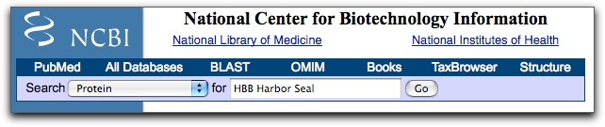

NOTE: This database was developed by humans, so sometimes it is not organized logically. Don’t get frustrated; be patient. If your search returns several answers that you have to choose between, look for the listing with a “P0####” number. That will be the correct protein!

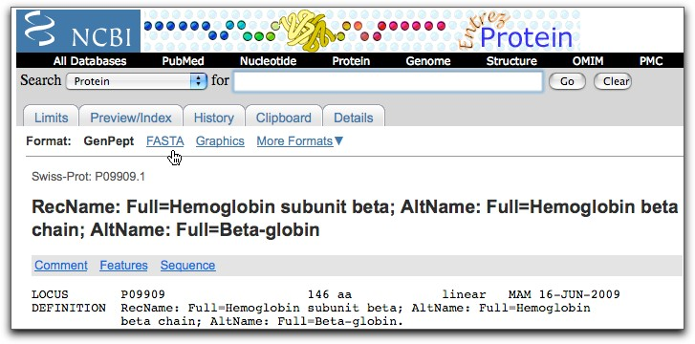
3. The search result is a page with a lot of information about the protein from this organism. To see the actual amino sequence for this protein, click on the “FASTA” link near the top of the page.

4. The FASTA page presents the amino acid sequence of the protein in a coded format using single letters to represent each of the 20 amino acids (A=alanine, M=methionine, P=proline, etc.) Copy the amino acid sequence. You must include the header line, starting from the greater than symbol (>). THIS IS IMPORTANT!

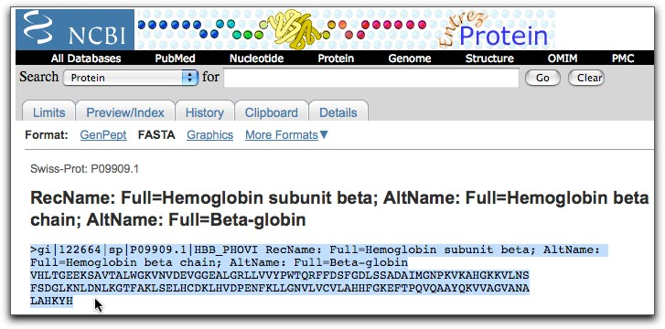

5. Go to: http://workbench.sdsc.edu and set up a free account (register), then enter workbench (3.2)

Part I: Enter your sequences

6. Select “protein tools”, then select “add new protein sequence” and “run” (note: if you were working with nucleic acid sequences you would select “nucleic tools” and then “add new nucleic sequence)
7. “Paste” in your sequences, then edit the file a bit to make our phylogenetic tree read more clearly. Let’s look at the sequence header at the top of each protein sequence that we have copied into the FASTA text file. The species title that will show up on your tree will be the first line of each set of sequence data following the “>” symbol. So right now, our tree will say things like “gi|122664|sp|P09909.1”. That won’t make a lot of sense will it! This header can be edited for clarity, but you MUST preserve the “>” symbol. You can use the scientific name or the common name to identify your sequence.

For example:
The harbor seal sequence begins like this:

>gi|122664|sp|P09909.1|HBB_PHOVI RecName: Full=Hemoglobin subunit beta

This can be edited to simply say this:

>Harbor_seal

Tip: If you want to use more than one word in your label, like “harbor seal” you must add an underscore “_” between the words (harbor_seal) instead of a space between words. This is the only way that all the words will show up as labels on your tree. Do not use names longer than 30 characters.
8. In the “label” box, type in the name of the organism. Select “save
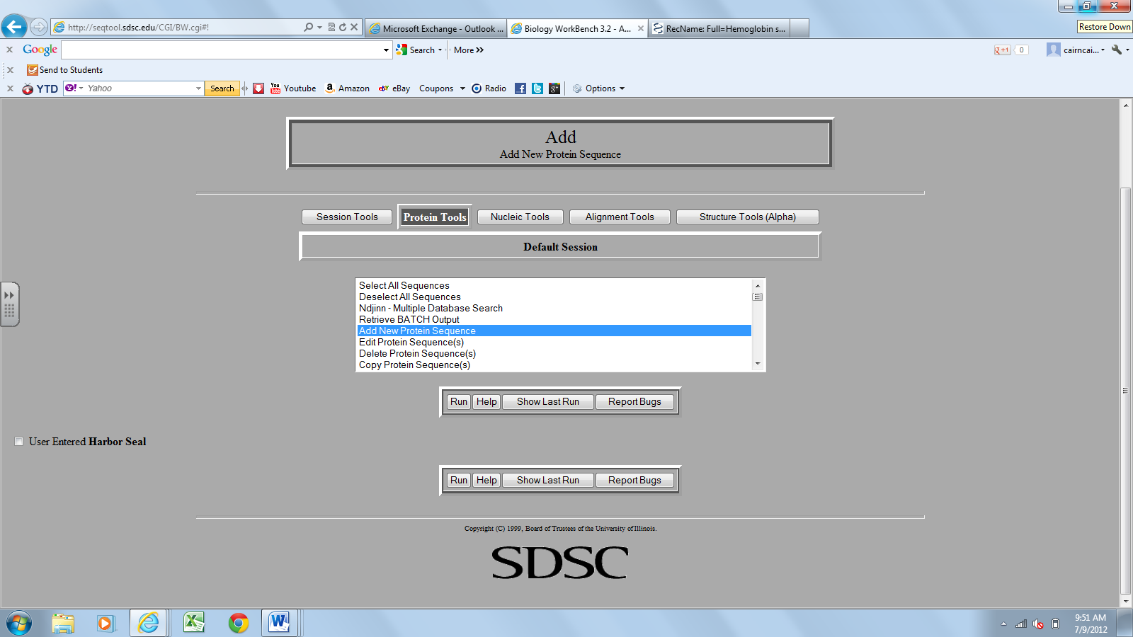
These will appear as you add sequences

9. Go back to GenBank and collect the amino acid sequences for the HBB gene from Balaenoptera acutorostrata (minke whale), Canis familiaris (dog), and Bos taurus (cow).

Part II: Align the Different Sequences
1. In Biology Workbench, select “protein tools” and select (check the boxes) of the organisms you are comparing.
2. From protein tools menu box, choose “CLUSTALW”, then click “run” then click “submit”. Wait for the new window to completely load and then click “import alignment”

Build a Phylogenetic Tree
1. From Alignment Tools Menu, choose “DRAWGRAM”, then “run” and “submit”
2. Record diagram: right click over image, choose “save as”, save the file, then paste into word document.

Tip: If your tree doesn’t look right, check for the following common problems:

a. You need one return after the name following the “>” character

b. You need the “>” character at the beginning of each sequence header.

PART B

1. Below are the representative marine mammals for your new cladogram:

minke whale (baleen whale), Balaenoptera acutorostrata
dolphin (toothed whale), Tursiops truncatus
harbor seal, Phoca vitulina
walrus, Odobenus rosmarus
otter, Lutra lutra
manatee, Trichechus inunguis

2. In this exercise, we will compare the hemoglobin proteins of these marine mammals to some representatives of the major taxa of land mammals:

carnivora: dog, Canis familiaris
rodentia: rat, Rattus norvegicus
herbivore: cow, Bos taurus
primates: human, Homo sapiens
proboscidea: African elephant, Loxodonta africana
marsupials: red kangaroo, Macropus rufus

3. Reminder: We are testing the hypothesis that all marine mammals have a common land mammal ancestor.

4. Once again, use the hemoglobin beta protein sequence to test this hypothesis. You will be building a tree with all the marine mammals and all the land mammals listed above.

5. Follow the complete process we used in Part A to obtain your amino acid sequences from GenBank, align them and build the evolutionary tree.

6. Then use your phylogenetic tree to determine the evolutionary relationships amongst marine mammals and the representative land mammals. Determine whether your hypothesis was supported by the molecular data.

