Modern Global Studies
Introduction to Essential Questions
Throughout this year in Global Studies, you will answer a series of essential questions related to Global History. An essential question can:
      - provoke deep thought,
      - solicit information-gathering and evaluation of data,
      - result in an original answer,
      - produce original ideas rather than predetermined answers (critical thought?),
      - possibly have no answer (!!!)
How then should we think?
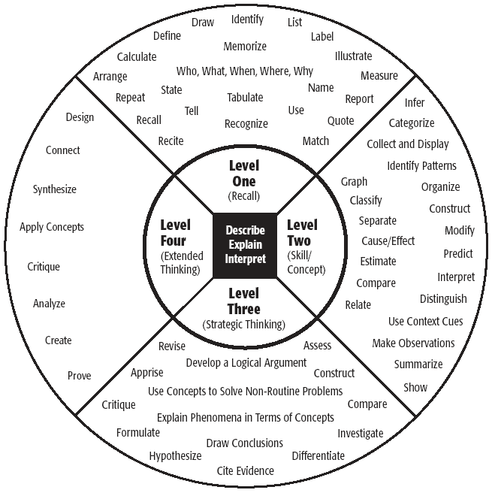

Directions: With your group, read each essential question on the reverse side of the paper. Define the meaning of the question in your our own words and then discuss your opinion of the quote provided, supporting your discussion with a “real-life” example of the concept that illustrates and reinforces your answer. The final category will be completed as a class.

Essential Question #1: Do Individuals have power?
William Ernest Henly "I am the master of my fate; I am the captain of my soul."
Re- Rewrite the essential question in your own words:

In your group, discuss your opinion of the quote above. Do you agree or disagree? Why or why not?

How will this course address this topic? (to be completed with your teacher)

Essential Question #2: What is the true nature of man?
Margaret Mead “Human nature is potentially aggressive and destructive and potentially orderly and constructive.”
Re- Rewrite the essential question in your own words:

In your group, discuss your opinion of the quote above. Do you agree or disagree? Why or why not?

How will this course address this topic? (to be completed with your teacher)

Essential Question #3: Does hope exist in the horrors of conflict?
Stephen King “Hope is a good thing - maybe the best thing, and no good thing ever dies”.
Re- Rewrite the essential question in your own words:

In your group, discuss your opinion of the quote above. Do you agree or disagree? Why or why not?

How will this course address this topic? (to be completed with your teacher)

Essential Question #4: Do individuals have rights?
John Adams “Government is instituted for the common good; for the protection, safety, prosperity, and happiness of the people; and not for profit, honor, or private interest of any one man, family, or class of men; therefore, the people alone have an incontestable, unalienable, and indefeasible right to institute government; and to reform, alter, or totally change the same, when their protection, safety, prosperity, and happiness require it.”
Aristotle “The only stable state is the one in which all men are equal before the law.”
Re- Rewrite the essential question in your own words:

In your group, discuss your opinion of the quotes above. Do you agree or disagree? Why or why not?

How will this course address this topic? (to be completed with your teacher)

