Parents helping Teachers helping Students
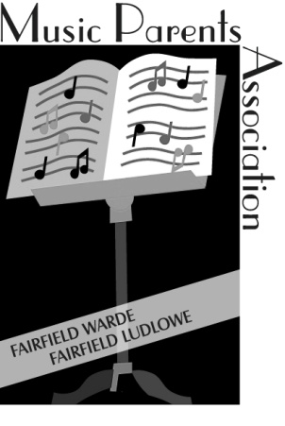
Making Beautiful Music Together
We are the MPA
The Music Parents’ Association
of the Fairfield High Schools, Inc.
supporting Music Education at the Ludlowe and Warde High Schools and beyond

Help us make a difference for all Fairfield student musicians

With your support, the MPA is able to:
- Provide student scholarships to summer music programs, conservatories and colleges.

- Help families save money on the cost of instruments at our Annual Used Instrument Sale where you can buy or consign a wide variety of instruments. (Coming up soon! Consignments: Friday, September 15th, Sale: Saturday, September 16th )

- Keep our student musicians looking their best by coordinating the schools’ Concert Attire Rental programs

- Support all 14+ school concerts, the Pep Bands, the Memorial Day Parade with ushers and refreshments for our student musicians after each performance.

- Share news and valuable information about upcoming concerts, our students’ accomplishments, and music education throught the year in our Emails, Newsletters and Website (www.fairfieldmpa.org)

- Host the Annual Jazz Dinner Dance which raises thousands of dollars for music education in Fairfield.

- Support our teachers’ numerous special music events such as the Townwide Music Festival,
the Mark Wood strings workshop, and our popular holiday Candlelight and Carillon concerts.

Yes! I want to support Fairfield’s music students and teachers!
Please visit our website at FairfieldMPA.org and click on JOIN NOW

Last year’s members will receive a renewal notice via email

