***Lesson 1.4 Measuring Angles*** Name ______________________________date_______

***Student Target:*** *Students will be able to find and compare lengths of segments and angles.*

An _________________ is formed by two rays with the same endpoint.

The rays are the _______________ of the angle. The endpoint is the _____________ of the angle.

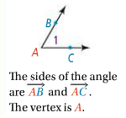

***3 ways to name an angle:***



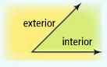

The ________________ of an angle is the region containing all of the points

between the two sides (rays) of the angle. The ________________ of an angle is

the region containing all of the points outside of the angle.

***Problem 1:***

1. 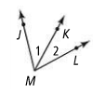***What are two other names for*** ***?***
2. ***What are two other names for*** ***?***
3. ***Would it be correct to name any of the angles*** ***? Explain.***

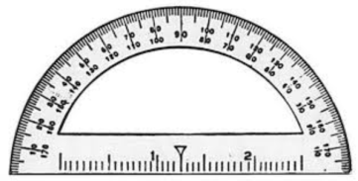

* We measure the size of angles in ________________ with a protractor.
* Angles with the same measure are ­­­­­­­­­­­­­­______________________________.
* Therefore…





*We mark congruent angles in a diagram with these little arches*

***Notation Summary:***

|  |  |  |
| --- | --- | --- |
| ***Name*** | ***Figure/Object*** | ***Length/Measure*** |
| ***Segment*** |  |  |
| ***Angle*** |  |  |

***Types of angles:***

|  |  |  |  |  |
| --- | --- | --- | --- | --- |
| ***Name*** | ***Acute*** | ***Right*** | ***Obtuse*** | ***Straight*** |
| ***Diagram*** |  |  |  |  |
| ***Definition*** |  |  |  |  |

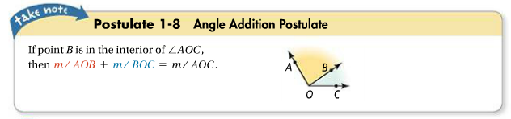

***Angle Addition Postulate:***

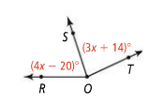***Problem 2a:***

***(LE S A)***



***Label diagram***

***Equation _____________________ reason __________________________***

***Solve:***

***Answer …*** m<ROS = ______ m<TOS = ______

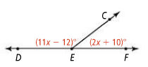***Problem 2b*;**



***(L E S A)***

***Label diagram***

***Equation _____________________ reason ____________________________________***

***Solve:***

***Answer …*** m<DEC = ______ m<CEF = ______

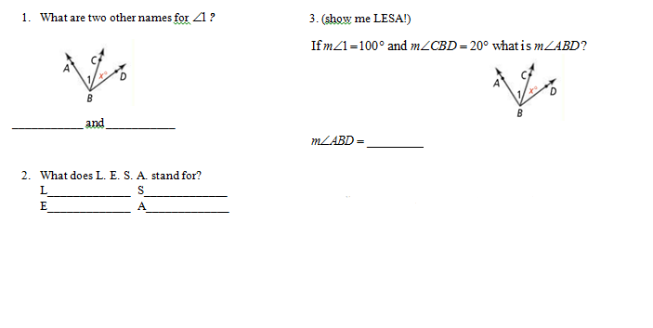**Practice 1.4;**

**\*A question I want to ask in class tomorrow🡪____________________________**

**___________________________________________________________________**

**Measuring Angles with a Protractor**

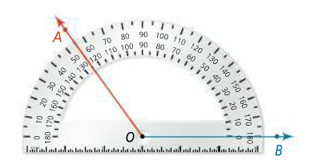

Follow the steps below to find the measure of this angle;

**m<AOB = ________**

**Steps;**

1. **Place the origin over the point, or vertex, of the angle you want to measure.**
2. **Align the bottom line of the angle with the base line.**
3. **Follow the top line of the angle up to the measurements on the protractor's arc.** To get an accurate measurement, extend the angle's line until it passes the protractor.
4. **Read the appropriate number from the protractor that lines up with the ray of the angle. Remember one ray lines up with zero…make sure you are counting up from zero and read the correct measurement. Acute angles are less than 90, obtuse are greater than 90!**

**Practice;** Measure each angle below with a protractor;

1. 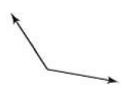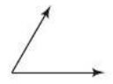 **2)**