**Lesson 1-3 Measuring Segments Name __________________per. _______**

**Student Target:** Students will be able to find and compare lengths of segments

**Vocabulary:**

Every point on a line can be paired with a real number.

The real number that corresponds to a point is called the of the point.

The between points A and B is the absolute value of the difference of their coordinates, or |a – b|.

**Example 1:**

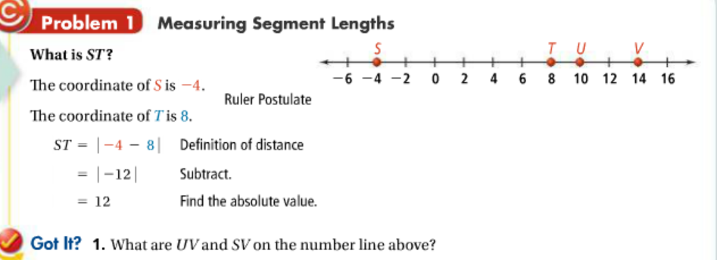

UV:

SV:

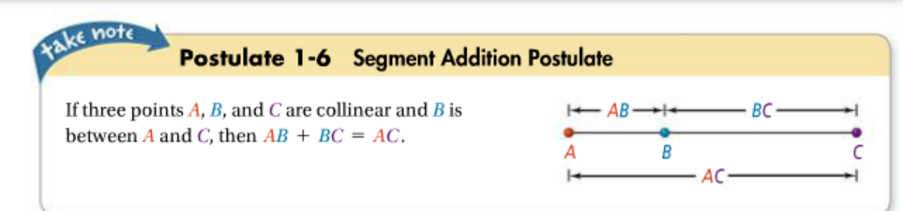

Using the SEGMENT ADDITION POSTULATE;

When solving these problems, remember: **L . e . s . a**

* **Label diagram** with ALL of the given information from the statements and diagram
* **equation** that makes sense from the diagram – in this case based on the Segment Addition Postulate
* **Solve** the equation for the variable
* **Answer the question** that was asked! Be sure to plug the variable back in to find what is asked for.

**L . e . s . a…**

Example: If **AC = 25**, find length of **AB**.

Hint…use the given information (AC=25) and the diagram information, to substitute into the segment addition postulate.

EQUATION ____________________________________ x = _______ therefore AB = __________

Let’s try another one…

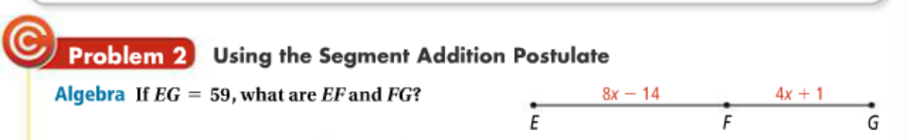

For problem 2 above…

Label…EG = 59 on the diagram.

Equation…____________________________ 🡪 reason? __________________________________

Solve…

x = _________

Answer…plug your value for ‘x’ into the expressions given to find EF and FG.

EF = 8x – 14 FG = 4x + 1

EF = __________ FG = ___________

**Important Vocabulary:**

When Numerical expressions have the same value, you say that they are equal. If two segments have the

____________ ____________________then the segments are **CONGRUENT**. The symbol for congruent is

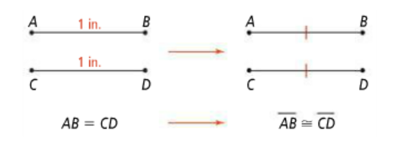

Notice: we mark congruent segments

On a diagram with ‘tick’ marks.

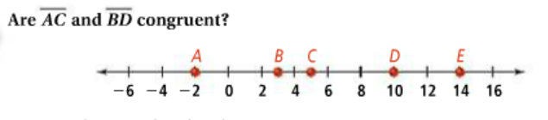Try this**

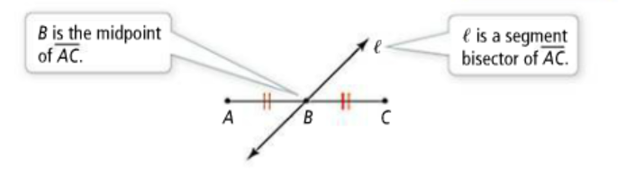The **MIDPOINT** of a segment is a point that divides the segment into ____ ________________ segments.

A point, line, ray or other segment that intersects a segment at its midpoint is said to **bisect** the segment. The point, line, ray or segment is called a .

**Think!** (don’t forget L.E.S.A)



Try these on your own:

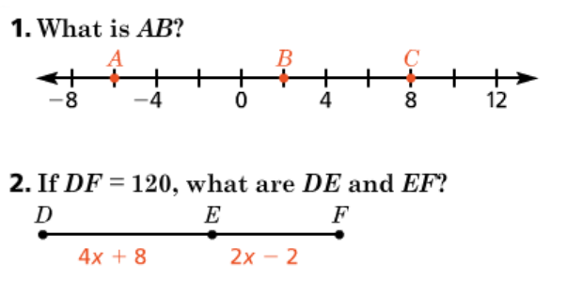

1. AB = __________________
2. EQUATION:

________________________🡪reason? _______________

X = _______

DE = _________ EF = __________

**3. If C is the midpoint of segment AB, find the value of x;** 3) EQUATION: (be careful…different reason this time!)

****________________________🡪reason? _______________

X = _______

**4. Fill in the blank; *Ray ________ is the segment b_______________ of segment ______.***