Name_______________________________________________Period______Date__________

**Geometry 22: Practice with Unit 1**

This practice should be used as practice for the Unit 1 assessment. This **should not** be the only tool that you use to prepare yourself for the assessment. You must go through your notes, re-do homework problems, class work problems and formative assessment problems.

**1.2**

**Use the figure below for Exercises 1–12. Note that pierces the plane at *N****.* **It is not coplanar with *V*.**

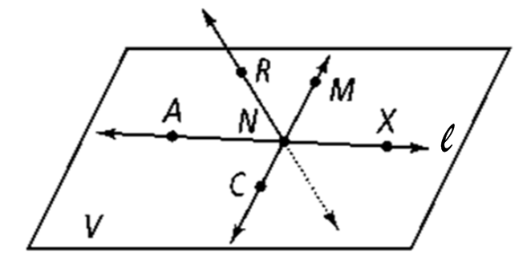

**1.** Name two segments shown in the figure.

**2.** What is the intersection ofand*?*

**3.** Name three collinear points.

**4.** What are two other ways to name plane *V?*

**5.** Are points *R, N, M,* and *X* coplanar?

**6.** Name two rays shown in the figure.

**7.** Name the pair of opposite rays with endpoint *N.*

**8.** Name two other ways.

**9.** Name a straight angle.

**10.** Name the intersection of *plane ACX* and *line CM*

**11.** When two distinct planes intersect, their intersection is a ­­­­­­­­­­­­­­___________.

**12.** Name intersection of *plane ACX* and line *RN*

**13.** Circle the 4 expressions that use correct notation. (one from each column)

AB  CD = 12 cm mFEG = 32o mABC  mDEF

 XY = 12 cm FEG = 32o mABC = mDEF

**14.** is the same as . True or false? Explain

**1.3**

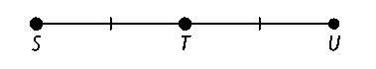**1.** Given: *ST* = 4*x* + 5 and *TU* = 2*x* + 13.

**a.** What is the value of *ST?*

**b.** What is the value of *TU?*

**c.** What is the value of SU?

**2**. Given that B is between points A and C, AB = 4x, BC = 5x – 8, and AC = 19.

a. *x = _________*

b. *AB = _________ BC = _________*

**3**. Draw a diagram in which $\vec{QS}$ bisects $\overline{XY}$ at point M.

Given XM = 2x + 5 and XY = 5x, write an equation and solve for x.

Diagram: Equation: ____________________ *x* = _______

**1.4**

**1.** ∠*JKL* and ∠*CDE* are congruent. If *m*∠*JKL* = 137, what is *m*∠*CDE?*

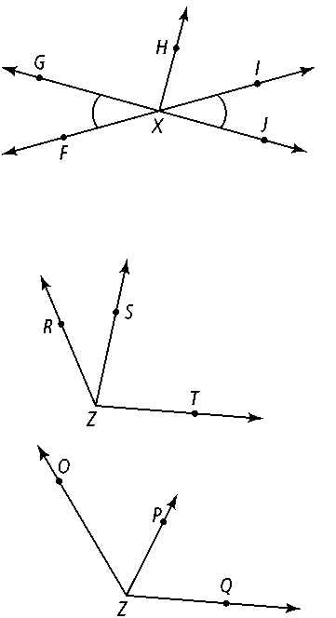**Use the figure at the right for Exercises 2-5. *m*∠*FXH* = 130 and *m*∠*FXG* = 49.**

**2.** ∠*FXG* ≅  *________*

**3.** *m*∠*GXH = ________*

**4.** Name a straight angle in the figure. ___________

**5.** ∠*FXG* and ∠ _________ form a linear pair.



**6.** Complete the angle addition postulate for the diagram at right.

m∠*RZS* + m∠________= m∠*RZT*

**7. Reasoning** ∠*JNR* and ∠*RNX* are congruent. If the sum of the measures of

the two angles is 180, what type of angle are they?

**1.5**

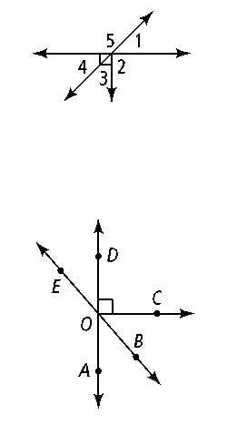**Use the diagram at right. Is each statement true? Explain.**

**1. ∠**2 and ∠5 are adjacent angles.

**2.** ∠1 and ∠4 are vertical angles.

**3.** ∠4 and ∠5 are complementary.

**Name an angle or angles in the diagram described by each of the following.**

**4.** complementary to ∠*BOC*

**5.** supplementary to ∠*DOB*

**6.** adjacent and supplementary to ∠*AOC*

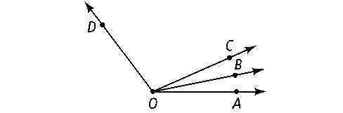**Use the diagram at right for Exercises 7 and 8. Solve for *x.*Find the angle measures.**

**7.** *m*∠*COD* = 8*x* + 13; *m*∠*BOC* = 3*x* − 10; *m*∠*BOD* = 12*x* − 6

**8.** ∠*JKL* and ∠*MNP* are complementary, *m*∠*JKL* = 2*x* − 3 and *m*∠*MNP* = 5*x* + 2.

What are *m*∠*JKL* and *m*∠*MNP?*

**For Exercises 9-11, $\vec{QS}$ bisects ∠*PQR.* Solve for *x* and find *m*∠*PQR.***

**9.** *m*∠*PQS* = 3*x; m*∠*SQR* = 5*x* − 20

**10.** *m*∠*PQR* = 3*x* − 12; *m*∠*PQS* = 30

**11.** *m*∠*PQS* = 2*x* + 10; *m*∠*SQR* = 5*x* − 17

**12.** Supplementary angles and a linear pair are the same thing. True or False? Explain.

**Mixed Review/Practice.** *Write an equation and solve for x in each diagram.*

| ***Diagram*** | ***Equation*** | ***x =*** |
| --- | --- | --- |
| 1. |  | *x = _________* |
| 2. |  | *x = _________* |
| 3. |  | *x = _________* |
| 4. |  | *x = _________* |
| 5. |  | *x = _________* |
| 6. |  | *x = _________*  *m∠IHJ = ________* |
| 7. AE = 3x2 + 4x – 1  EC = 2x2 – 7x + 11 |  | *x = _________* |

**Draw a sketch and label as needed. Do the best that you can with the drawings.**

**8.** Three collinear points *A, B*, and *C.* **9.** 

**10.** Coplanar points *W, X, Y*, and *Z*. **11.** 

**12.**  Acute angle *LMN* **13.** Obtuse angle *XYZ*

**14.** with midpoint *E* **15.** Angles that are supplementary, but **not** a linear pair.

**16.** Straight angle *BAL* **17.** bisects, but **does not** bisect 