***Lesson 1.5 Exploring Angle Pairs Name ___________________ per____***

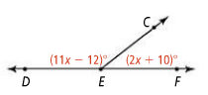***Student Target:*** *Students will be able to identify adjacent, vertical, complementary, supplementary angles, linear pairs, and angle bisectors and use their relationships to write equations to solve problems.*

Review: ***?***

***In lesson 1.4,*** we were able to use the given information, the diagram and then use the _____________ _______________ __________________ to write an equation, (using L. E. S. A) and solve.

What types of angles did we learn about other than STRAIGHT <’s? ___________________________________________

***Now in lesson 1.5*** we will look at ***PAIRS*** of angles…

**ADJACENT ANGLES**

Two angles that…

 * Are coplanar *share a side * have the SAME vertex *have NO common interior points(no overlap)

<1 and <2 are adjacent.

<3 is adjacent to <4 as well.

**VERTICAL ANGLES**

Two angles whose sides are opposite rays.

<1 and <2 are vertical angles. Also, <3 and <4 are vertical <’s.

**COMPLEMENTARY ANGLES**

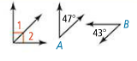Two angles whose measures add up to **90** degrees. Each angle is called the ***complement*** of the other.

<1 is the complement of <2.

Also, <A and <B are complementary angles

**SUPPLEMENTARY ANGLES**

Two angles whose measures add up to **180** degrees. Each angle is called the ***supplement*** of the other.

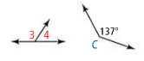 <3 and <4 are supplementary angles.

Also, <C is the supplement of <B.

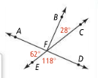In the diagram, name a pair of each type of angle;

1. Supplementary; __________ and ___________
2. Complementary; __________ and ____________
3. Adjacent; ____________ and ______________
4. Vertical; ____________ and ______________

Use the diagram at the right for the following examples. State if each statement is **true or false**.

1. ______ 6) _______
2. _______ 7) 

**LINEAR PAIRS**

A Linear Pair is a pair of angles that are ADJACENT that together form a STRAIGHT angle.

For example, <AFE and <EFD form a linear pair in the diagram above.

**LINEAR PAIR POSTULATE**

If 2 angles form a Linear Pair, then they are supplementary. (their measures always add up to 180)

***Problem #3:***



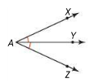

**ANGLE BISECTOR**

An angle bisector divides an angle into 2 congruent angles.

ray AY is the angle bisector of < _______

***Problem #4:***



**Using DIAGRAMS**

The **ONLY** things you can ‘assume’ when looking at a diagram are…

*angles are adjacent *angles are vertical angles *angles form a linear pair

***NEVER*** assume…

*congruence *right <’s

***Problem #2:***

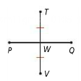What conclusions can we draw from the following diagrams?

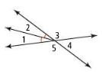

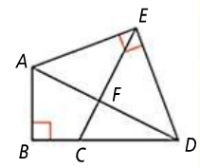***QUICK RECAP:***

1. ***Using the image below, name a pair of each of the following types of angles:***
2. ***Vertical angles***
3. ***Complementary angles***
4. ***Linear pair***



1. ***Using the image to the right, is the _____________________________ to .***
2. ***Sketch the following descriptions:***
3. 
4. 
5. 
6. Ray AB is the angle bisector of <CAD