**Getting into Beta Classroom IC and setting up your gradebook.**

**Setting up Beta**

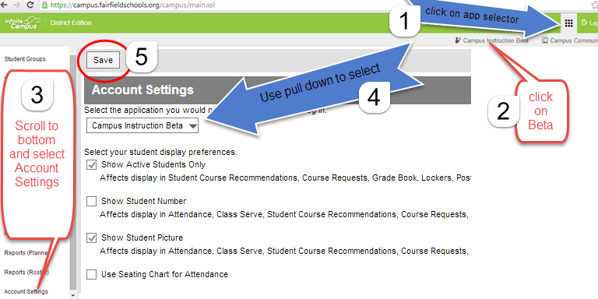

**Setting up your gradebook**

**A B**

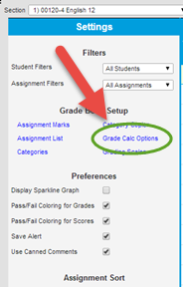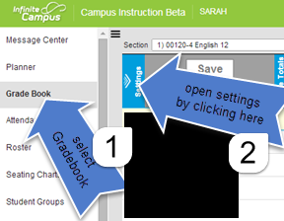

**Work above the grey bar to affect all grading**

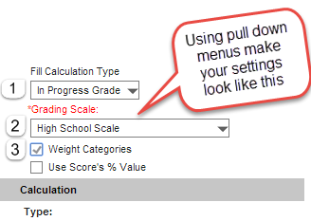

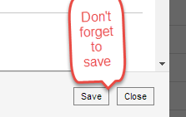

**Repeat for all classes.**