Geometry 2.5 Reasoning in Algebra and Geometry Name ________________________per ______
Target: The students will be able to connect reasoning in algebra and geometry. They will become familiar with algebraic properties of equality and congruence and begin to write justifications for conclusions about given information which will eventually lead to creating 2 column proofs.
We will begin by looking at the “Solve it” on page 113 (and on the computer)
**Postulates and Properties are statements in geometry that we accept as true.
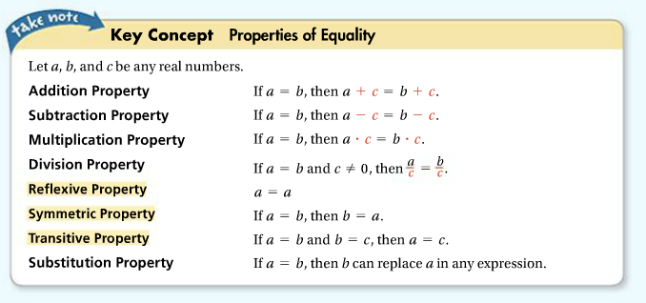
ALGEBRAIC PROPERTIES: you may remember using these in algebra before…

Notice:
These 3 are also properties of congruence

ALSO, remember…Distributive Property

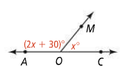
~~~~~~~~~~~~~~~~~~~~~~~~~~~~~~~~~~~~~~~~~~~~~~~~~~~~~~~~~~~~~~~~~~~~~~~~~~~~~~~~~~~~~~~~~~

Given this diagram: Write an equation to solve for x: ___________________________
JUSTIFY!!!!! What do you know about these angles that helped you write the equation? Look at the steps below and let’s justify each one with one of the properties that we know…
________________________________________________________
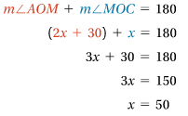
________________________________________________________
________________________________________________________
________________________________________________________
________________________________________________________
________________________________________________________
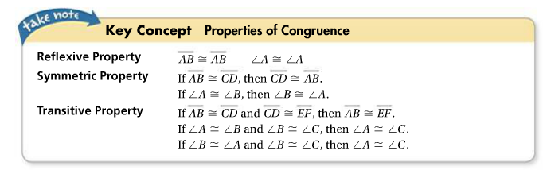
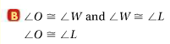
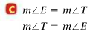
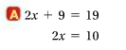
_________________ ___________________ ________________

__________________ ___________________ ____________________

____________________
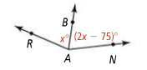
Putting it all together! Use the given diagram and information and fill in the missing steps or justifications to solve for x…

STEPS to SOLVING… Justification…
- 1) given information
- m<RAB = m<BAN 2) definition of __________________
- x = 2x – 75 3) __________________________ property of equality
- 0 = x – 75 4) __________________________ property of equality
- 75 = x 5) __________________________ property of equality
- X = 75 6) __________________________ property of equality
Homework: page 116-118 #1-12, and # 14 – 19

