Geometry **2.6 Proving Angles are Congruent** Name _________________________per _____

**Objective:** To Prove and apply theorems about angles.

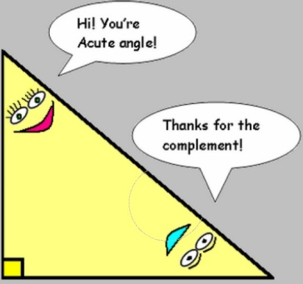A ***theorem*** is a conjecture or statement that you prove to be true using a formal proof. We are going to continue investigating how to write a formal proof. (2-column proofs) We will learn several new theorems in this lesson 2.6.

{*Remember a **POSTULATE** is a true fact that we accept as being true *without proof*.}

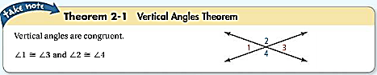

Write this theorem as a conditional statement…

_________________________________________________________________________________________________

What is the hypothesis? ______________________________________________________ 🡪 becomes the “GIVEN”

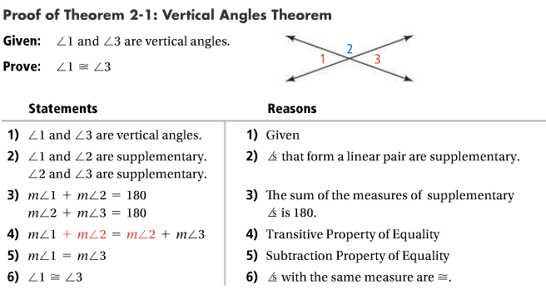What is the conclusion? ______________________________________________________ 🡪becomes the “PROVE”

1.) 1.)

2.) 2.)

3.) 3.)

4.) 4.)

5.) 5.)

6.) 6.)

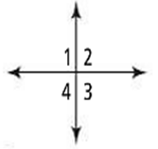***Proof USING the Vertical Angles Theorem:***

Given: <1  <4 Prove: <2  <3

STATEMENTS REASONS

1) 1) given

2) <4  <2 2)

3) <1  <2 3)

4) <1 < _____ 4) Vertical Angles Theorem

5) 5)

***Discovering More Theorems***…

|  |
| --- |
| * Theorem 2.2 **The ______________________ Supplements Theorem**   *If 2 angles are supplements of the same angle (or of*  *angles),*  *then the 2 angles are _________________________.* |

Let’s think about this theorem and discover what it is saying by following the steps below…

1. First draw “2 angles that are supplements of the same angle” let’s use <A



* 60o a) Draw <B that is supplementary to <A 🡪

b) Now draw <C that is also supplementary to <A 🡪

2) How many degrees is <B? ______ How many degrees is <C? ______

3) So what can you conclude about <B and <C? __________________________(fill in the blanks in theorem above)

|  |
| --- |
| * Theorem 2.3 **The ______________________ Complements Theorem**     *If 2 angles are complements of the same angle (…),*  *then the 2 angles are _________________________.* |

Follow the same steps as above, except this time with COMPLEMENTARY ANGLES;

1. First draw “2 angles that are supplements of the same angle” let’s use <A



* 60o a) Draw <B that is supplementary to <A 🡪

b) Now draw <C that is also supplementary to <A 🡪

2) How many degrees is <B? ______ How many degrees is <C? ______

3) So what can you conclude about <B and <C? __________________________(fill in the blanks in theorem above)

|  |
| --- |
| * Theorem 2.4 **The Right Angles Theorem**   If 2 angles are right angles, then they are ______________________. |

Draw 2 angles that are right angles. What is the measure of each angle?

What can you conclude about these angles? Fill in the blank in the theorem above.

|  |
| --- |
| * Theorem 2.5   If 2 angles are congruent AND supplementary, then each angle is a ______________________. |

Draw 2 angles that are congruent and supplementary.

What type of angle is each angle? Fill in the blank in the theorem above.

~~~~~~~~~~~~~~~~~~~~~~~~~~~~~~~~~~~~~~~~~~~~~~~~~~~~~~~~~~~~~~~~~~~~~~~~~~~~~~~~~~~~~~~~~~~~~~~~~~

TRY THESE proofs…

1. Given: *9 = 4x – 3(x – 2)* Prove: *x = 3 2.*

Given: 

|  |  |
| --- | --- |
| Statements | Reasons |
| 1. *9 = 4x - 3(x - 2)* | 1 |
| 2. *9 = 4x - 3x + 6* | 2 |
| 3. *9 = x + 6* | 3 |
| 4. *6 = 6* | 4 |
| 5.  *3 = x* | 5 |
| 6.  *x = 3* | 6 |

Prove:  1 2 3

*STATEMENTS REASONS*

1) 1)

2) <2 and < 3 are a linear pr. 2)

3) <2 and <3 are ___________ 3) Linear Pair Postulate

4) m<2 + m<3 = _______ 4) defn. of ____________

5) m<2 + m< 3 = m<1 + m<3 5) ___________________

6) 6) subtraction POE

7) 7) symmetric POE

8)  8)