Name____________________________________________________Period______Date__________

**Geometry 22: Practice with Lines Cut by a Transversal (3.1-3.3, 3.5)**

**Use the diagram to name each of the following.**

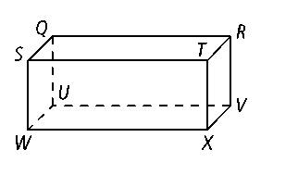**1.** a plane parallel to *plane* *SUQ*

**2.** two lines that are parallel to 

**3.** three lines that are skew to 

**4.** two lines that are parallel to plane *QUR*

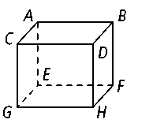**In the following exercises, describe the statement as *true* or *false.* If false, explain why, also state their intersection point(s) if possible.**

**5. **and are skew lines. **6.** plane *DBF* ║plane *ABD*

**7.** **8.** 

**9.** plane *EFH* ║ **10.** **and are skew lines.

**Name the special pair of angles listed below.**

**11. **

**12. **

**13. **

**14. **

**15. **

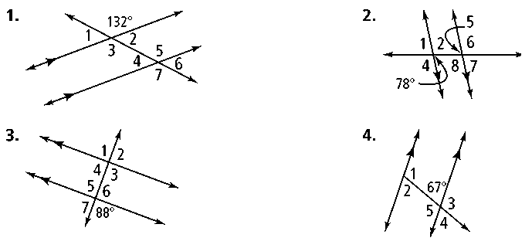**16. Identify all the numbered angles that are congruent to the given angle. State the theorem or postulate that supports your answer.**

**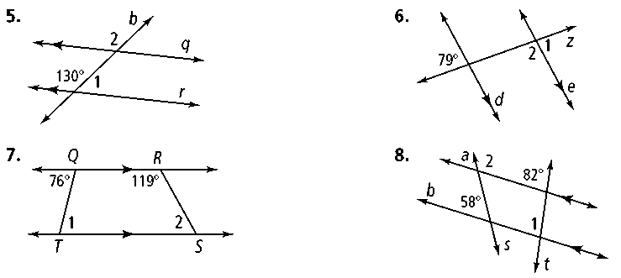****Find *m***∠**1 and *m***∠**2. State the theorem or postulate that supports your answer.**

**17. 18.**

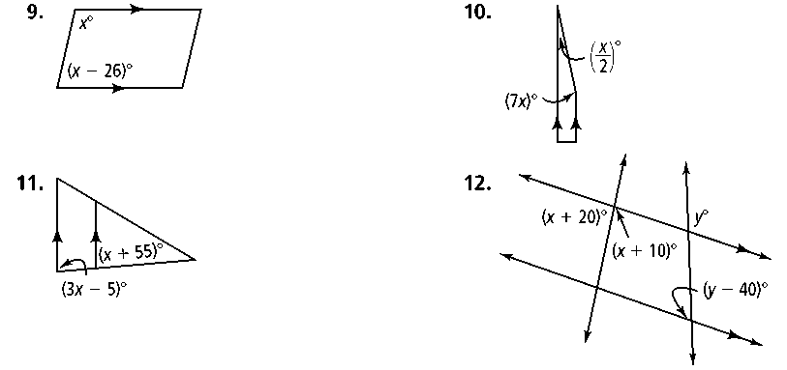**Find the value of *x* and *y****.* **Then find the measure of each labeled angle.**

**19.** **20.**

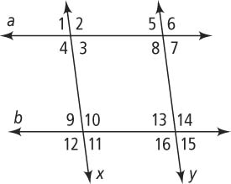**21.** Fill out the two-column proof.

**Given:** *a* ║ *b*, *x* ║ *y*

**Prove:** ∠4 and ∠15 are supplementary

|  |  |
| --- | --- |
| **STATEMENTS** | **REASONS** |
| 1.  *a* ║ *b*, *x* ║ *y* | 1. Given |
| 2. ∠15 and ∠9 are alternate exterior angles | 2. |
| 3. ∠15∠9 | 3. |
| 4. | 4. Definition of angle congruence |
| 5. ∠9 and ∠4 are same side interior angles | 5. |
| 6. ∠9 and ∠4 are supplementary | 6. |
| 7. | 7. |
| 8. | 8. Substitution Property of Equality |
| 9. | 9. |

**22. Error Analysis** Which solution for the figure at the right is incorrect? Explain.

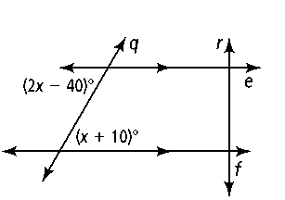2*x* − 40 = *x* + 10 2*x* − 40 + (*x* + 10) = 180

*x* − 40 = 10 3*x* − 30 = 180

*x* = 50 3*x* = 210

*x* = 70

**23.** Factor the following polynomial. 

**24.** Given the following information, find the value of *x*.



For each of the following statements, write **yes** or **no** based on the given information. **THEN,** if no, explain why, if yes state the theorem or postulate that supports your answer.

1. Yes or No



Reasoning: ________________________________________________



1. Yes or No



Reasoning: ________________________________________________



1. Yes or No

Reasoning: ________________________________________________



1. Yes or No

Reasoning: ________________________________________________



1. Yes or No



Reasoning: ________________________________________________

1. Yes or No



Reasoning: ________________________________________________



1. Yes or No

Reasoning: ________________________________________________



1. Yes or No



Reasoning: ________________________________________________

1. **In the problems below, find the value of *x*.**

1

2

1. 

3

4

1. 
2. 

1

2

1. 

4

3

***Find the missing angle measures;***

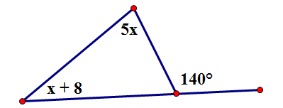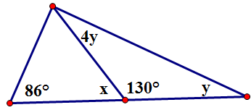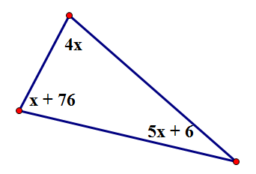

1. 35. 36.

Find the value of x that would the given lines parallel.**State the theorem or postulate to support your answer.**

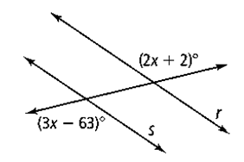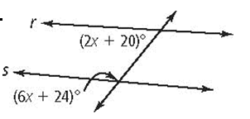

37. 38. 39.