***Lesson 3-1 Lines and Angles***

*Target: To identify relationship between figures in space.*

*To identify angles formed by two lines and a transversal.*

|  |  |  |  |
| --- | --- | --- | --- |
| **Term** | **Definition** | **Symbols** | **Diagram** |
| **Parallel Lines** |  |  |  |
| **Skew Lines** |  |  |
| **Parallel Planes** |  |  |

**Problem # 1:** Use the figure below to answer the following questions.

1. 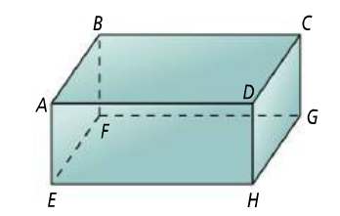Which segments are parallel to ?
2. Which segments are skew to ?
3. What are two pairs of parallel planes?
4. What are two segments parallel to *plane BCFG*?

*When a line intersects two or more lines, the angles formed at the intersection points create special angle pairs.*

**Transversal:**

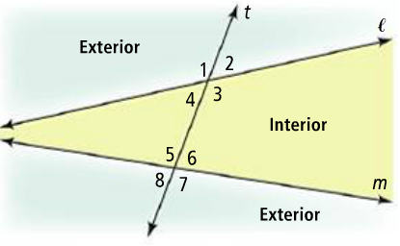

|  |  |  |
| --- | --- | --- |
| **Angles Pairs Formed by Transversals** | | |
| **Term** | **Definition** | **Examples** |
| **Alternate Interior Angles** |  |  |
| **Same-Side Interior Angles** |  |  |
| **Corresponding Angles** |  |  |
| **Alternate Exterior Angles** |  |  |

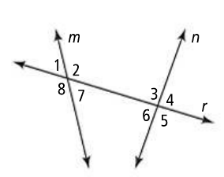**Problem # 2**: Use the figure below to answer the following questions.

1. Name a pair of angles that are alternate interior angles.
2. What are three pairs of corresponding angles?

**Lesson Check:**

*Name one pair each of the segments, planes, or angles. Note the first figure is a rectangular prism (the lines and planes that appear to be parallel are parallel).*

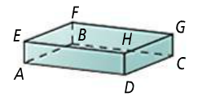

1. parallel segments
2. skew segments
3. parallel planes

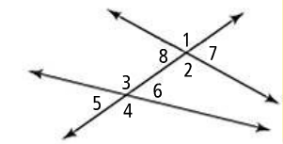~~~~~~~~~~~~~~~~~~~~~~~~~~~~~~~~~~~~~~~~~~~~~~~~~~~~~~~~~~~~~~~~~~~~~~~~~~~~~~~~

1. alternate interior angles
2. same-side interior angles
3. corresponding angles
4. alternate exterior angles

~~~~~~~~~~~~~~~~~~~~~~~~~~~~~~~~~~~~~~~~~~~~~~~~~~~~~~~~~~~~~~~~~~~~~~~~~~~~~~~~

1. Why is the word *coplanar* included in the definition for parallel lines?
2. How does the phrase *alternate interior angles* describe the positions of the two angles?
3. 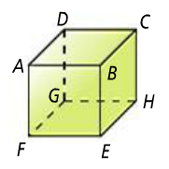In the figure at the right, lines and planes that appear to be parallel are parallel.

*Dan says . Mary says are skew. Who is correct? Explain.*