**Geometry22** Name: ____________________________________________________ Per: ______ Date: ____________

**3-2 Properties of Parallel Lines** *Target: To prove theorems about parallel lines.*

*To use properties of parallel lines to find angle measures.*

|  |  |  |
| --- | --- | --- |
| **Postulate 3-1 Same-Side Interior Angles Postulate** | | |
| **Postulate** | **If…** | **Then…** |
| If a transversal intersects two parallel lines, then same-side interior angles are supplementary. |  |  |

We can use this postulate to PROVE the other angle pair THEOREMS.

**ALL of these theorems are saying:**

**IF the lines are PARALLEL, THEN the special angle relationships are true.**

|  |  |  |
| --- | --- | --- |
| **Theorem 3-1 Alternate Interior Angles Theorem** | | |
| **Theorem** | **If…** | **Then…** |
| If a transversal intersects two parallel lines, then alternate interior angles are congruent. |  |  |

|  |  |  |
| --- | --- | --- |
| **Theorem 3-2 Corresponding Angles Theorem** | | |
| **Theorem** | **If…** | **Then…** |
| If a transversal intersects two parallel lines, then corresponding angles are congruent. |  |  |

|  |  |  |
| --- | --- | --- |
| **Theorem 3-3 Alternate Exterior Angles Theorem** | | |
| **Theorem** | **If…** | **Then…** |
| If a transversal intersects two parallel lines, then alternate exterior angles are congruent. |  |  |

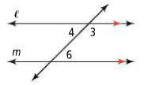Use the diagram below to write a 2 column proof of the **Alternate Interior Angles Theorem**:

Given:  Prove: 

|  |  |
| --- | --- |
| **STATEMENTS** | **REASONS** |
| 1. | 1. Given |
| 2. | 2. |
| 4. | 4. |
| 5. | 5. Definition of Supplementary Angles |
| 6. | 6. |
| 7. | 7. Linear Pair Postulate |
| 8. | 8. |
| 9. | 9. |
| 10. | 10. Subtraction Property of Equality |
| 11. | 11. |

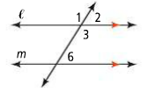Use the diagram below to write a 2 column proof of the **Corresponding Angles Theorem**:

Given:  Prove: 

|  |  |
| --- | --- |
| **STATEMENTS** | **REASONS** |
| 1. | 1. Given |
| 2. | 2. |
| 3. | 3. |
| 4. | 4. |
| 5. | 5. Linear Pair Postulate |
| 6. | 6. |

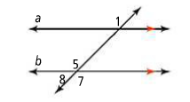Use the diagram below to write a 2 column proof of the **Alternate Exterior Angles Theorem**:

Given:  Prove: 

|  |  |
| --- | --- |
| **STATEMENTS** | **REASONS** |
| 1. | 1. Given |
| 2. | 2. |
| 3. | 3. |
| 4. | 4. |
| 5. | 5. Vertical Angles Theorem |
| 6. | 6. Transitive Property of Congruence |

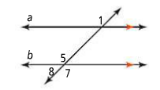**Now we can use these theorems as REASONS in proofs dealing with parallel lines…**

Given:  Prove: 

|  |  |
| --- | --- |
| **STATEMENTS** | **REASONS** |
| 1. | 1. Given |
| 2. | 2. Definition of corresponding angles |
| 3. | 3. Corresponding Angles Theorem |
| 4. | 4. |
| 5. | 5. |
| 6. | 6. |
| 7. | 7. Definition of supplementary angles |
| 8. | 8. |
| 9. | 9. |

…Or to find the missing angle measures in a diagram…

**Notice**: *these arrows mean the 2 lines are parallel to each other.*

Find the measure of each numbered angle. Justify each answer with a theorem or postulate.

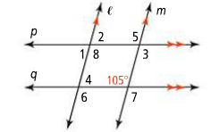m∠7 =_______ because of ____________________theorem

m∠6 =_______ because it is ____________________angle to ∠7

m∠8 = ______ because it is ____________________angle to ∠6

m∠4 = ______ because it is ____________________angle to ∠8

m∠5 = ______ because it is ____________________angle to ∠8

m∠3 = ______ because it is ____________________angle to ∠5

m∠2 = ______ because it is ____________________angle to ∠5

m∠1 = ______ because it is ____________________angle to ∠2

Directions: Refer to the figure to the right and answer the following questions:

1) If , find

2) If , find

3) If , find

4) If and the , find

5) If and the , find