**Geometry21** Name: ____________________________________________________ Per: ______ Date: ____________

**3-4 Parallel and Perpendicular Lines**

You can use the relationships of two lines to a third line to decide whether the lines are parallel or perpendicular to each other.

**Theorem 3-8: Transitive Property of Parallel Lines. If two lines are parallel to the same line, then they are parallel to each other.**

Given:  and   Prove: 

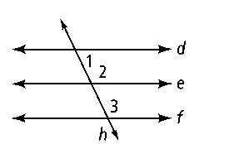

|  |  |
| --- | --- |
| Statements | Reasons |
|  | 1  1 |

**Theorem 3-9: In a plane, if two lines are perpendicular to the same line, then those two lines are parallel to each other.**

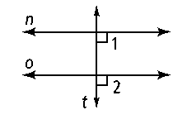

|  |  |
| --- | --- |
| Statements | Reasons |
|  |  |

**Given:** In a plane, *t* ⊥ *n, t* ⊥ *o* **Prove:** *n* || *o*

**Theorem 3-10: Perpendicular Transversal Theorem. If a line is perpendicular to one of two parallel lines, then it is also perpendicular to the other line.**

|  |  |
| --- | --- |
| Statements | Reasons |
|  | 2 |

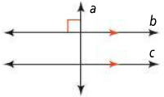**Given:** In a plane*, a* ⊥ *b* and *b* || *c* **Prove:** *a* ⊥ *c*

1

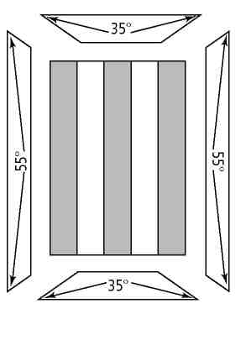

***Exercise 1.*** A carpenter is building a cabinet. A decorative door will be set into an outer frame.

**a.** If the lines on the door are perpendicular to the top of the outer frame, what must be true about the lines?

Why?

**b.** The outer frame is made of four separate pieces of molding. Each piece has angled corners as shown. When the pieces are fitted together, will each set of sides be parallel? Explain.

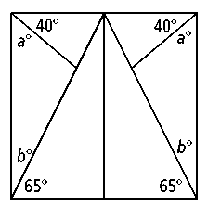

***Exercise 2.*** An artist is building a mosaic. The mosaic consists of the repeating pattern shown at the right. What must be true of *a* and *b* to ensure that the sides of the mosaic are parallel?

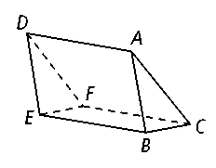

|  |  |
| --- | --- |
| Statements | Reasons  2 |
|  | 3  1 |

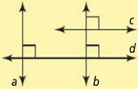***Exercise 3.*** A student says that according to Theorem 3-9, if ** and * ,* then * .* Explain the student’s error.

***Exercise 4.***