Geometry 22 3.5 notes – Parallel Lines and Triangles Name ___________________per____
Target: students will be able to use triangle sum theorem and triangle exterior angles theorem in proofs and ‘solves’.
start with ‘solve it’
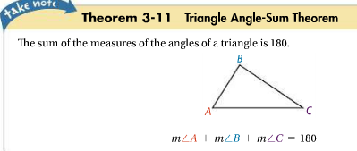
TRIANGLE SUM THEOREM:
The sum of the measures of the angles of a triangle is 180.
m<A + m<B + m<C = 180

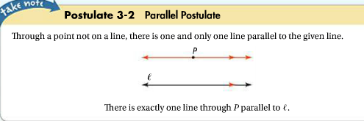

(this is used to PROVE triangle sum theorem, but we are not going to do that proof at this point…just know the postulate)

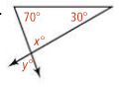
- SOLVE using triangle sum theorem:
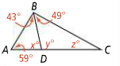
1 2.

x = ______ y = _______ x = ______ y = _______ z =_______
*DEFINITIONS:
**EXTERIOR ANGLE of a polygon: the angle that forms a linear pair with an interior angle of the polygon, when one of the sides of the polygon is extended.
Diagram

** REMOTE INTERIOR ANGLES of a triangle: for each exterior angle, the 2 nonadjacent interior angles in the triangle.
Diagram
<____ and <_____ are the remote interior angles to <_____
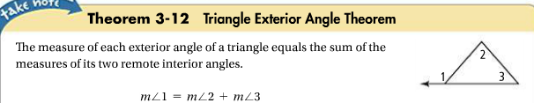
- SOLVE using triangle EXTERIOR angle theorem:
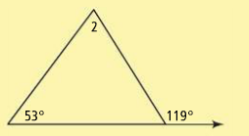
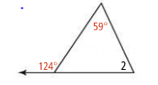
3. 4.

3.5 MORE PRACTICE
Find the measure of angle 1;
5. 6. 7.
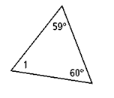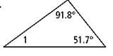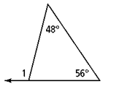

Find the value of each variable;
8. 9. 10.
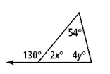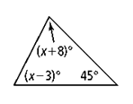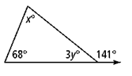

HW pg. 175 #9-15, # 17-22 and #30, 31

