***Lesson 4-4: Using Corresponding Parts of Congruent Triangles*** Name ____________________________

*Target: To use triangle congruence and corresponding parts of congruent triangles to prove that parts of two triangles are congruent.*

Is ? How do you know?

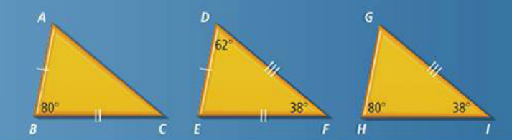

**Once you show two triangles are congruent, you can make conclusions about their other corresponding parts because by definition, corresponding parts of congruent triangles are congruent.**

**(this is the ‘Reason’ in a proof for stating a 4th pair of parts is congruent)**

**You must FIRST prove the triangles are congruent!!**

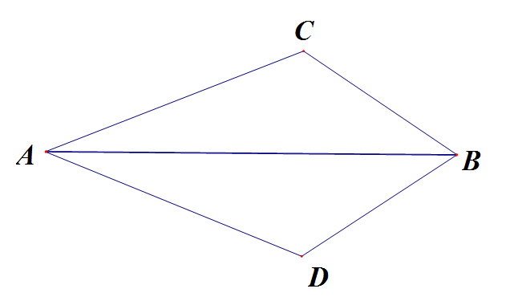

**So let’s take a proof like we have seen before…**

1. 

|  |  |
| --- | --- |
| Statements | Reasons |
| 1. | 1. |
| 2. | 2. |
| 3. | 3. Definition of Angle Bisector |
| 4. | 4. Reflexive Property |
| 5. | 5. |
| 6. | 6. |

**The following is called a FLOW CHART PROOF;**

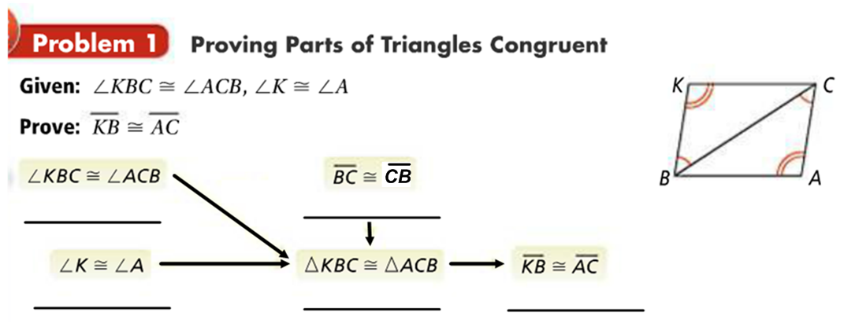

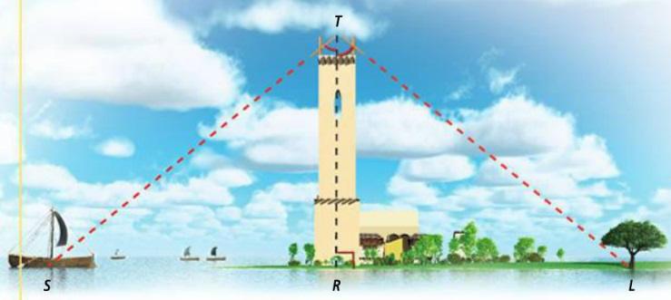Thales, a Greek philosopher, is said to have developed a method to measure the distance to a ship at sea. He made a compass by nailing two sticks together. Standing on top of a tower, he would hold one stick vertical and tilt the other until he could see the ship *S* along the line of the tilted stick. With this compass setting, he would find a landmark *L* on the shore along the line of the tilted stick. How far would the ship be from the base of the tower?





|  |  |
| --- | --- |
| Statements | Reasons |
| 1. | 1. |
| 2. | 2. |
| 3. | 3. |
| 4. | 4. |
| 5. | 5. |
| 6. | 6. |

1. 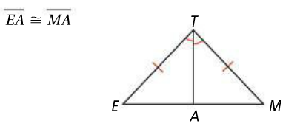Write a congruence statement to state what 2 triangles are congruent to each other. Then b) state a 4th pair of sides or angles that are congruent by C
2. 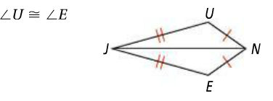 *2)*

 

***corresponding parts of congruent triangles are congruent ____________________________________***

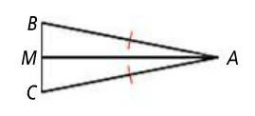



|  |  |
| --- | --- |
| Statements | Reasons |
| 2. ______________________ 3. ______________________ | 1)  2) Definition of midpoint  3) Reflexive |
| 2. ___________________________________ | 4)__________________  5) ________________________________________ |
|  |  |
|  |  |
|  |  |
|  |  |



|  |  |
| --- | --- |
| Statements | Reasons |
|  |  |
|  |  |
|  |  |
|  |  |
|  |  |
|  |  |



|  |  |
| --- | --- |
| Statements | Reasons |
|  |  |
|  |  |
|  |  |
|  |  |
|  |  |
|  |  |

*Hmwk: pgs.246-248 # 5-7, 11, 12, 14, 25, 27-32*