***Lesson 4-6: Congruence in Right Triangles*** Name _____________________

*Objective: To prove right triangles congruent using the Hypotenuse-Leg Theorem*

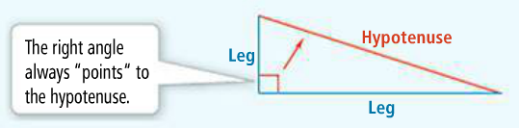**RIGHT TRIANGLES**

Vocabulary…know the parts of a right

**Hypotenuse:** the side opposite the right angle

**Legs:** the other two sides

|  |  |  |
| --- | --- | --- |
| **Theorem 4-6 Hypotenuse-Leg (HL) Theorem** | | |
| **Theorem** | **If…** | **Then…** |
| If the hypotenuse and a leg of one right triangle are congruent to the hypotenuse and leg of another right triangle, then the triangles are congruent. |  |  |

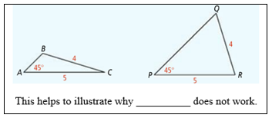**\*\*REMEMBER… HL is the ‘special case’ of SSA – When the angle (A) is a right angle, then SSA works!! But we don’t call it SSA, we call it HL☺**

**Conditions for HL Theorem:**

* There are 2 right triangles
* The triangles have congruent hypotenuses
* There is one pair of congruent legs

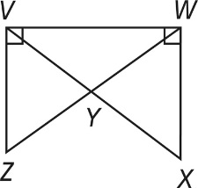**So, in a proof, you must have 3 statements stating those conditions BEFORE using HL Theorem.**

1. **Given:** ∠W*VZ* and ∠V*WX* are right angles. 

**Prove:** Δ*WVZ* ≅ Δ*VWX*

(To prove that right triangles Δ*WVZ* and Δ*VWX* are congruent, you must prove that the hypotenuses are congruent and that one _____________is congruent.)

|  |  |
| --- | --- |
| **STATEMENTS** | **REASONS** |
| 1. ∠W*VZ* and ∠V*WX* are right angles | 1) |
| 1. are right triangles | 2) |
|  | 3)given |
|  | 4)reflexive |
| 1. Δ*WVZ* ≅ Δ*VWX* | 5) |

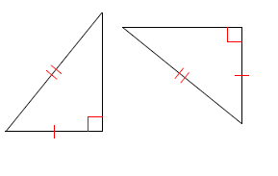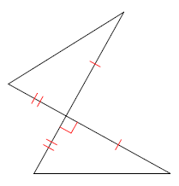2) State if the triangles below are congruent. Then state why you know.

a. b.

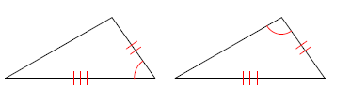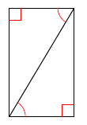

c. d.

FLOW CHART PROOF:

3)

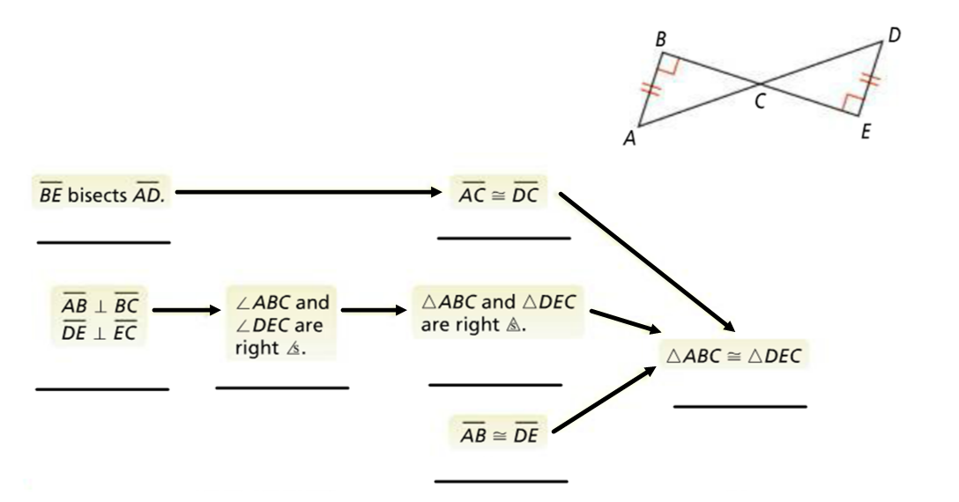

**What additional information would prove each pair of triangles congruent by the Hypotenuse –Leg Theorem?**

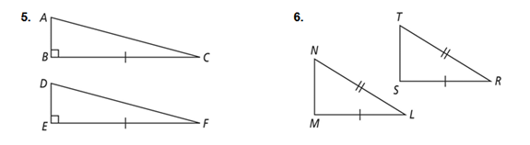

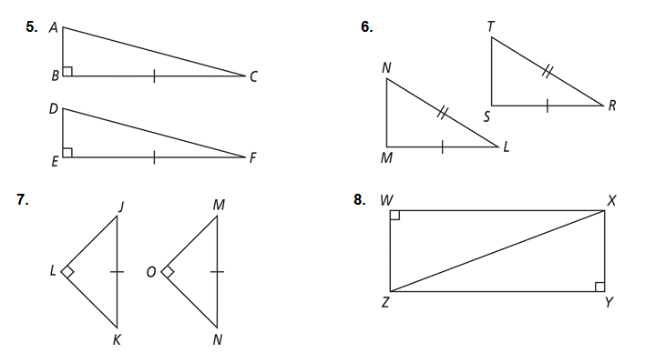

9**. For what values of *x* and *y* are the triangles congruent by HL?

