Geometry 22 **5.2 Perpendicular and Angle Bisectors** Name ___________________per____

*Objective: The students will be able to define and use the properties of perpendicular bisectors and angle bisectors.*

**Perpendicular Bisector:**

 Draw the perpendicular bisector of the segment;

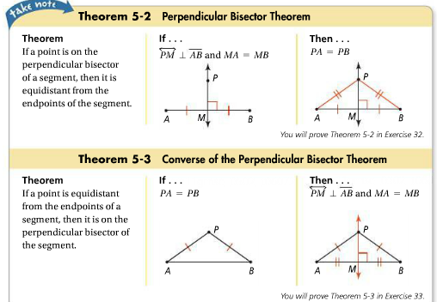 (now draw a bisector that is NOT a bisector!... )

**Equidistant**: (defn)

The same or equal distance



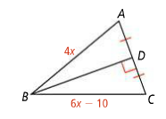

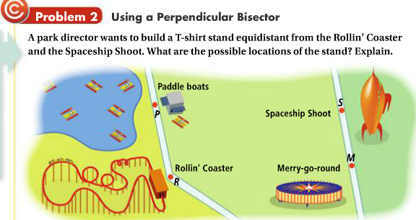

Draw the line on which the stand should be built.

**Distance from a point to a line**…

C:\Users\Meyers Family\AppData\Local\Microsoft\Windows\Temporary Internet Files\Content.IE5\QPB76N15\MC900389392[1].wmf How far is this house from the street? Draw the segment you would measure to determine the distance.

C:\Users\Meyers Family\AppData\Local\Microsoft\Windows\Temporary Internet Files\Content.IE5\DCOJO2JC\MC900364164[1].wmfC:\Users\Meyers Family\AppData\Local\Microsoft\Windows\Temporary Internet Files\Content.IE5\DCOJO2JC\MC900364164[1].wmf

So, the distance from a point to a line is defined as ______________________________________________________

In a geometric figure like the one below, to measure the distance from point D to ray AC or ray AB, you would need to measure the length of the segment drawn from point D perpendicular to the ray as shown…

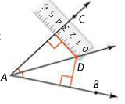

E

NOTE** Since ray AD is the angle bisector of <CAB, then these 2 distances are the same. DE = DF (see theorem below)

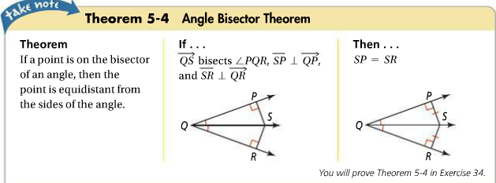 F

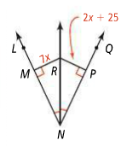

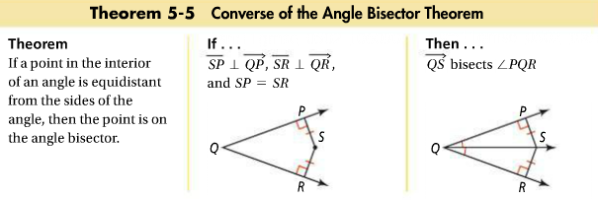



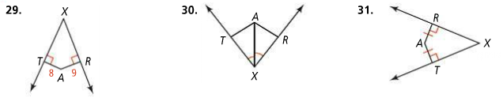

HW pg. 296-298 #6 – 28 EVEN

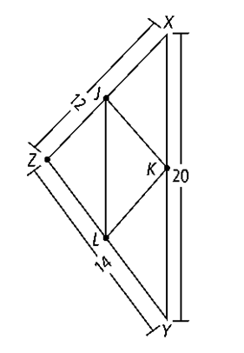**5.1 practice and review**

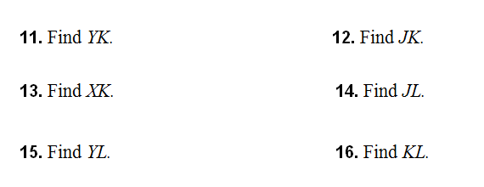

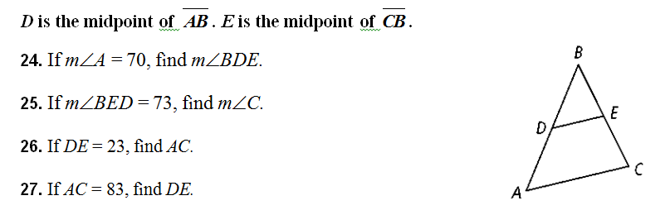

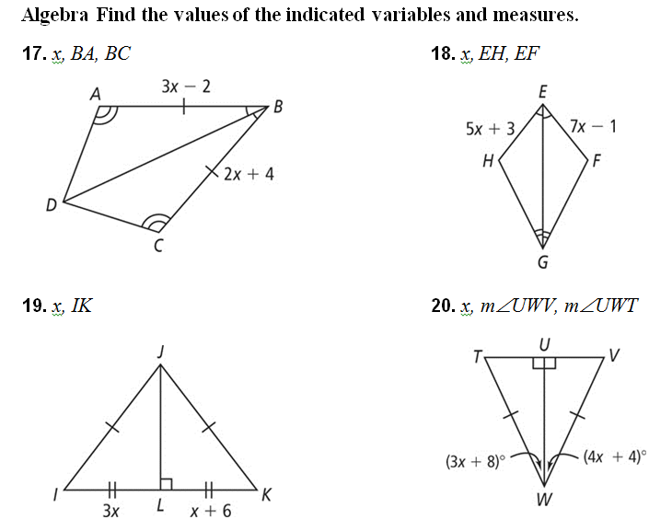**5.2 practice**