6.1 Polygon Angle Sum Theorems - Intro Name: ____________________________
Polygon - a closed plane figure with at least three straight sides and angles

(Examples include, in order of number of sides: triangle, quadrilateral, pentagon, hexagon, heptagon, octagon, nonagon, decagon, 11-gon, dodecagon, 13-gon, 14-gon, etc…)

Interior angles of a polygon - angles inside a polygon formed by the intersection of two sides

Exterior angles of a polygon - the angle between any side of a shape, and a line extended from the
next side. Each exterior angle forms a linear pair with one of the interior angles
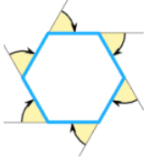

interior Exterior angles
angles

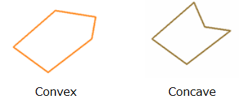
Convex Polygon - has no angles pointing inwards. More precisely, no interior angle can be more than 180°.

Concave Polygon – has an interior angle that is more than 180°. (Think: Concave has a “cave” in it, or "caves in".)

Equilateral Polygon – polygon with all sides the same length

Equiangular Polygon – polygon with all the interior angles the same measure (all exterior angles = too)
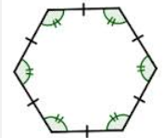
Regular Polygon – a polygon that is BOTH equilateral AND equiangular

Diagonal of a polygon – a segment that connects two non-consecutive vertices.
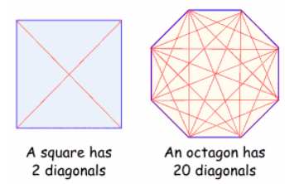
All possible diagonals can be drawn at once…
Or diagonals can be drawn from just ONE vertex…

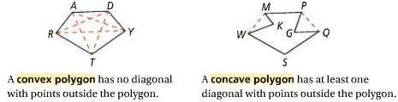

Discovering the SUM of the INTERIOR ANGLES of a Polygon
Diagram | Name of Polygon | Number of sides (n) | Number of triangles formed (when drawing diagonals from one vertex) | Sum of the  interior angles | Degree measure of each interior angle  (if it is a regular polygon)
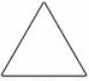
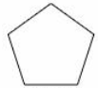
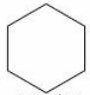
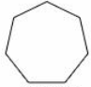
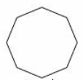
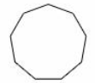
n-gon | Regular n-gon

6.1 Polygon Angle Sum Theorems (continued) - Notes Name: ____________________________
Objective: The students will be able to find the sum of the interior angles of a polygon and the sum of the exterior angles of a polygon.

or 180(n – 2)
LET’S TRY:
- Find the sum of the interior angles of an octagon.

- How many sides does a polygon have if the sum of the interior angles is 1980º?
(HINT: Write an equation using the formula.)
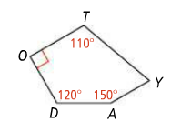
- Find the measure of ∠Y.

YOU TRY:
- Find the sum of the interior angles of a heptagon.

- How many sides does a polygon have if the sum of the interior angles is 3240 º?

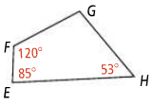
- Find the measure of ∠G.

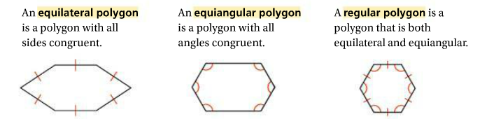
Recall…

- The individual cells of a honeycomb are regular hexagons. What is the measure of an interior angle of a honeycomb cell?

[***Please note…there are 2 ways to solve this type of problem. We will use an easier method following the next theorem…]
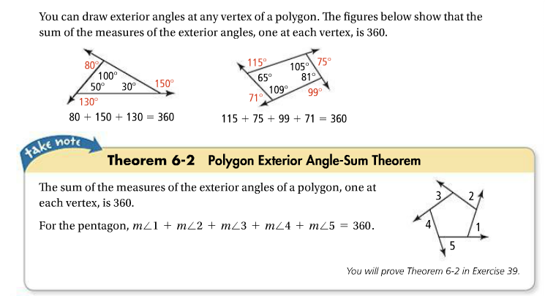

- What is the measure of an exterior angle of a regular nonagon?

YOU TRY What is the measure of each exterior angle of a regular 18-gon?

***Let’s try that easier method for each INTERIOR angle…
- Find the measure of each interior angle of a regular nonagon.
(HINT: Think about how you can use each EXTERIOR angle to make this an easier method than in #4.)
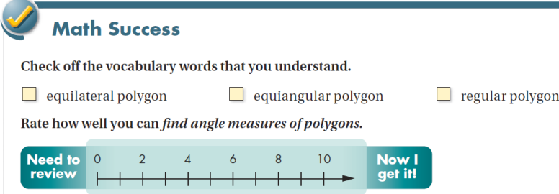

YOU TRY Find the measure of each interior angle of a regular dodecagon.

HW pgs. 356-357 # 1-3, 7, 8, 11, 12, 15-25 odd, 29 (for geo 21 also do #30-33, 36, 41, 45-48)

