**6.6 notes Trapezoids and Kites** (VIDEO) Name _________________________

*Objectives – Students will be able to verify and use properties of trapezoids and kites.*

A **trapezoid** is a quadrilateral with *exactly one pair* of parallel sides.

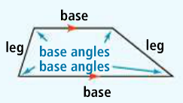***Parts of a trapezoid:***

**Bases**: parallel sides of the trapezoid

**Legs**: non-parallel sides of the trapezoid

**Base Angles**: two angles that share a base of the trapezoid (two pairs)

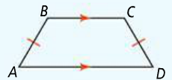

An **isosceles trapezoid** is a trapezoid with legs that are congruent.

|  |  |  |
| --- | --- | --- |
| **Theorem 6-19** | | |
| **Theorem** | **If…** | **Then…** |
| If a quadrilateral is an isosceles trapezoid, then each pair of base angles is congruent. |  |  |

|  |  |  |
| --- | --- | --- |
| **Theorem 6-20** | | |
| **Theorem** | **If…** | **Then…** |
| If a quadrilateral is an isosceles trapezoid, then its diagonals are congruent. |  |  |

The **midsegment of a trapezoid** is the segment that joins the midpoints of its legs.

*How many midsegments can a trapezoid have?*

|  |  |  |
| --- | --- | --- |
| **Theorem 6-21: Trapezoid Midsegment Theorem** | | |
| **Theorem** | **If…** | **Then…** |
| If a quadrilateral is a trapezoid then…  1. the midsegment is parallel to the bases, and  2. the length of the midsegment is half the sum of the lengths of the bases. |  |  |

1. 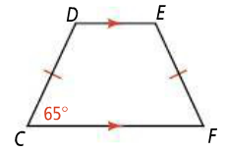*CDEF* is an isosceles trapezoid and . What are , , and ?
2. If *CDEF* were not an isosceles trapezoid, would andstill be supplementary? Explain.
3. Find the length of the missing segments.
4. is the midsegment b. is the midsegment

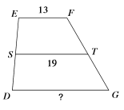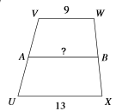

1. 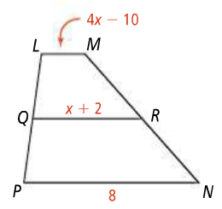is the midsegment of trapezoid *LMNP*. What is *x*?

*You Try!*

1. *RSTU* is an isosceles trapezoid and. What are , , and ?

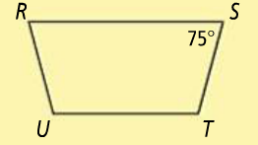

1. is the midsegment of trapezoid *WXYZ*. What is *x*?

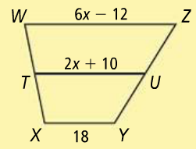

A **kite** is a quadrilateral with two pairs of consecutive sides congruent and not opposite sides congruent.

|  |  |  |
| --- | --- | --- |
| **Theorem 6-22** | | |
| **Theorem** | **If…** | **Then…** |
| If a quadrilateral is a kite then its diagonals are perpendicular. |  |  |

1. 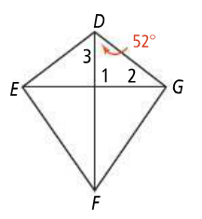*DEFG* is a kite. What are , , and ?
2. 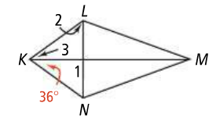*KLMN* is a kite. What are , , and ?

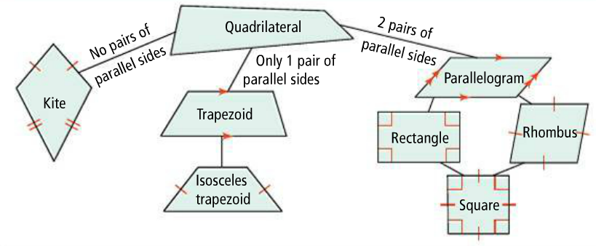**Relationships Among Quadrilaterals**

*Place a check mark in the box if the description fits the figure.*

|  |  |  |
| --- | --- | --- |
| ***Kite*** | ***Description*** | ***Rhombus*** |
|  | Quadrilateral |  |
|  | Perpendicular diagonals |  |
|  | Each diagonal bisects a pair of opposite angles |  |
|  | Congruent opposite sides |  |
|  | Two pairs of congruent consecutive sides |  |
|  | Two pairs of congruent opposite angles |  |
|  | Supplementary consecutive angles |  |

*HMWK:* pgs. 393-395 #1-3, 5-21 odds, 30, 57-62