**Bio 21: Ch. 12 Pedigree Review**



**HUNTINGTON’S DISEASE**

I

1 2

II 1 2 4 5

3 6 7 8

III

1 2 3 4 5

1. Which members of the family above are afflicted with Huntington’s Disease? ____________________________

2. There are no carriers for Huntington’s Disease- you either have it or you don’t.

With this in mind, is Huntington’s disease caused by a dominant or recessive trait? ___________________

3. How many children did individuals I-1 and I-2 have? _______________________________________________

4. How many girls did II-1 and II-2 have? ___________ How many have Huntington’s Disease? _______________

5. How is individual III-2 and II-4 related? _____________________ I-2 and III-5? _______________________

6. The pedigree to the right shows the passing on

of Hitchhiker’s Thumb in a family. Is this trait

dominant or recessive? ____________________

7. How do you know? ______________________

8. How are individuals III-1

and III-2 related? ________________________

9. Name 2 individuals that

have hitchhiker’s thumb. __________________

10. Name 2 individuals that were

carriers of hitchhiker’s thumb. ______________

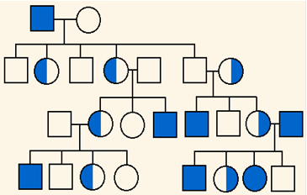11. Is it possible for individual IV-2 to be a carrier? __________ Why? _____________________________

12. The pedigree to the right shows the passing on of

colorblindness. What sex can ONLY be carriers of

colorblindness? __________________________

13. With this in mind, what kind of non-mendelian

trait is colorblindness? ______________________

14. Why does individual IV-7 have colorblindness?

__________________________________________

15. Why do all the daughters in generation II carry

the colorblind gene? _________________________

16. Name 2 IV generation colorblind males. _________