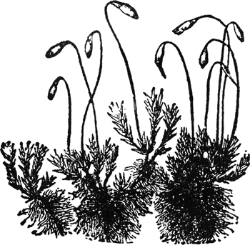Name: Smigala¹⁵
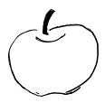Bio 21 Ch 28 Plant Evolution Table
Plant Group (give examples) | Vascular Tissue | Spores or seeds | Method of moving sperm/pollen | Method to Prevent from Drying out | Method to allow for Gas Exchange

