Name: Smigala¹⁵

Bio 21: Ch. 4 Cell Parts

Watch the “Tour of the Cell” webcast at http://www.bozemanscience.com/a-tour-of-the-cell . Take notes as you go. Rewind, rewatch as necessary. Make note of anything you have questions about.

1. Why are cells so small but not infinitesimally small?

2. a. Complete the following Venn diagram for Prokaryotic and Eukaryotic cells.

b. Give examples of organisms of each.
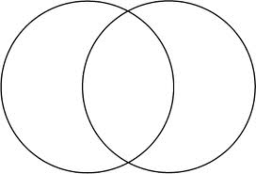

3. Cell Parts
Cell Part | Job Description | Found where in cell?  nucleus, cytoplasm | This cell part is like…

Nucleolus

Nucleus

Ribosome

Vesicle

Rough ER

Golgi

Apparatus

Cytoskeleton

Smooth ER

Mitochondria

Vacuole

Cytosol

Lysosome

Centriole

