Name: Smigala¹⁵

Bio 21: Ch 9 Flower Diagram

1. Color and label the diagram of the flower.

2. Define the functions of each of the *starred* parts.

Flower parts:

Sepal

Petal

Ovary

Ovule

Anther

Stigma

Pistil*

Style

Stamen*

Filament

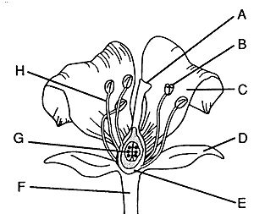

3. Put a check in the appropriate box to classify the flower parts as male or female:

Flower Part | Male | Female

Anther

Filament

Ovary

Ovule

Pistil

Pollen

Stamen

Stigma

Style

4. What is pollen?

5. Contrast:

Self-pollination and Cross pollination

