Body systems, Thermoregulation and Homeostasis
Key Concepts and Comparisons Learning Objectives
Homeostasis and temperature regulation:
- Homeostasis – Maintaining internal environment in the presence of a changing external environment. (This requires energy!)
- Examples of maintaining homeostasis:
  - Life processes such as regulating respiratory gases (oxygen and co2 maintained by negative feedback)
  - maintaining fluid and ion balance – thirst and urination via kidneys and hormones maintain water and salt levels
  - coping with disease causing organisms/pathogens
  - Thermoregulation and coordinating responses from the environment
  - maintaining nutrient supplies (cycles of hunger, eating, digestion and absorption) insulin and glucagon very important in maintaining blood glucose levels
  - repairing injuries. (Biozone)
- Use of negative feedback mechanisms to stop variations or fluctuations (deviations from the favorable state) which work to return internal conditions back to normal. (Ex: temperature, glucose, blood pressure).
--Examine cycle of negative feedback:
  - External or internal simuli received by receptors
  - Sensory neurons connected to receptors and relay information to brain or spinal cord
  - CNS coordinates a response (impulse to effectors such as gland or muscle)
  - Glands or muscles (effectors) bring about a response.
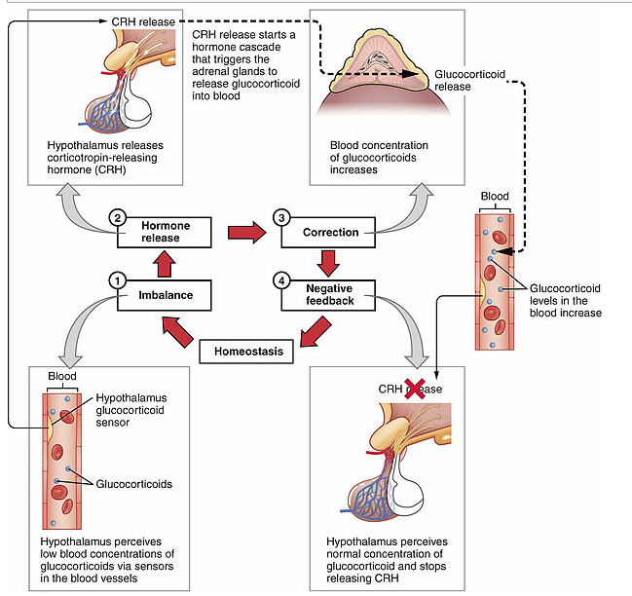
NEGATIVE VS. POSITIVE FEEDBACK __________

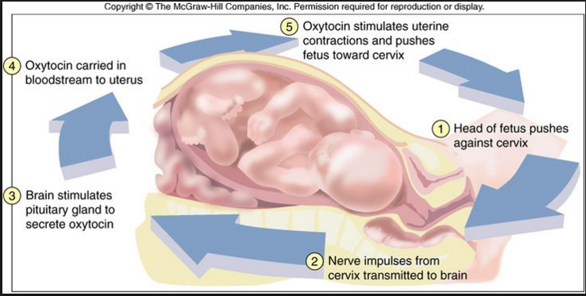

- Thermoregulation - Compare and contrast endotherms and ectotherms and how organisms of both types regulate and maintain body temperature. Outline advantages and disadvantages of both types.
  - Ectotherm - depend on environment for heat energy. Lower metabolism but limited in habitat.
  - Endotherm – generate most body heat from internal metabolism. Very high metabolism and must consume lots of food and oxygen to maintain.
    - Poikilotherms – variable body temp
    - Homeotherms – stable body temp

- Countercurrent exchange of gasses or blood flow. Examples:
- fish gills for oxygen exchange and in the human placenta,
- heat exchange in the deep arteries and veins and in the leg of a bird standing on an ice.
- There are also veins close to the surface of the arm which constrict s on a cold day so that most blood flows back to the heart through the deep veins, which are close to the arteries and flowing in an opposite direction creating a counter-current heat exchanger. On a warm day, your internal arm veins constrict while the surface veins dilate to allow more blood to flow to the heart from surface veins where heat was dissipated into environment. Great example of counter-current AND homeostatic system for maintaining body temperature in humans.

Respiratory system:
- Why is a respiratory system needed? Do all organisms need a respiratory system?
- What are the components of Fick’s law of diffusion?
- How does the organization of respiratory systems maximize the diffusion of respiratory gases?
- Why is air a better medium for gas exchange than water?
- Compare and contrast the respiratory systems of fish, insects, humans, and birds.

*Gas exchange usually occurs across thin surface with large surface area and must be moist (O2 from air and water).
-Single celled organisms – diffusion across surface of cell
-Multicellular organisms – substances have greater distances to travel for diffusion but diffusion is far more efficient with:
1. Greater surface area (movement from trachea, gills, alveoli allow for greater surface area)
2. High concentration gradient
3. Small distances by which to diffuse

Fick’s Law determines diffusion rate across membranes and is determined by looking at

Rate of Diffusion Surface area of membrane X concentration difference
Thickness of membrane
human lungs | 600 million alveoli with a total area of 100m² | each alveolus is only one cell thick | constant ventilation replaces the air
Fish gills | feathery filaments with lamellae | lamellae are two cells thick | water pumped over gills in countercurrent to blood
Leaves | surface area of leaves of 1 tree is 200m², surface area of spongy cells inside leaves of 1 tree is 6000m². | gases diffuse straight into leaf cells | wind replaces air round leaves, and photosynthesis counteracts respiration

-Fish more active, gas exchange at gills which have many folds to increase surface area.
-Bony fish have counter current flow adding efficiency. (Water is dense with much lower oxygen content than air so need efficient exchange.) – See diagram of counter current exchange.
-Worms – low oxygen requirement, low metabolic rate, diffusion across moist skin surface, no specialized gas exchange.

-Terrestrial vertebrates (amphibians, reptiles, birds and mammals) have systems adapted for exchange with air instead of water and thus have internal lungs which minimize loss of water and heat
Amphibian – lungs for land but gas exchange through skin in water
Reptiles (lungs inside ribs) and birds (air sacs and flight muscles to ventilate) have more efficient lungs than amphibians.
Insects - inefficient open circulatory system thus they have evolved a tracheal system with small tubes that channel oxygen directly to parts of the body
Humans – blood carries oxygen, alveoli allow for diffusion of gases over large surface area and short distance and great concentration gradient
Alveoli in lungs
- CO2 moves from the blood into the alveoli (alveolar air)
- O2 moves from oxygen-containing air, across to the red blood cells (tidal air) 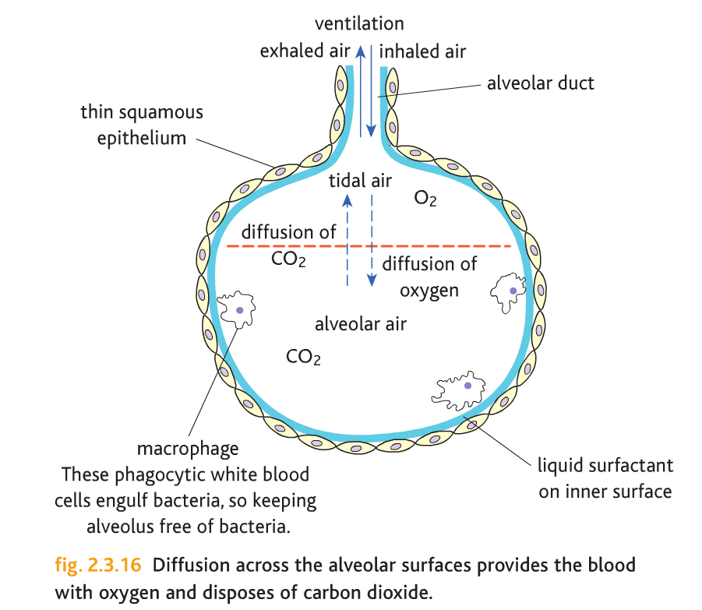

Circulatory systems – evolution of:
- Open (arthropods, molluscs, other invertebrates) vs. closed systems (some invertebrates and all vertebrates).
- As circulatory systems evolved and became more complex the blood that flows to the gas exchange organs became more completely separated.
- Efficiency increased as process of gas exchange involved transporting oxygen and carbon dioxide to and from tissues and lungs.

-Humans have advantage because oxygen diffuses much more readily from air than water
-Marine mammals breathe air and use altered metabolism to hold breadth for long periods
-Countercurrent exchange allows for max absorption of oxygen from the water as it runs over the gills found in fish.
-Insects exchange gasses through trachea and tracheids while amphibians use their skin and lungs (simple sac) or gills when appropriate.
-Nervous system controls breathing. Receptors in brain sense carbon dioxide levels and if too high (ph has lowered), rate of breathing increases to get rid of co2 (raises ph) and as ph falls, breathing rate decreases. Chemoreceptors in arteries are sensitive to oxygen levels and alter breathing rate accordingly. In a prolonged state of keto-acidosis breathing rate may be continually faster to try to get rid of more co2.

Circulatory systems cont.:
- Why is a circulatory system needed? Do all organisms need a circulatory system?
- What is the difference between an open and closed circulatory system? Outline the advantages of a closed circulatory system.
- Compare and contrast the circulatory systems of fish, amphibians, reptiles, birds and mammals.
  - Trace the evolution of the circulatory system from a 2 to 3 to 4 chambered heart.
  - How does the evolution of increased separation between oxygenated and deoxygenated blood lead to the support of higher metabolic activity.
  - Why is it necessary for endothermic organisms like birds and mammals to have a 4-chambered heart with fully separated pulmonic and systemic circuits?

- Circulatory systems play a huge role or essential function in gas exchange but single celled… simple organisms such as flatworms and sponges use diffusion.
- More complex organisms use internal movement of fluids to move food and nutrients. EX: Heart moves blood to areas where gas exchange occurs.
- Veins return blood to heart for oxygenation.
- Open – baths organs, heart pumps to one end of body
- Closed single circuit
- Closed double circuit – oxygenated and deoxygenated do not mix
- Amphibians and reptiles have 2 atria and one ventricle (receiving and pumping)
- Vertebrate heart – 4 chambered
2 chambered heart. Found in fish does not provide much pressure but because fish are in aquatic environments, gravity is not an issue. Gills are the equivalent of lungs to present blood with oxygen.
3 chambered hearts – amphibian and reptile - (2 atrium and one ventricle) has more pressure but because it mixes deoxygenated blood with oxygenated blood, it does not provide the amount of oxygen needed to stay active very active.
4 chambered hearts - Mammals and birds (2 atrium and 2 ventricles) create far more pressure to get blood around the entire organism AND separate oxygenated and deoxygenated blood thus providing the oxygen needed for the very active lifestyle. Mammals in particular also need an organ that can generate far more pressure to make sure blood can get around the entire organism

. 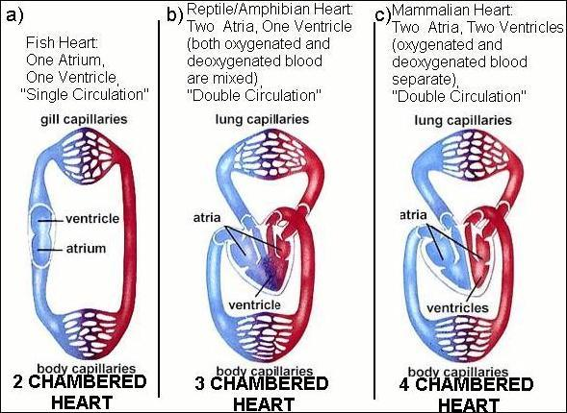
*See Circulatory Systems Review Sheet

Digestive systems:
- Trace the evolution of a digestive system from a simple gastrovascular cavity to a full, multi-sectioned tubular gut. What are the advantages of a tubular gut?
- What other adaptations make for an effective digestive system?

Heterotrophic organisms:
- Saprobes (also called saprotrophs or decomposers) feed on bacteria and fungi by using enzymes to break down and absorb absorb nutrients.
- Detritivores, (vultures ) feed on and consume dead organic material.
- Predators: feed on living…..
  - Herbivores prey on plants
  - Carnivores prey on animals
  - Omnivores prey on both
- Organisms Ingest, Digest (mechanical and chemical) Absorb and Eliminate.
- Simplest Systems
  - Gastrovascular cavity – single opening – cells lining cavity use endocytosis and lysosomes with digestive enzymes to break down food. Nutrients are released into cytoplasm as vesicles break down.
  - Tubular gut – animals – openings at beginning and end. Food and molecules are digested and absorbed the length of the gut . Different regions are specialized for particular functions and allow for a coordinated function that maximizes efficiency and absorption.
*See figures 51.7 ad 51.9.

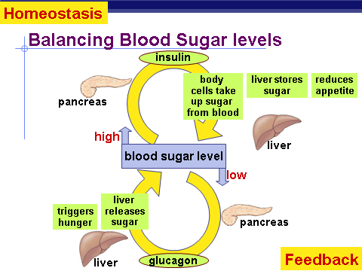

Excretory systems and osmoregulation:
- All organisms need to excrete nitrogenous waste that occurs from breakdown of proteins (and nucleic acids).
- Compare and contrast the three main ways organisms excrete nitrogenous waste: ammonia excretion, urea excretion, and uric acid secretion. What are the advantages and disadvantages of each type of excretion?
- Organisms achieve osmoregulation by regulating salt and water balance within their cells and tissues.
- Compare and contrast the osmoregulation of marine fish, freshwater fish, sharks and rays, and terrestrial organisms.

- Osmoregulation: control solute concentrations and balance water gain/loss
  - Salt and water balance
    - Marine fish: Lose water across gills, must actively remove salts.
    - Freshwater fish: Gain water across gills, must remove excess water, retain salts.
    - Marine sharks and rays: Build up urea in body fluids to be osmotically balanced, but use rectal salt glands to remove excess salt.
Terrestrial organisms: Depends on consumption, but must typically conserve water and salts
- Excretion: removal of nitrogenous wastes from body
Types of Nitrogenous Wastes:
  - Ammonia – water soluble, very toxic; aquatic animals can afford to pass this through their membrane/gills into the water
  - Urea – produced by liver; less toxic, conserves water; most vertebrates have less access to water and were under selective pressure to repackage ammonia into something less harmful. Flush waste out with less water to conserve water. Repackaging into urea by the liver decreases toxicity but happens at high energy cost
  - Uric acid – excreted as paste or crystals; birds & reptiles excrete uric acid. This requires more energy to metabolize than urea but eliminates more N2 and uses less water.
Types of waste:
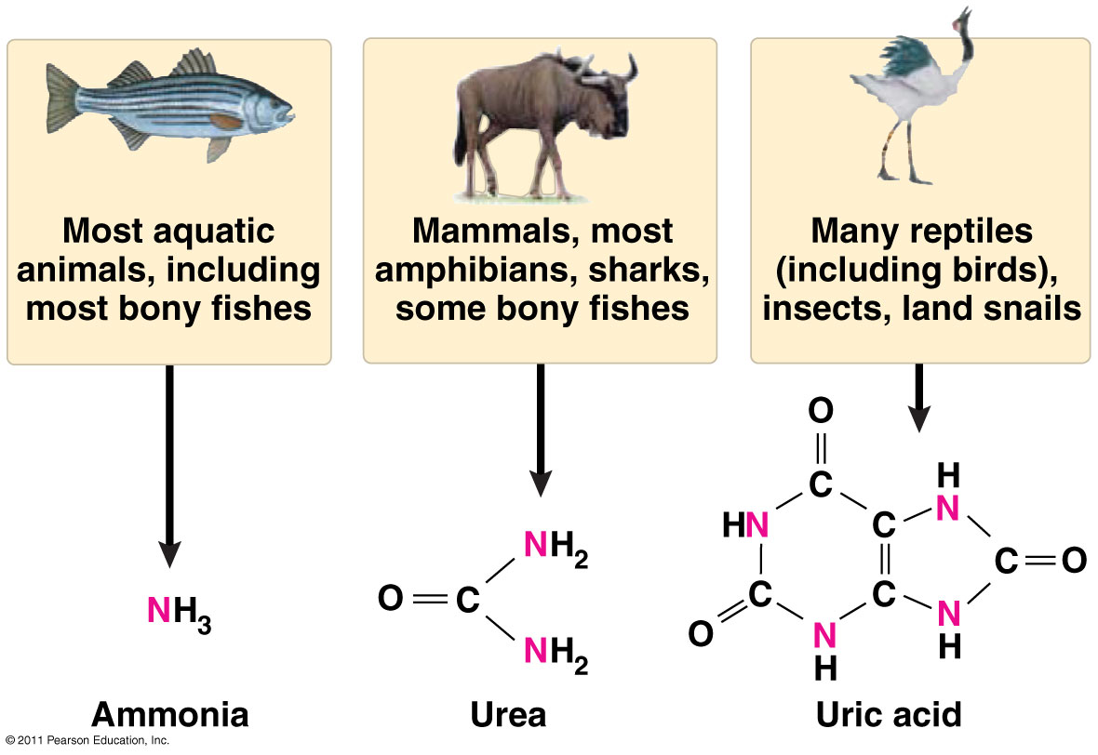

http://slideplayer.com/slide/4651181/ - slide 14

Immune system:
- Why do organisms need an immune system?
- What are non-specific defenses to pathogen infection?
- Mammals evolved an immune system capable of targeting and eliminating specific pathogens.
  - The mammalian immune system includes two types of specific responses: cell mediated and humoral.
  - In the cell-mediated response, cytotoxic T cells, a type of lymphocytic white blood cell, “target” intracellular pathogens when antigens are displayed on the outside of the cells.
  - In the humoral response, B cells, a type of lymphocytic white blood cell, produce antibodies against specific antigens.
  - Antigens are recognized by antibodies to the antigen.
  - Antibodies are proteins produced by B cells, and each antibody is specific to a particular antigen. Note: Memorization of the structures of specific antibodies is beyond the scope of the course and the AP Exam.
  - A second exposure to an antigen results in a more rapid and enhanced immune response.

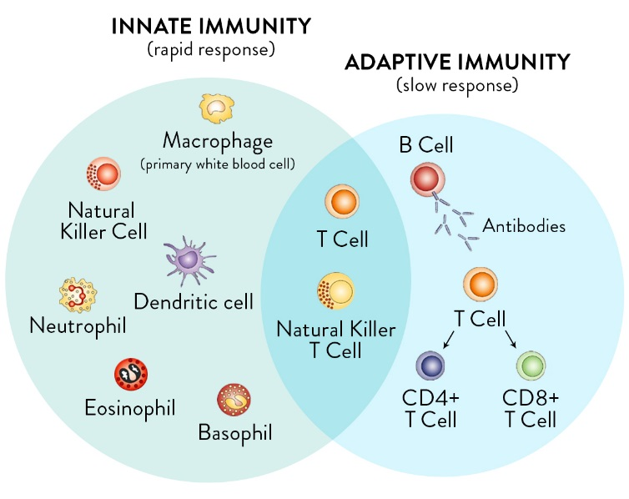
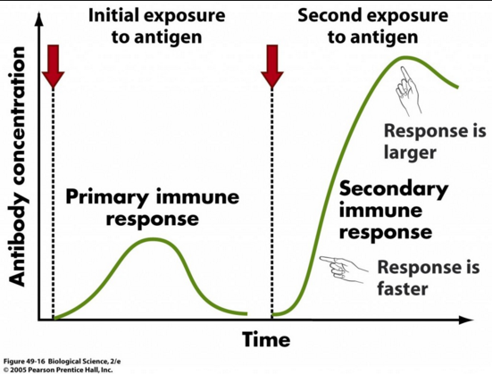

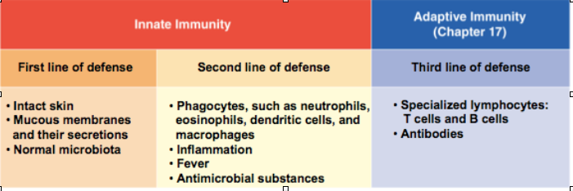
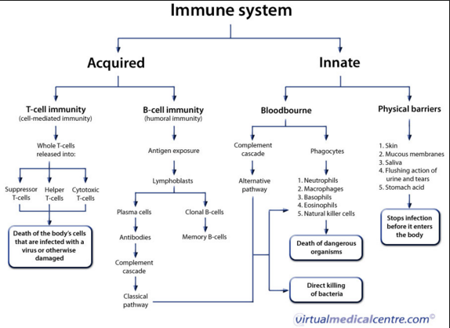
- Non-specific defenses (Table 42.1)
  - We have a host of non-specific defenses that protect us.
- The Specific Immune System (Fig. 42.6)
  - Your body is full of an army of specific immune cells called B cells and T cells.
  - You have both T_{H} (T-helper cells) and T_{C} (cytotoxic T cells).
  - You need to recognize about 100 million unique antigens.
  - You have about 18 billion B cells and T cells in your bloodstream and many more in your lymph nodes.
  - B cells and T cells are all born a little bit different. They all have slightly different receptors that recognize different antigens.
  - Those receptors can recognize antigen directly, but more often than not the antigen is presented to them by a phagocytic white blood cell.
  - And B cells and T cells are fully activated by stimulation from T_{H} cells.
  - “Humoral immunity”: Activated B cells multiply and start producing large quantities of specific antibodies that will bind and neutralize the pathogen.
  - “Cellular immunity”: Activated T_{C} cells multiply and will directly attack and kill the pathogen or virus-infected cell.
  - Activating the specific immune system can take 4-5 days. This is why you usually feel sick for about a week.
  - After the battle is over, some activated B cells and T cells remain in your bloodstream to serve as “memory cells” to protect you from possible reinfection.
  - Immune system related topics:
    - Vaccines
    - Allergic reactions
    - Autoimmune diseases
    - Immune deficiency disorders: congenital vs. acquired (HIV).

http://www.highlands.edu/academics/divisions/scipe/biology/faculty/harnden/2122/notes/immune.htm

