Cell Energetics Websites
Crash Course: Cell Respiration #7 (14 min)
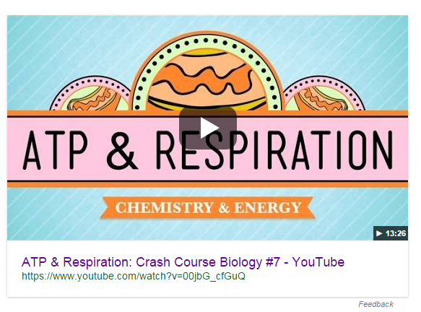
https://www.youtube.com/watch?v=00jbG_cfGuQ

Bioflix: Cellular Respiration tutorial and animated video (4 min)
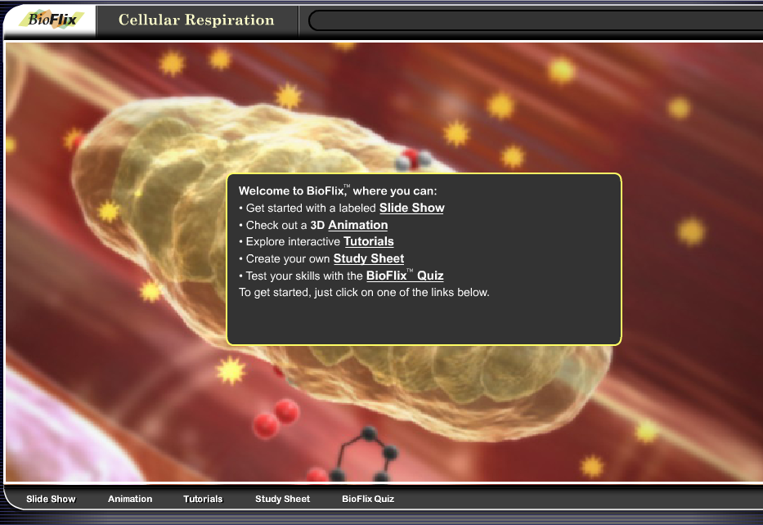
http://media.pearsoncmg.com/bc/bc_0media_bio/bioflix/bioflix.htm?c7erespiration
Bozeman: Cellular Respiration (14 min)
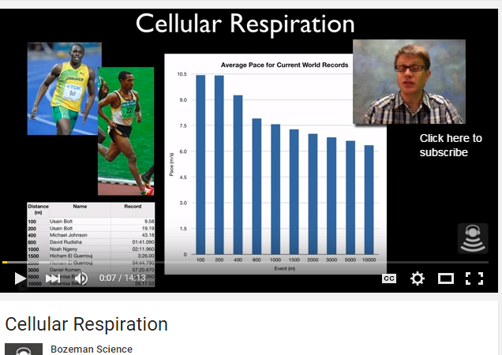
https://www.youtube.com/watch?v=Gh2P5CmCC0M

Bozeman: Life Requeires Free Energy (13min)
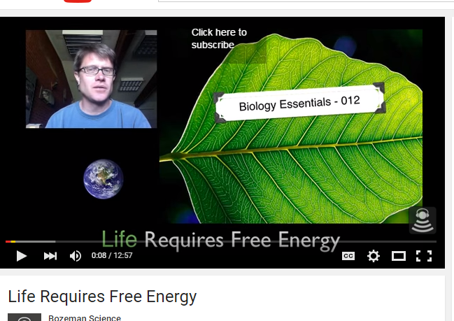
https://www.youtube.com/watch?v=JBmykor-2kU

Bozeman: Gibbs Free Energy (13min)

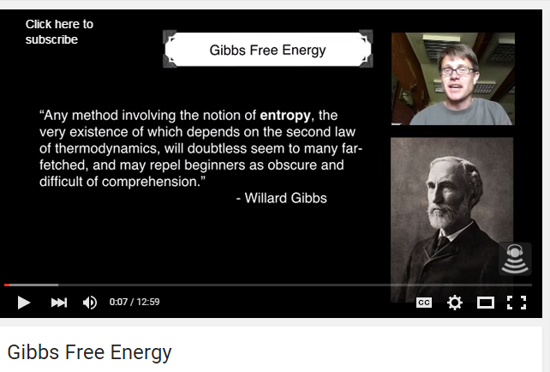
https://www.youtube.com/watch?v=DPjMPeU5OeM
Bozeman: Using Gibbs Free Energy (8min)
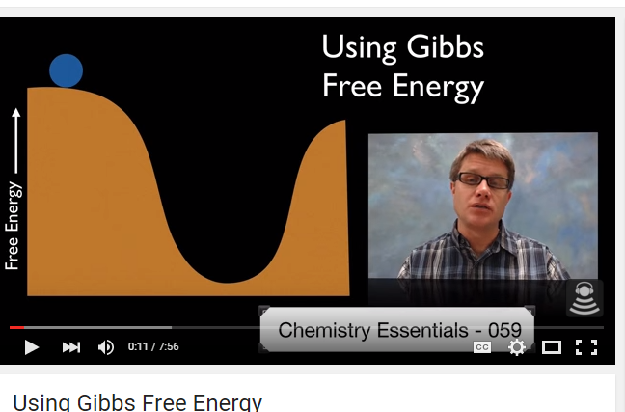
https://www.youtube.com/watch?v=huKBuShAa1w

Bozeman: ATP (10min)
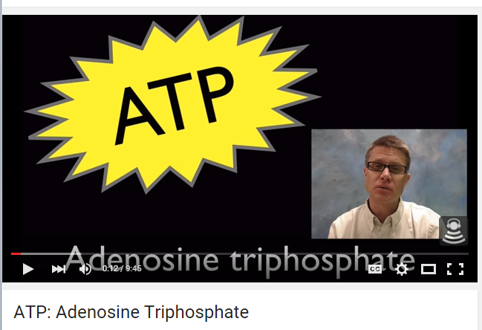
https://www.youtube.com/watch?v=5GMLIMIVUvo

Bozeman: AP Bio Lab 5: Cellular Respiration (6min)
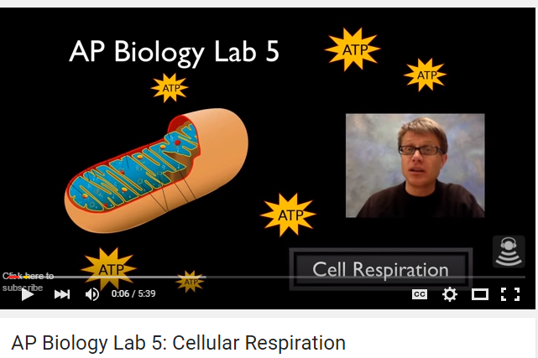
https://www.youtube.com/watch?v=r9o_VdToClE

Bozeman: Information Processing (6min)
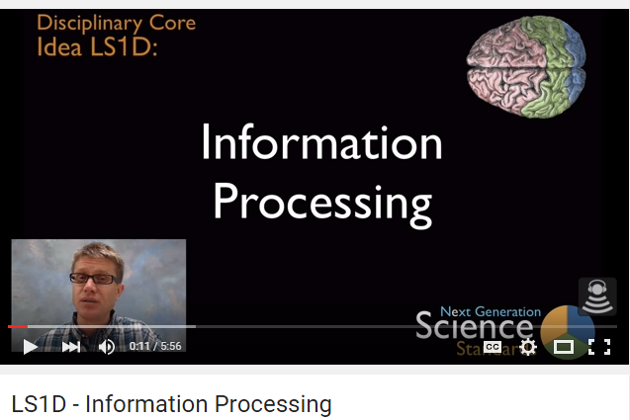
https://www.youtube.com/watch?v=72wfQq5zaxM

