Name: Smigala¹⁴

Crime Lab Forensics: Impressions & Arson Units Study Guide

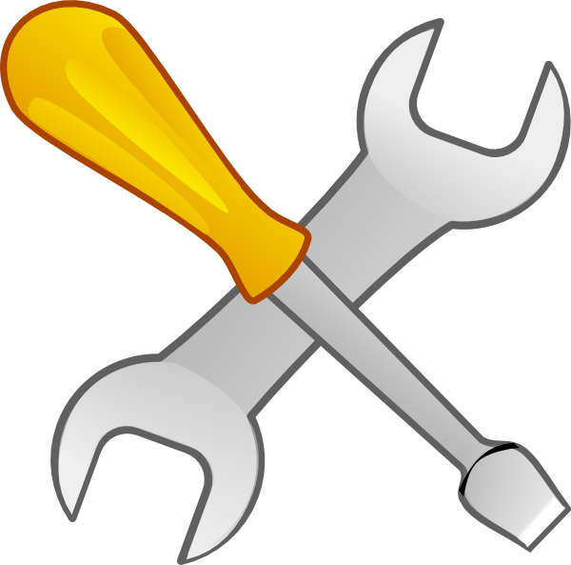

Vocabulary- write definitions on a separate sheet or highlight terms and definitions in your notes for credit.

Tool marks

Arson

Fire

Flash point

Point of origin

Burn patterns

Combustible

Accelerants

Fire triangle

Fuel

Char pattern

V- pattern and U-pattern

Heat shadow

Chimney effect

Incendiary device

Patent impression

Labs:

Tire tracks with toy cars

Screwdriver/drill/wire cutter tool marks

Cases:

Sidney Fox

John Orr

Ted Bundy

Concepts:

What is a fire triangle?

What 3 factors are necessary to get a fire to start?

1.

2.

3.

What evidence is looked at a fire scene to determine where the fire’s point of origin is? List at least 3 things.

What evidence is looked at to determine the cause of a fire?

What kinds of evidence helps indicate that a fire was likely caused by arson rather than by accident? List at least 3 things.

How should evidence be ^{a.} documented and ^{b.} collected at a fire scene?

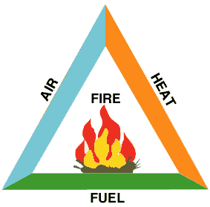

How does fire evidence get tested for traces of accelerants?

What are 3 common causes of accidental fire?

What are 3 common motives for arson fires?

a. What is a tool mark?

b. Is it considered individual or class evidence?

c. How can a tool mark made at a crime be useful in trying to identify who

committed the crime?

How is a cast of a print or a tool mark made?

a. How can a shoeprint be identified?

b. Is it individual or class evidence?

a. What other forms of impression evidence are there besides tool marks and shoeprints? List at least 2.

b. How can they be used investigating a criminal case?

