Name: Smigala¹⁵

Crime Lab: Toxicology Unit Study Guide

*Find the following vocabulary word in your notes. Either highlight them or rewrite them on a separate sheet of paper.

Vocabulary:

Toxicology

Toxin

Toxicity

Field test

Screening test

Confirmatory/lab tests

Chromatography

Spectrophotometry

Mass spectrometry

LD₅₀

Chronic exposure

Acute exposure

Synergism

Antagonism

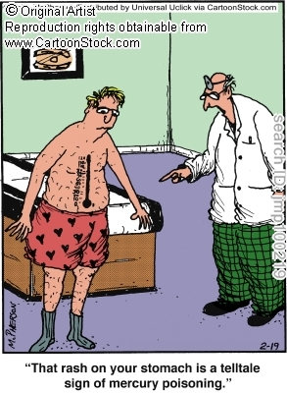

Locate these articles/your notes and review them.

Cases:

Charles Hall

Eva and Carroll Rablen

Famous Poisoning Student Projects

Answer these questions on a separate sheet of paper.

Concepts:

What are instances in which toxicology testing is needed in forensics?

Describe 5 factors determine how toxic a substance will be to a person.

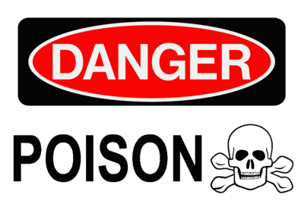

Distinguish between chronic and acute toxic exposure.

a. The increased effects can the combination of 2 or more chemicals have on their level of toxicity is called: . Give an example that explains how this works.

b. The decreased effects can the combination of 2 or more chemicals have on their level of toxicity is called: . Give an example that explains how this works.

Name 4 agencies that are involved in regulating toxic substances in the U.S.

1. 3.

2. 4.

Describe 3 methods that can ID drugs or other toxic chemicals.

1.

2.

3.

Explain why both field tests and laboratory tests are used in the identification of an unknown substance.

List 5 tissues/fluids that can be collected from a person to try and identify a particular toxic chemical.

1. 3. 5.

2. 4.

Distinguish among the purposes of chromatography, spectrophotometry and mass spectrometry.

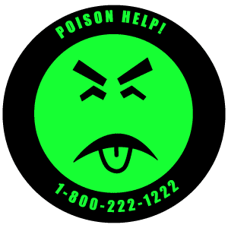From the Famous Poisoning Student Projects: what are examples of poisons used to harm or kill people? What are their effects? What is notable about each individual case?

