**Evolution and AP Biology Calculations Grid-Ins Review**

**A Reminder Regarding the Test Format:**

The AP Biology Exam is approximately 3 hours in length. There are two sections.

1. Section I is 90 minutes and consists of 63 multiple-choice questions and 6 grid-in questions accounting for 50 percent of the final score.
2. Section II is 90 minutes and consists of 2 long free-response questions and 6 short free-response questions accounting for 50 percent of the final score. It begins with a 10-minute reading period to read the questions and plan your answers. The remaining 1 hour and 20 minutes is for writing. The 2 long free-response questions should require about 20 minutes each to answer. Questions 3 through 8 are short free-response questions and should require about 6 minutes each to answer. Questions 3-5 are worth 4 points each; questions 5-8 are worth 3 points each.

**Calculation Grid-In Tips:**

1. If a diagram is provided, analyze the diagram before you start calculating. You have to know what you are looking for!
2. They won’t ask you for units in your answers on the calculation questions, but they may on the short / long response questions. However, looking at the units may give you a hint as to which term in the equation you are being asked to find.
3. Don’t round your work until you get to the answer!
4. Read the directions carefully for each question you answer. The question will indicate whether you should round to the nearest whole number, tenth, hundredth, etc. If you round to a different place, your answer will be scored as INCORRECT!
5. With your four function calculator, there is no exponent function. You must use the “old school” method of multiplying a number by itself to square it.

**Example:** 23 = 2 X 2 X 2 = 8

1. You must be able to convert back and forth between scientific notation and whole numbers.

**Examples:**

* 5.1 X 103 = 5100
* 6.2 X 10-4 = 0.00062
* 442 = 4.42 X 102
* 0.008 = 8.0 X 10-3

1. If you want to “get rid” of an exponent on the variable you are solving for, take each side of the equation to the power of the inverse of the exponent

**Example:** X1/3 = 5 can be adjusted to (X1/3)3 = (5)3 to isolate “X” and further simplified to X = 125

**The “Grid-In Chart”**

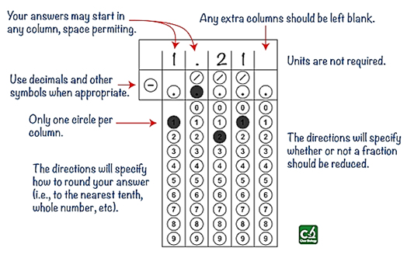

**Acceptable Grid-In Responses:**

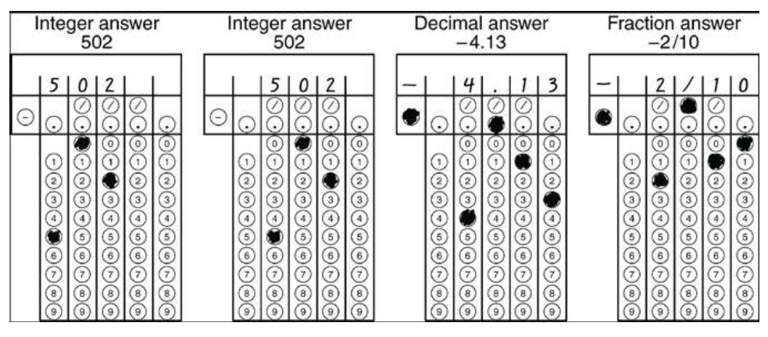

**AP Biology Formula Sheet – Page 1**

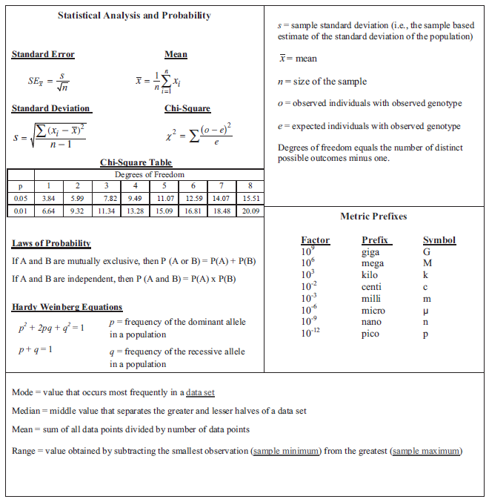

**13**

**10**

**4**

**3**

**2**

**1**

**AP Biology Formula Sheet – Page 2**

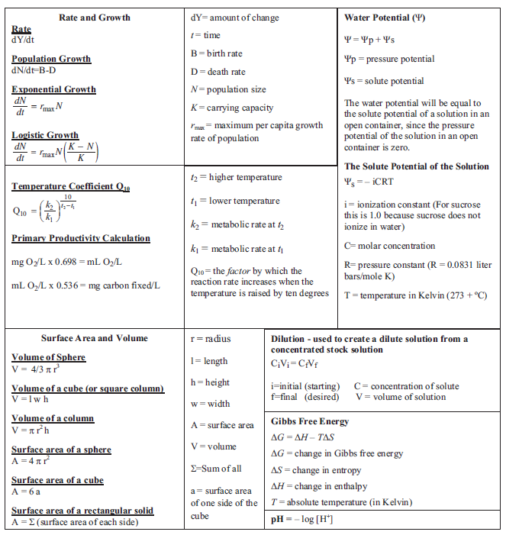

**15**

**14**

**8**

**11**

**5**

**12**

**9**

**7**

**6**

**#1: Mean**

***Why use this formula?***

Use the mean formula when you want to calculate the average of a set of values (data points).

***Formula***



***Additional Information from the Formula Sheet***



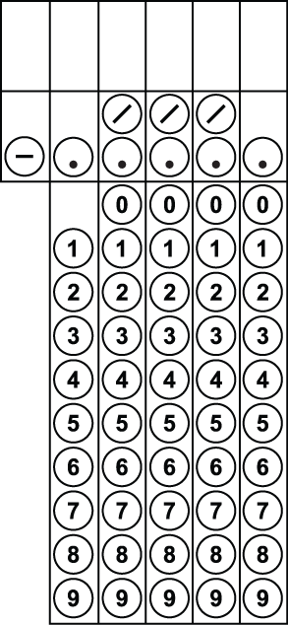

1. The following onion root lengths were recorded in centimeters. Calculate the average (mean) root length. Give the answer in cm to the nearest tenth.

5.4 7.2 4.9 9.3 7.2 8.1 8.5 5.4 7.8 10.2

2. Paper disks were coated in a yeast mixture containing the enzyme catalase. When these paper disks were placed in a beaker containing 3% hydrogen peroxide, the enzyme catalase broke down the hydrogen peroxide in the following reaction.

H2O2 (hydrogen peroxide) 🡪 O2 (oxygen gas) + H2O (water)

Students measured the amount of time it took for each disk to rise to the top of the beaker (based on the amount of oxygen gas produced). The amount of time in seconds for each paper disk is listed below. Calculate the average (mean) time for the disks to rise. Give the answer in seconds to the nearest hundredth.

20.5 21.2 17.4 23.8 18.9 24.6

**#2: Standard Deviation**

***Why use this formula?***

Use standard deviation formula to determine the amount by which your values (data points) typically differ from the mean value. In other words, the standard deviation determines the amount of variation in your data.

***Helpful Videos***

Bozeman Biology – Standard Deviation: <http://www.youtube.com/watch?v=09kiX3p5Vek&list=PLllVwaZQkS2omBpLjQm_BAQKsQ7lq86ku>

***Formula***



***Additional Information from the Formula Sheet***

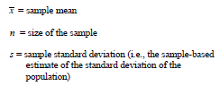



3. Calculate the standard deviation for the data set given in #1. Give the answer in cm to the nearest tenth.



4. Calculate the standard deviation for the data set given in #2. Give the answer in seconds to the nearest hundredth.

**#3: Standard Error**

***Why use this formula?***

Use the standard error formula to determine the precision of the mean value. In other words, we are determining how confident we are in our mean value by considering both the standard deviation (s) and the number of data points (n). Typically, when we have more data points, we can be more confident in our data (i.e. a lower standard error).

***Helpful Videos***

Bozeman Biology – Standard Error: <http://www.youtube.com/watch?v=BwYj69LAQOI>

***Formula***



***Additional Information from the Formula Sheet***

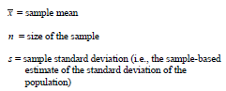

5. Calculate the standard error for the data set given in #1. Give the answer in cm to the nearest tenth.

6. Calculate the standard error for the data set given in #2. Give the answer in seconds to the nearest hundredth.

**#4: Chi Square**

***Why use this formula?***

Use the Chi square formula to determine if there is a statistically significant difference between expected results (hypothesized results) and observed results (actually experimental data).

***Helpful Videos***

Bozeman Biology—Chi-squared Test:

<https://www.youtube.com/watch?v=WXPBoFDqNVk>

***Formula***



***Additional Information from the Formula Sheet***

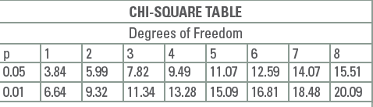

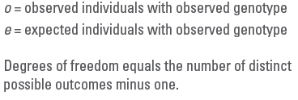

7.

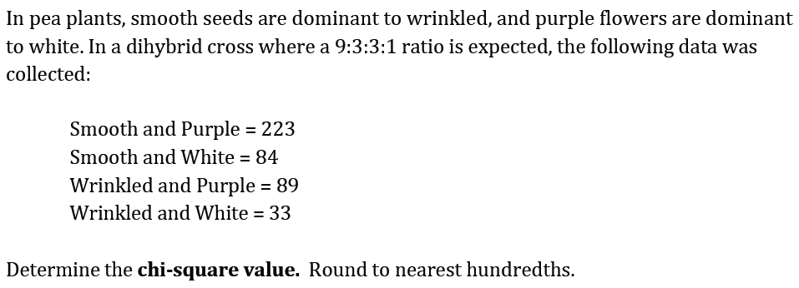

8.

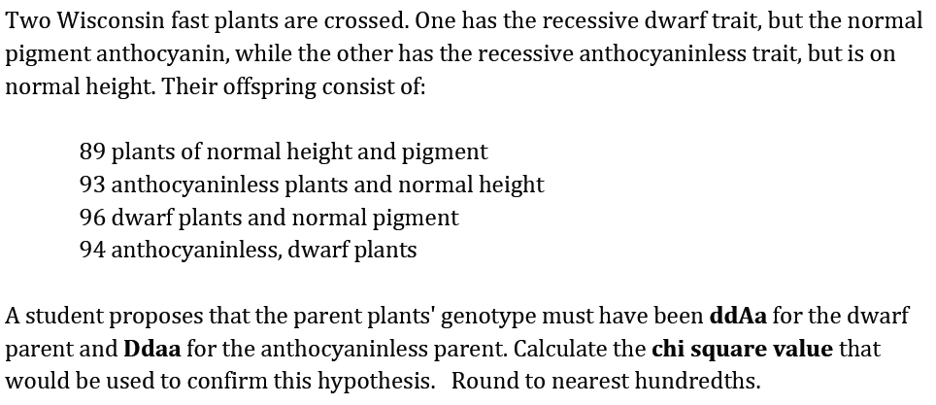

9.

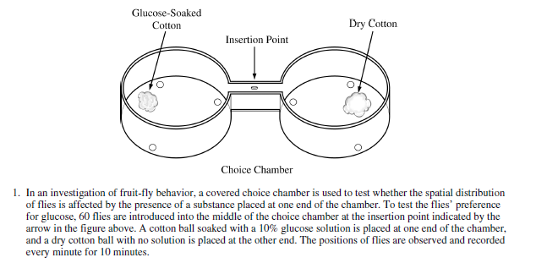



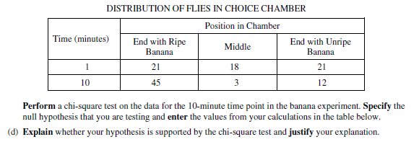

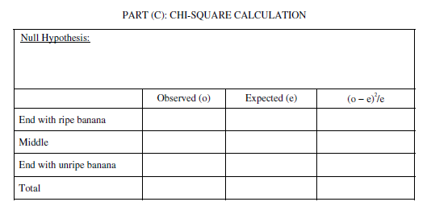

**#5: Rate**

***Why use this formula?***

Use the rate formula to determine how quickly a particular process is occurring over a given period of time.

***Formula***



***Additional Information from the Formula Sheet***



10.

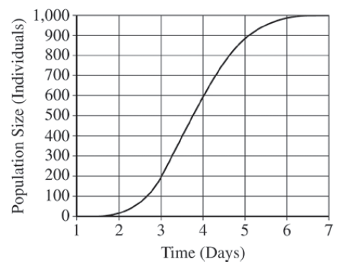

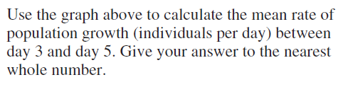

12.

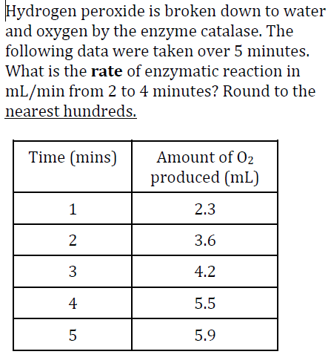

**#6: Dilution**

***Why use this formula?***

Use this formula in the lab to create a dilute solution (high water, low solute) from a concentrated stock solution (low water, high solute).

***Formula***



***Additional Information from the Formula Sheet***

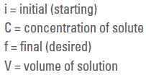

13.

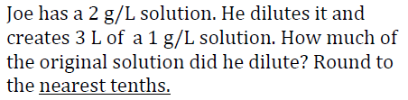



14. Joe has 20 L of a 2 g/L solution. To this solution he adds 30 L of water. What is the final concentration of the solution? Round to the nearest tenth.

**#7: Q10**

***Why use this formula?***

The Q10 value represents the factor by which the rate of a reaction increases for every 10-degree rise in the temperature.

***Helpful Videos***

Bozeman Biology – Q10 – The Temperature Coefficient:

<https://www.youtube.com/watch?v=UQWWSmGM0yQ>

***Formula***

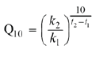

***Additional Information from the Formula Sheet***

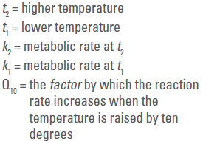

15.

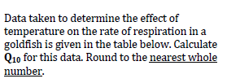

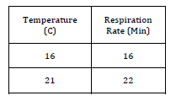

16. The rate of metabolism of a certain animal at 10ºC, is 27 microliters O2 g-1h-1. What is its rate of metabolism at 20ºC if the Q10 is 2? Round to the nearest whole number.

**#8: Primary Productivity**

***Why use this formula?***

The primary productivity formula can be used to determine the mass of carbon fixed to glucose during photosynthesis based on measurements of the amount of oxygen gas produced.

***Formula***



17. A scientist recorded the amount of dissolved oxygen produced by elodea, an underwater plant, as 52 mg O2/L. How much carbon (in mg/L) was fixed by this plant? Round your answer to the nearest tenth.



18. An elodea plant fixed 1.5 mg carbon / L. How much dissolved oxygen (in mg / L) was produced by this plant?

**#9: pH**

***Why use this formula?***

Use the hydrogen ion concentration of a solution to determine the pH or vice versa.

***Formula***



19. What is the pH of a solution with a hydrogen ion concentration of 1.0 x 10-8? Express your answer as a whole number.





20. According to the Acid Rain Monitoring Project at the University of Mass, the pH measured at King Phillip Brook on April 10, 2012, was near 5, which the pH measured at Robbins Pond on that same date was near 9. Determine to the nearest whole number how many times greater the hydrogen ion concentration was at King Phillip Brook.

**#10: Hardy Weinberg Equilibrium**

***Why use this formula?***

The Hardy Weinberg formulas are used to determine the allele or genotype frequencies for a population of organisms that is not evolving.

***Helpful Videos***

Bozeman Biology – Solving Hardy Weinberg Problems

<https://www.youtube.com/watch?v=xPkOAnK20kw>

***Formula***

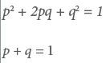

***Additional Information from the Formula Sheet***

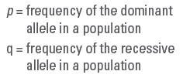

21. Express your answer to the question below as a whole number.

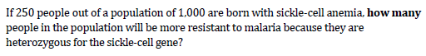



22. Express your answer as a decimal between 0 and 1 to the nearest hundredth.



**#11: Surface Area and Volume**

***Why use this formula?***

Biologists compare the surface area to volume ratio of cells of various shapes and sizes because this ratio is an indicator of the efficiency of transport across the cell membrane.

***Formula***

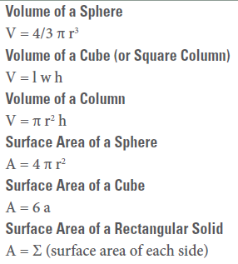

***Additional Information from the Formula Sheet***

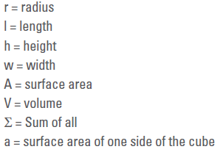

25. What is the SA/V for this cell? Round your answer to the nearest hundredth.





26. Four blocks of pink phenolphthalein agar are placed in a vinegar solution. Which block would the vinegar solution penetrate most thoroughly into after ten minutes? Determine the surface area to volume ratio for this block, and round your answer to the nearest hundredth.

* + 1. Block 1: 2 cm x 4 cm x 4 cm
    2. Block 2: 2 cm x 8 cm x 4 cm
    3. Block 3: 1 cm x 8 cm x 8 cm
    4. 1 cm x 1 cm x 64 cm

27. For the problem above, which block would have the greatest volume of pink phenolphthalein (untouched by the vinegar) remaining at the end of ten minutes? Determine the surface area to volume ratio for this block, and round your answer to the nearest hundredth.

**#12: Water Potential and Solute Potential**

***Why use this formula?***

The water potential and solute potential calculations help determine the direction of water movement (from a high water potential to a low / more negative water potential).

***Helpful Videos***

Bozeman Biology – Water Potential

<https://www.youtube.com/watch?v=nDZud2g1RVY>

***Formula***

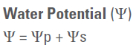

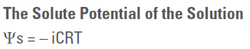

***Additional Information from the Formula Sheet***

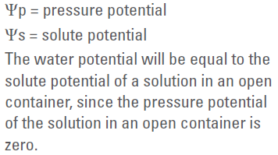

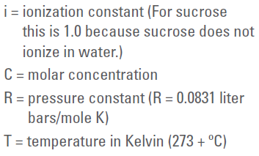

28.

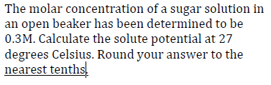

29. Scientists are trying to determine under what conditions a plant can survive. They collect the following data and would like to know the water potential of the plant cell. The solute potential is -0.6 MPa and the pressure potential is -1.0 MPa. What is the water potential? Round your answer to the nearest tenth.

**#13: The Laws of Probability**

***Why use this formula?***

The Multiplication Law of Probabilities enables you to determine the probability that two events will occur simultaneously. The Addition Law of Probabilities enables you to determine the probability that one event OR another will occur.

***Helpful Videos***

Bozeman Biology – Probability in Genetics—Multiplication and Addition Rules:

<https://www.youtube.com/watch?v=y4Ne9DXk_Jc>

***Formula***

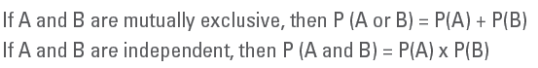



30. A certain species of plant has four unlinked genetic loci, *W, X, Y,* and *Z*. Each genetic locus has one dominant allele and one recessive allele. For a plant with the genotype *WwXxYyZz*, what is the probability that the plant will produce a gamete with a haploid genotype of *Wxyz*? Give your answer as a fraction or as a value between 0 and 1, to four decimal places.

31. In a population that is Hardy-Weinberg equilibrium, the frequency of the recessive allele is 0.3. What is the frequency of individuals that are homozygous and heterozygous for the dominant trait? Express your answer to the nearest hundredth.

**#14: Population Growth**

***Why use this formula?***

The population growth equations enable you to determine the rate of growth for population based on several factors including birth rate, death rate, carrying capacity (for logistic growth), etc.

***Helpful Videos***

Bozeman Biology – Exponential Growth

<https://www.youtube.com/watch?v=c6pcRR5Uy6w>

Bozeman Biology – Logistic Growth

<https://www.youtube.com/watch?v=rXlyYFXyfIM>

***Formula***

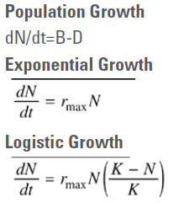

***Additional Information from the Formula Sheet***

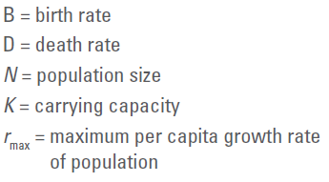



32. A hypothetical population has a carrying capacity of 1,500 individuals and rmax is 1.0. What is the population growth rate for a population with a size of 1,600 individuals? Round your answer to the nearest hundredth. What is happening to this population?

33. (Note: For the question below, your answer should be expressed as ___.___ millions of people.)

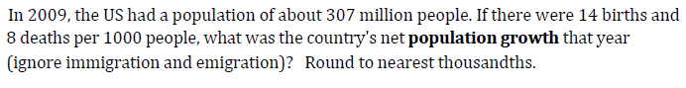

34.

There are 2,000 mice living in a field. If 1,000 mice are born each month and 200 mice die each month, what is the per capita growth rate of mice over a month? Round your answer to the nearest tenth.

**#15: Gibbs Free Energy**

***Why use this formula?***

Calculating the change in free energy enables you to determine whether the reaction is endergonic / anabolic (+ΔG, products have a higher free energy than reactants) or exergonic / catabolic (-ΔG, products have a lower free energy than reactants).

***Helpful Videos***

Bozeman Biology – Gibbs Free Energy

<https://www.youtube.com/watch?v=DPjMPeU5OeM>

***Formula***



***Additional Information from the Formula Sheet***

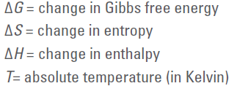

35. An experiment determined that when a protein unfolds to its denatured (D) state from the original folded (F) state, the change in **Enthalpy** is ΔH = H(D) – H(F) = 46,000 joules/mol. Also the change in **Entropy** is ΔS = S(D) – S(F) = 178 joules/mol. At a temperature of 20⁰C, calculate the change in Free Energy ΔG, in j/mol, when the protein unfolds from its folded state.