Name_______________________________________________Period______Date__________

**Geometry 21: A Little More Practice with Triangle Congruence (4.1-4.4, 4.6)**

1. State if the following triangles are congruent or not. If so, state the postulate or theorem you used.

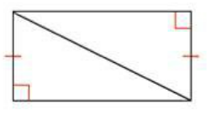a. 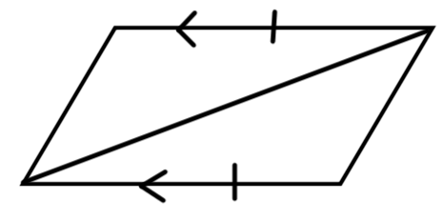 b. 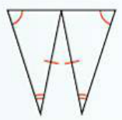 c.

d. e. 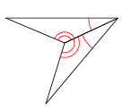 f. 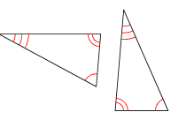

1. Label and state what additional information the triangles need to be congruent for the given reason. Then, complete the triangle congruence statements.

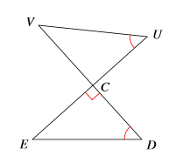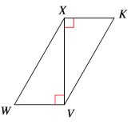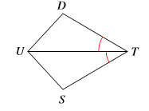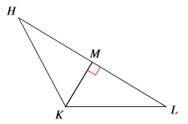 a. **AAS** b. **SAS** c. **ASA** c. **HL**

   

1. 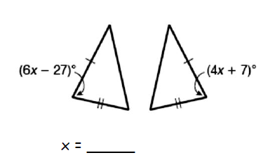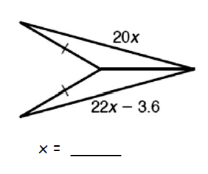Find the value of *x* that makes the triangles congruent.
2. b.
3. 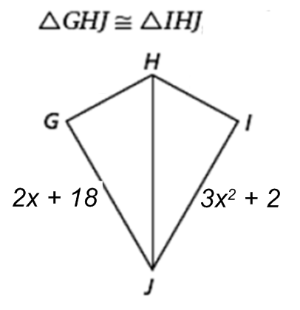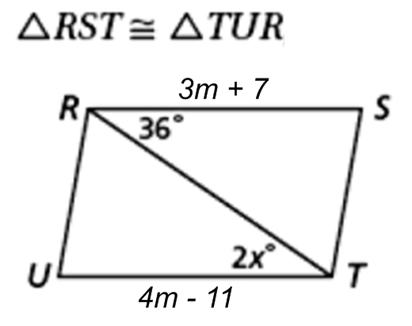Find the values of the missing variables, given the following triangle congruence statements.

a. b.

5. Solve for x.

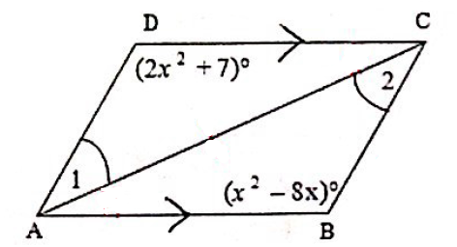

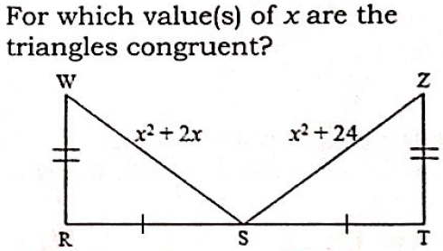6.

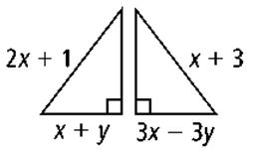7. For what values of x and y are the triangles congruent by HL?

8. Describe the situation in which “SSA” works. What do we call it?