Geometry 21 Name: ___________________________________ Date: ________ Per: _____
5-3 Bisectors in Triangles
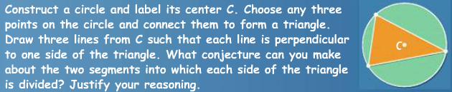
Objective: To identify properties of perpendicular bisectors and angle bisectors.
Warm up:

When three or more lines intersect at one point, they are ____________________.
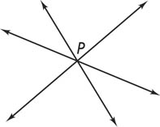
The point at which they intersect is the ___________________________________.
The following sets of lines are always concurrent:
- the perpendicular bisectors of a triangle’s 3 sides
- the bisectors of a triangle’s 3 angles
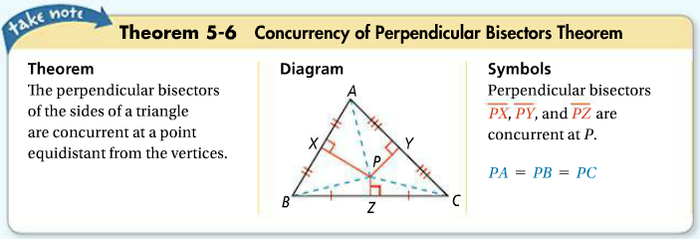
*PERPENDICULAR BISECTORS of a triangle

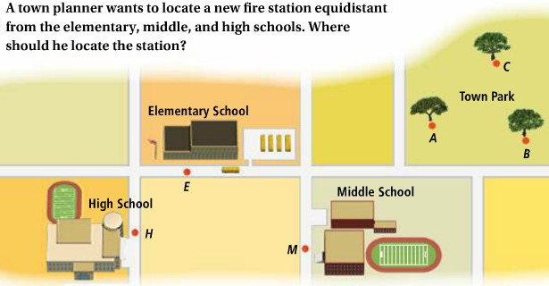

Problem 2
Where should a bench be placed if it needs to be equidistant from the 3 trees shown?

circumcenter of the triangle – the point of concurrency of the perpendicular bisectors of a triangle
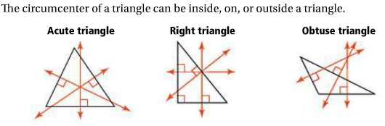
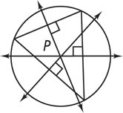
The circle is circumscribed about the triangle when the circle contains each
vertex of the triangle. The circumcenter is the center of the circumscribed circle.
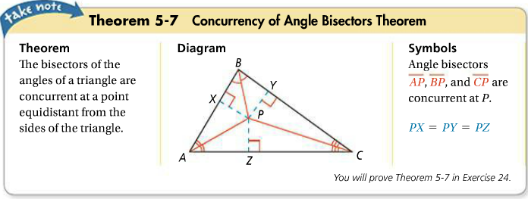
*ANGLE BISECTORS of a triangle

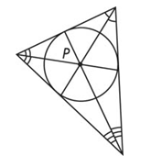
The incenter of the triangle is the point of concurrency of the angle bisectors of a triangle.
Circle P is inscribed in the triangle at right. The incenter is the center of the inscribed circle.

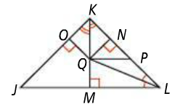
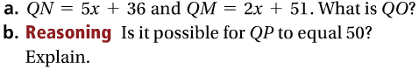
Problem 3

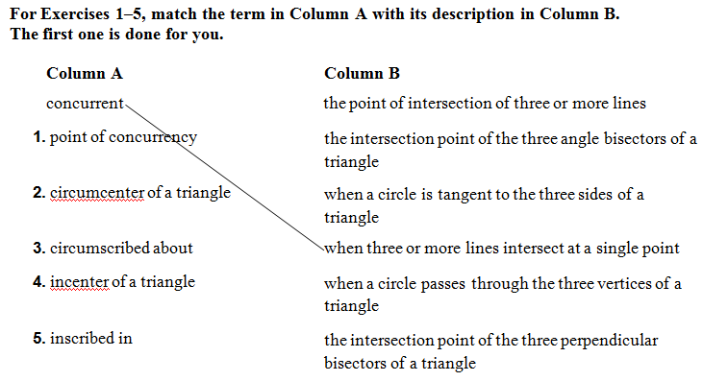

6. In the figure below, which point is the circumcenter? ____________
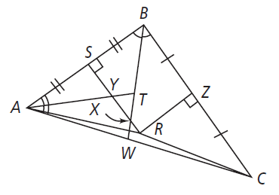
Which point is the incenter? __________

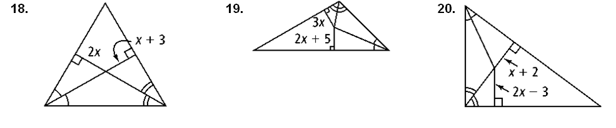
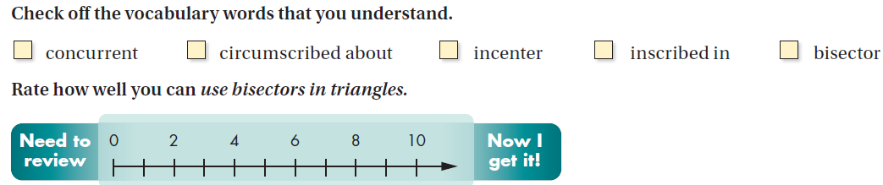
Find x.

HW pg. 304-305 # 2-5, 14 -18, 22, 26-29

