Geometry 22 Name: __________________________________________________ Date: _________________ Per: _____
6.2 Properties of Parallelograms - Intro
Objectives – Students will be able to solve problems using relationships among sides, angles, and diagonals of parallelograms.

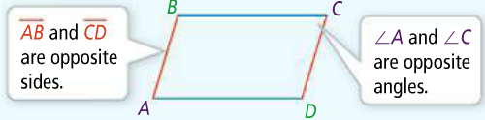
Parallelogram (defn) – a quadril. with both pairs of opposite sides parallel Symbol:

Opposite Sides – sides that do not share a vertex.
- Name another pair of opposite sides from the
diagram. ______and______

Opposite Angles – angles that do not share a side.
- Name another pair of opposite angles from the
diagram. ______and______

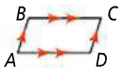
Consecutive Angles - share a common side. (one right after the other, clockwise or counterclockwise)

Name all pairs of consecutive angles in the figure at right.

<A is consecutive with <_____ and <_____

<B is consecutive with <_____ and <_____

<C is consecutive with <_____ and <_____
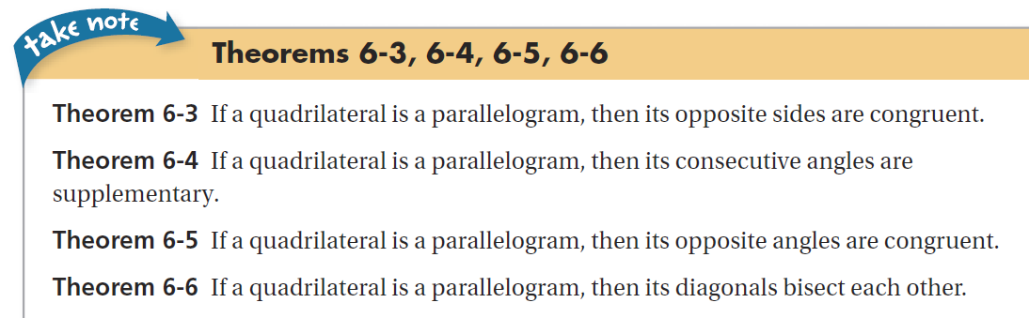
<D is consecutive with <_____ and <_____

4 Properties of Parallelograms;
- OPPOSITE SIDES ARE CONGRUENT – therefore they are equal lengths

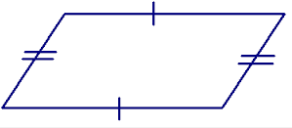 write an equation with sides set equal to each other
Example:
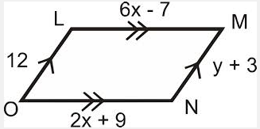
Solve for x; Solve for y;
LM = ON LO = MN

- CONSECUTIVE ANGLES ARE SUPPLEMENTARY
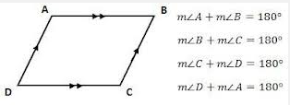
**This is true because they are same side interior angles with parallel lines cut by a transversal!

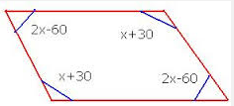
Example:
Write equation to solve for x;
________ + __________ = 180

- OPPOSITE ANGLES ARE CONGRUENT
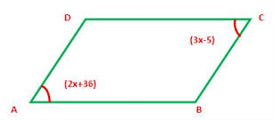
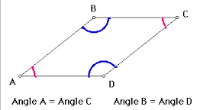
Example: Write the equation to solve for x
m<A = m<C

- DIAGONALS BISECT EACH OTHER
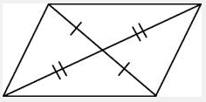
Example: Write the equation to solve for x
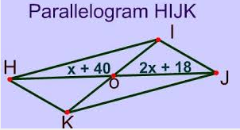
HO = OJ

PRACTICE:

