How to WATCH the GEOMETRY videos for HOMEWORK
For Mrs. Meyers ‘flipped’ classroom
*It is absolutely CRUCIAL that you watch the video lessons and take notes when assigned to do so for homework. You will be expected to have watched and learned the lesson in order to participate in the activities during class time the following day.
STEPS:
- Go to http://fairfieldschools.org/schools/flhs/

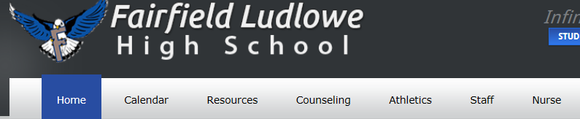
- Click on ‘Staff’

- Click on Mrs. Meyers’ name under the ‘Teacher Pages’ section
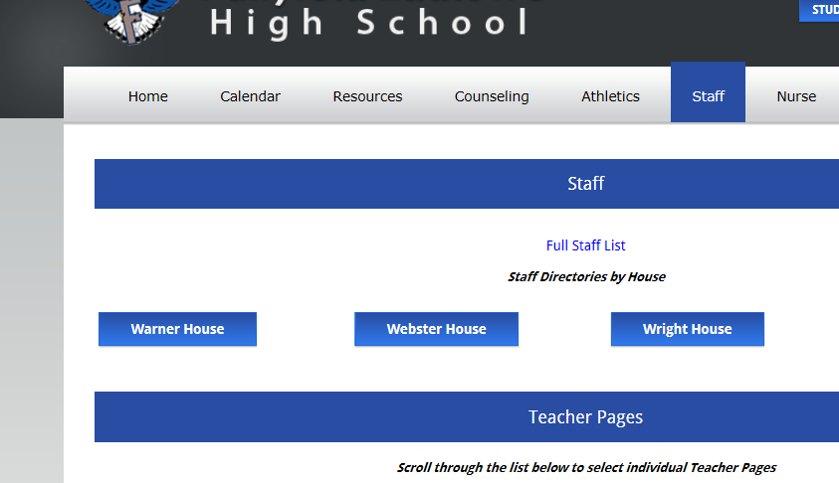

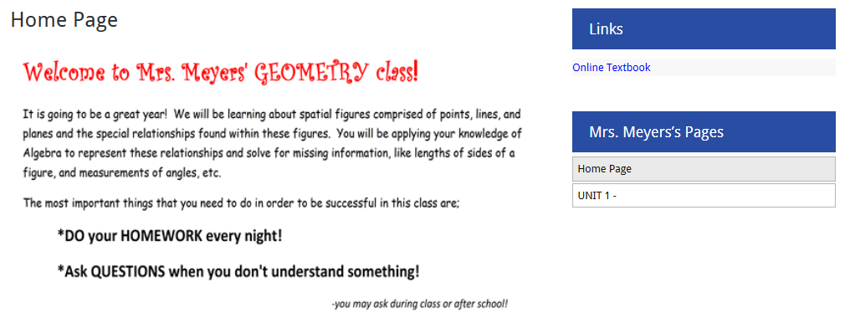
- This should take you to my webpage. There is information about ‘flipped’ classrooms and why I am choosing to teach my classes this way this year. When you have a chance, you can read more about it here. However, to watch an assigned video, find the blue bar to the right of the page that says “Mrs. Meyers pages” and CLICK ON THE ‘UNIT’page that we are currently working on. (we are in UNIT 1 now, for the list of units and chapter numbers please refer to your course handout sheet given the first week of school)

- Now just find the video for the chapter and section that you have been assigned. For example, if the assignment is for Lesson 1.4, click as indicated below;
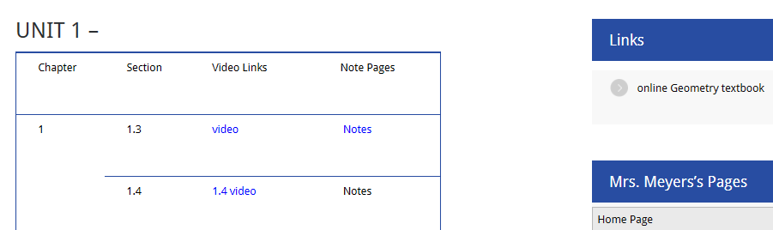

- You will be given the notes sheet to use and fill in as you watch and listen to the instructions on the video. However, if you are absent or if you lost your notes sheet, and need to watch the video, you can print out the corresponding NOTES sheet by clicking on the ’Notes’ to the right of the video you are watching.

- WATCH the video! Follow along with the instruction on the video and fill in the notes sheet that you were given during class. (or that you printed in step 6)

- You can pause and rewind if there is anything you don’t understand and would like to see again.
- Be sure to PAUSE the video when indicated to do so. It is important for you to practice doing some of the problems on your own. Then restart the video to check your work.
- ALSO, write down and ask Mrs. Meyers any questions you have about the lesson the following day.
- Your homework completion grade will be based on the notes that you fill out.

That’s it…it’s easy…and SO important that you keep up with the lessons by watching these videos!

