Photosynthesis Websites:
Bioflix: Photosynthesis 4 min- Overview:
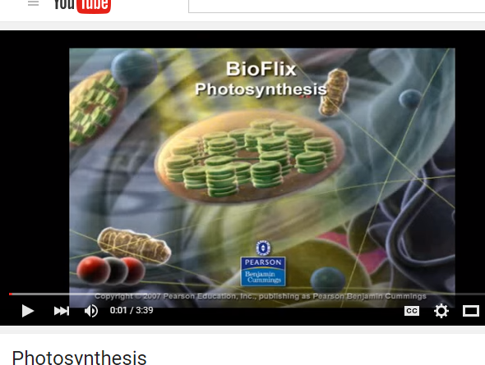
https://www.youtube.com/watch?v=YeD9idmcX0w

Bozeman: Photosynthesis 13 min Whole process
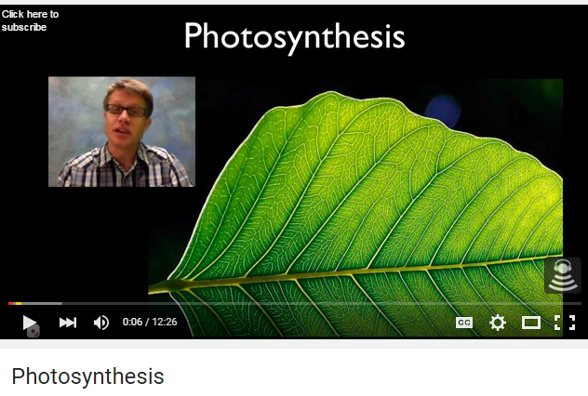
https://www.youtube.com/watch?v=g78utcLQrJ4

Penguin Prof: Photosynthesis Fun in the Sun 15 min Whole process (good extraction of chlorophyll and fluorescence 3:15-5 min)
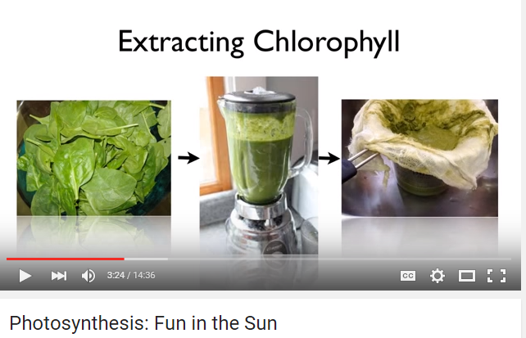
https://www.youtube.com/watch?v=FfLLHQDgpjI
Photo Light Lab Simulation
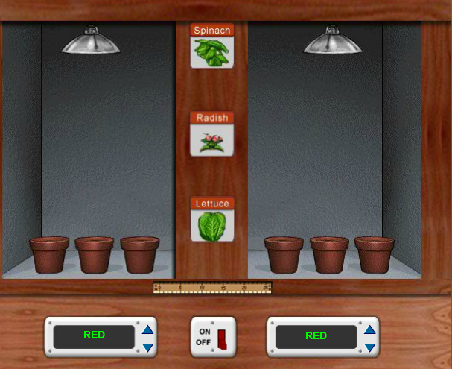
http://www.glencoe.com/sites/common_assets/science/virtual_labs/LS12/LS12.html

Bill Nye: Chemosynthesis with Bob Ballard 6 min
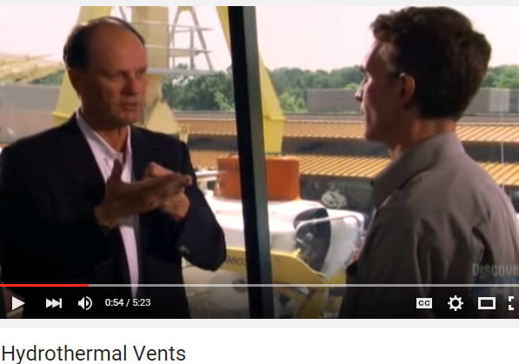
https://www.youtube.com/watch?v=D69hGvCsWgA

Bioman Photosynthesis Interactive Game
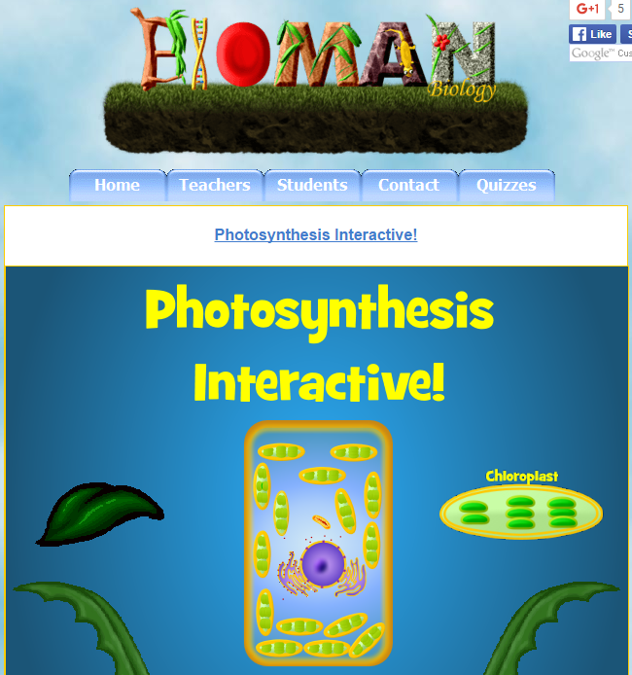
http://www.biomanbio.com/GamesandLabs/PhotoRespgames/photointeractive.html

Bozeman Photosynthesis Lab walkthrough 6 min
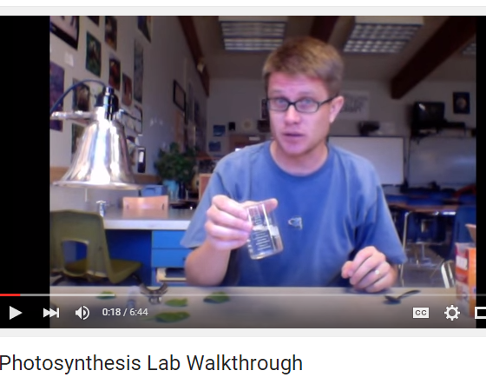
https://www.youtube.com/watch?v=ZnY9_wMZZWI

Bozeman AP Lab 4 Photosynthesis start at 2:35 for Photosynthesis
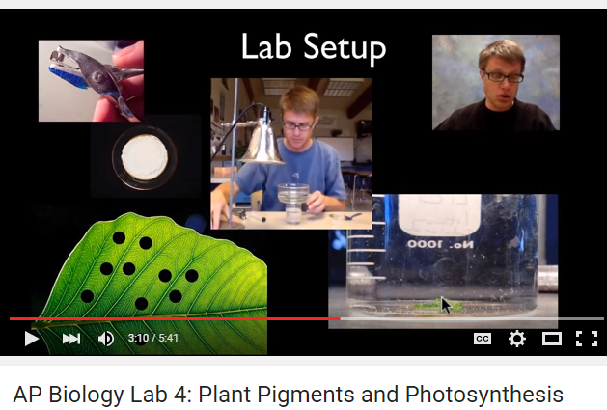
https://www.youtube.com/watch?v=6Z-SpXUeKr0

Good Xylem and Phloem images:
https://bio.rutgers.edu/~gb101/lab9_transport/transport2/9notebook3.html

