**Geometry 21 Extra Practice 6.4 , 6.5, 6.6 Name ______________________________**

**Choose the term that most specifically classifies each figure. Choose from the following list of terms;**

*Parallelogram, Rectangle, Rhombus, Square, Trapezoid, Isosceles Trapezoid, Kite*

1. 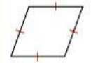 2) 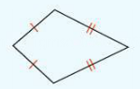 3) 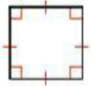

**_____________________ ______________________ ____________________**

4) 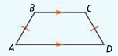 5) 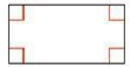 6) 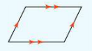

**_______________________ _______________________ ______________________**

**Complete each statement with *always, sometimes,* or *never*.**

1. A rhombus is ______________ a parallelogram.
2. A parallelogram is ______________ a rhombus.
3. A rectangle is ______________ a rhombus.
4. A square is ______________ a rhombus.
5. A rhombus is ______________a square.
6. 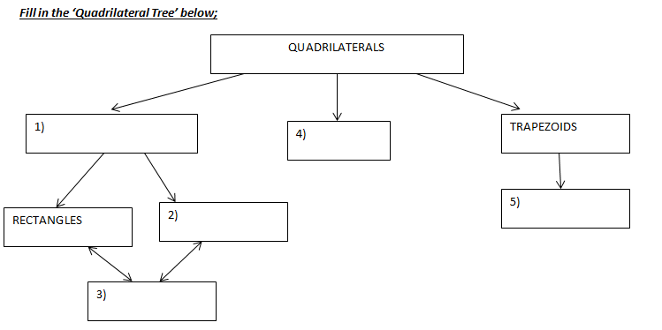A rhombus is ______________ a hexagon.

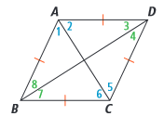**Use the diagram at the right for the following exercises.**

1. If *ABCD* is a rhombus, then .
2. If *ABCD* is a rhombus, then .
3. If *ABCD* is a rhombus, then .
4. If *ABCD* is a rhombus, then .
5. If *ABCD* is a rhombus, then .

**Find the values of the missing angles in each RHOMBUS below;** 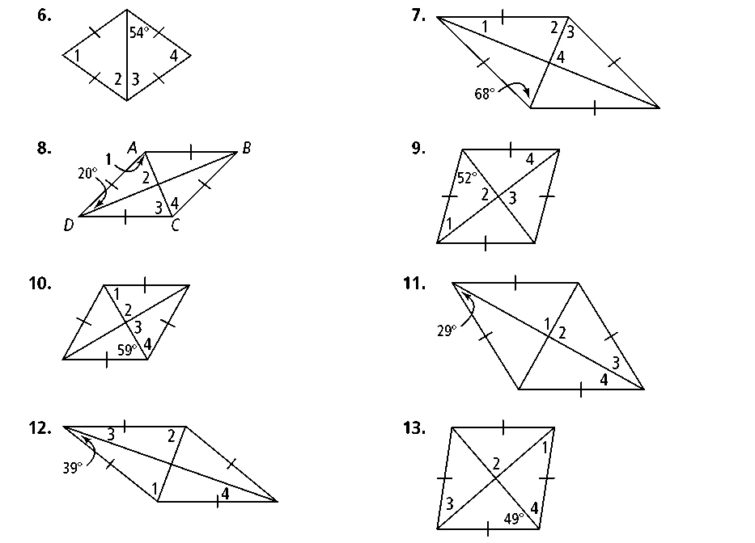

**25. 26.**

**27. 28.**

**Algebra *HIJK* is a rectangle. Find the value of *x* and the length of each diagonal.**

**29.** *HJ* = *x* and *IK* = 2*x* −7 **30.** *HJ* = 3*x* + 5 and *IK* = 5*x* −9

**Find the measures of the numbered angles in each isosceles trapezoid.**

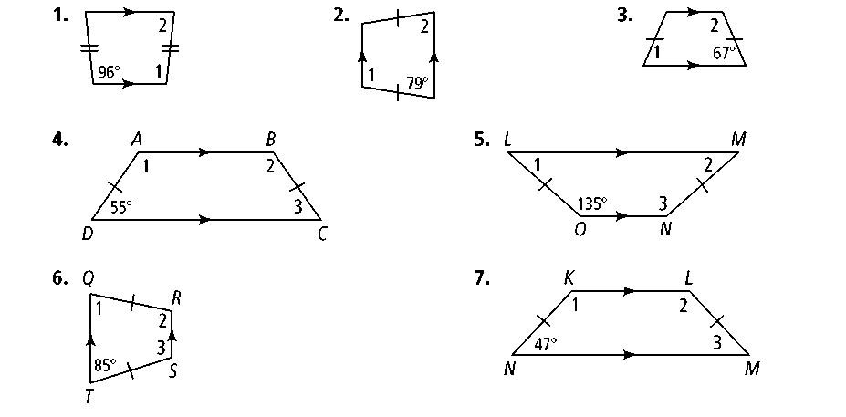 **31. 32. 33.**

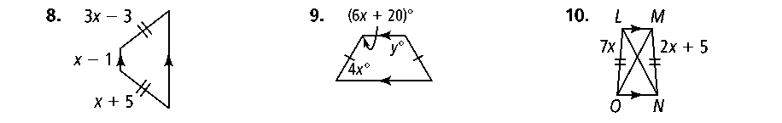

**Algebra Find the value(s) of the variable(s) in each isosceles trapezoid.**

**34. 35. 36.**

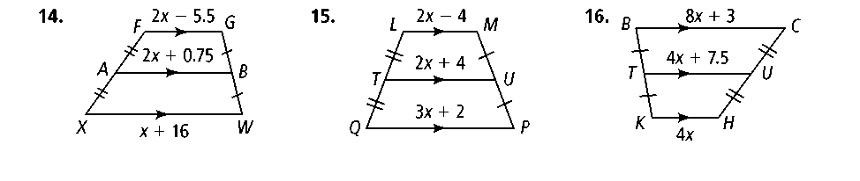**Find the lengths of the segments with variable expressions.**

 **40.**  **41.**

**Classify the quadrilateral, then find the values of the variables.**

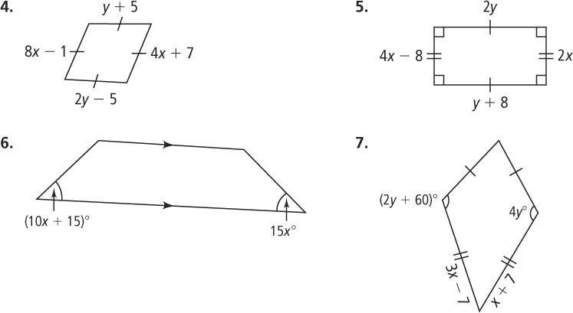

ANSWERS:

1. Rhombus 2) kite 3) square 4) isos. Trapezoid 5) rectangle 6) parallelogram

7) always 8) sometimes 9) sometimes 10) always 11) sometimes 12) never

20) BD 21) <BCD and <BAD

Parallelogram kite 22) <5 and <6 23) <ADC and <ABC

Rhombus isos. Trap 24) <4 , <8, <7

square

25) 59, 90, 90, 59 26) 38, 90, 90, 38 27) 51, 51, 39, 39 28) 41, 90, 41, 49

29) x = 7, 7, 7 30) x=7, 26, 26 31) 96, 84 32) 101, 79 33) 67, 113

34) x = 4 35) x = 16, y = 116 36) x = 1

40) x = 10, LM=16, TU=24, QP=32 41) x=3, BC=27, TU=19.5, KH=12

4) rhombus, x=2, y=10 5) rectangle, x = 4, y = 8 6) isos. Trap., x = 3 7) kite, x = 7, y = 30

**Lessons 6-4 and 6-5**

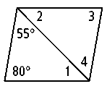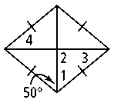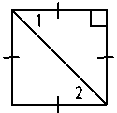**For each parallelogram, determine the most precise name and find the measures of the numbered angles.**

**1. 2. 3.**

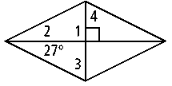

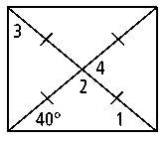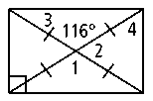4. 5. 6.

**7.** Use the information in the figure. **8.** *ABCD* is a rhombus. What is  
Explain how you know that *ABCD* the relationship between ∠1 and ∠2?  
is a rectangle. Explain.

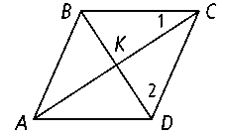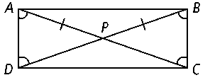

Y

O

T

R

E

G

M

16. If OT= 2a + b and ER = 80, and GY=3a-b, find a, b, & GY.

17. 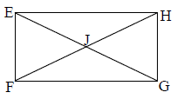

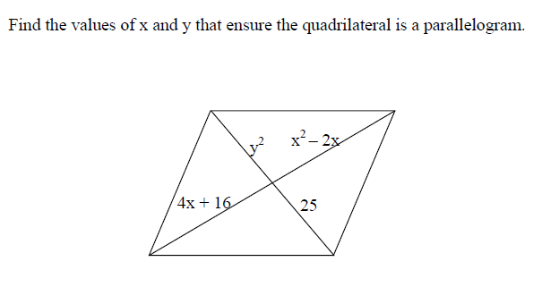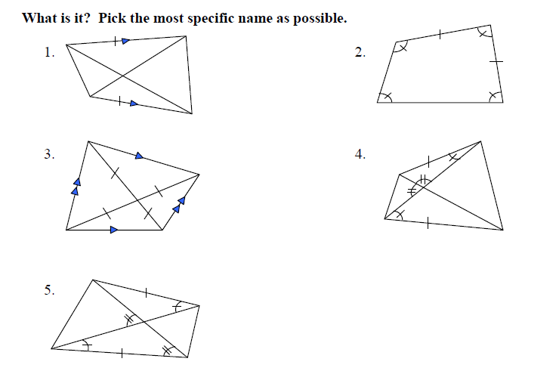

#1 - 12 Answer with Sometimes, Always or Never.

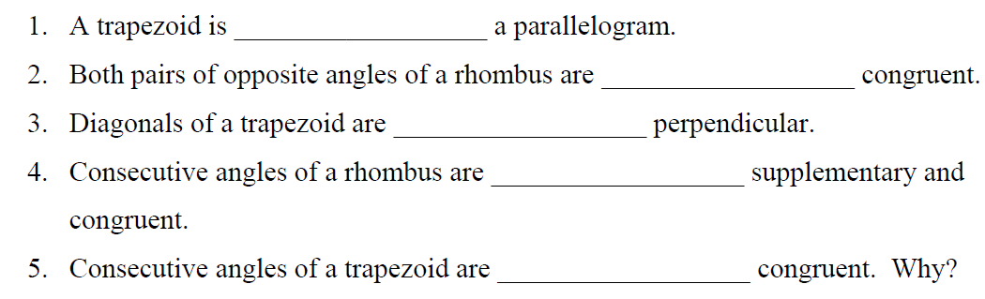

A

B

C

D

6.  ___________________ (Use parallelogram ABCD for #6-9.)

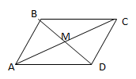 

7.  ___________________

8. ABCCDA ___________________

9. BAD &ABC are complementary ___________________

10. Find the best name for parallelogram ABCD using the given information:

A

B

C

D

M

a. M is the midpoint of  &  ___________________

b.  ___________________

2.





3.





5.



