GEOMETRY 21: Review for Final Exam

***Part 1***

**True or False:**

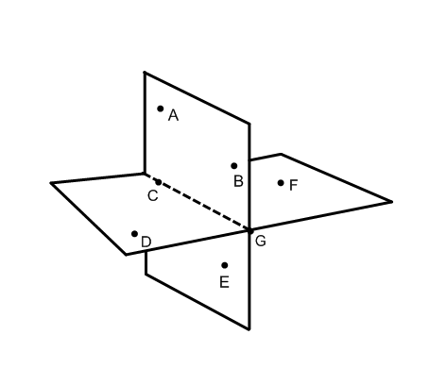

1. ____Any 2 lines always intersect at one point
2. ____Through any 2 points there is exactly one plane
3. ____Any 3 points are always coplanar
4. ____If bisects  at point E, then AE = EB.

**Use the diagram at the right to answer the questions #5-10:**

1. Name the intersection of $\overset{⃡}{CB}$ and plane DCF ______________
2. Name the intersection of $\overset{⃡}{AB}$ and plane ACE _______________
3. Name the intersection of plane DCF and plane ABE _____________
4. Are point A, B, and D coplanar? _________________
5. 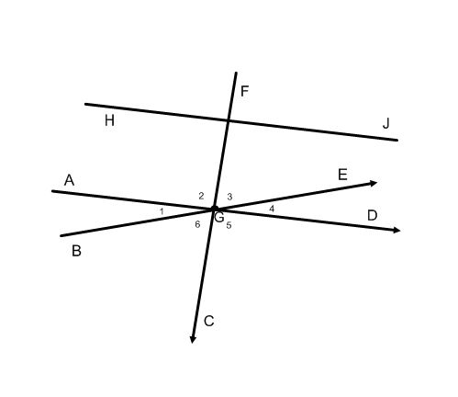Name the intersection of $\vec{EB}$ (ray) and $\vec{BE}$ (ray) _______________
6. How many planes can pass through $\overset{⃡}{CG}$? ____________

**Use the diagram below for questions #11-15:**

1. If ∡2 is a right angle and $m∡4 = 4x + 10$ degrees, and the $m∡6 = 8x – 4$ degrees, what is the value of $x$?

$x =____________$ m∡3 =_________

1. If m∡6 = y, then write an expression for the m∡BGF ____________________
2. If the m∡5 = 90°, then name 2 angles that are the complements of ∡4. _________ and ________
3. If m∡5 = 90°, name 2 angles that are supplementary, but do ***not*** form a linear pair. _______ and

$\overline{HJ}⏊\overline{FC}$ ________
4. and $\overline{AD}⏊\overline{FC}$, then $\overline{AD} _____\overline{HJ}$

**Identify the type of transformation. (Translation, reflection, rotation)**

1. 17) 18)

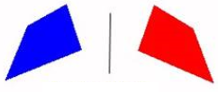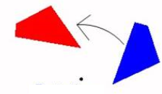

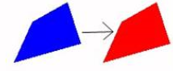

This is a ____________________________ This is a __________________________ This is a ________________________

19) The intersection of the angle bisectors is called the _________________________ and is the center of the ___________________________ circle.

20) The intersection of these perpendicular bisectors is called the _________________________ and is the center of the ___________________________ circle.

21) The intersection of the medians is called the ____________________________

22) The intersection of the altitudes is called the ____________________________

***Part 2***

**All turtles are reptiles.**

1. Rewrite the statement as a conditional. _____________________________________________________________

2. Identify the hypothesis ______________________________ and conclusion _______________________________

3. Draw a Venn diagram that illustrates the statement.

**Linear pairs are supplementary, adjacent angles.**

5. Rewrite the statement as a conditional. ________________________________________________________________________

_________________________________________________________________________________________________________________

6. Write the converse of the conditional. ___________________________________________________________________________

__________________________________________________________________________________________________________________

7. Write the statement as a biconditional __________________________________________________________________________

__________________________________________________________________________________________________________________

8. Is the statement is a definition? _______________ If so, explain your reasoning _________________________________

_________________________________________________________________________________________________________________

**Using each diagram, determine the value of .**

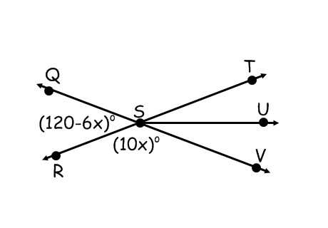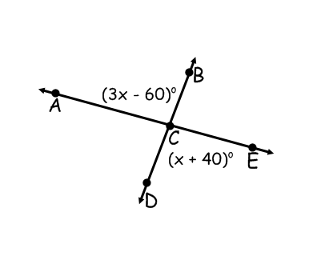

9. 10.

**Match each property with its definition.**

11. ____________ Addition property a.) If a = b, then ac = bc

12. ____________ Symmetric Property b.) If a = b, then a – c = b – c

13. ____________ Substitution Property c.) For all real numbers a, a = a.

14. ____________ Multiplication Property d.) If a = b, you may replace a with b in any true equation containing a and the resulting equation will still be true.

15. ____________ Division Property e.) If a = b, and c ≠ 0, then

16. ____________ Reflexive Property f.) If a = b, then a + c = b + c

17. ____________ Subtraction Property g.) For all real numbers a and b, if a = b, then b = a.

18. ____________ Transitive Property h.) For all real numbers a and b, if a = b and b = c, then a = c.

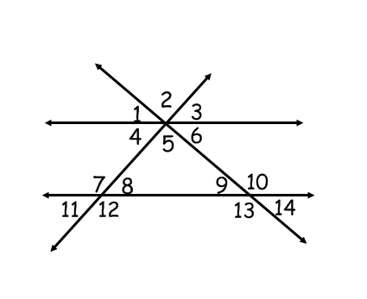**Use the figure at the right to determine the following angle measures**

Given: $∡8 ≅ ∡4$

$m∡5 + m∡8 + m∡9 = 180°$

$m∡2 = 102.16°$

$m∡8 = 7x + 19$

$m∡11 = 32x – 83$

19.) $x ______________$ 20.) m∡4= _____________ 21.) m∡5= _____________ 22.) m∡9= ____________

23.) m∡10= _________ 24.) m∡ =12 ____________ 25.) m∡1= _____________ 26.) m∡3= ____________

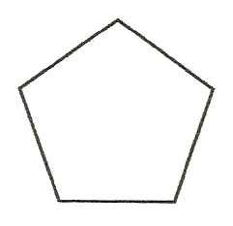***Part 3***

_____ 1. How many lines of symmetry does the figure at right have?

a. 0 b. 1 c. 5 d. 10

_____ 2. What is the angle of rotation for the rotational symmetry of the figure?

a. 0° b. 50° c. 72° d. 180°

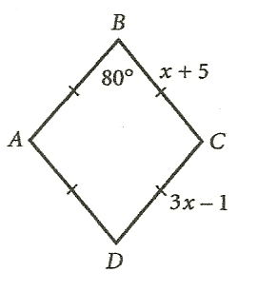_____ 3. What type of quadrilateral is ABCD?

a. square b. rhombus

c. rectangle d. trapezoid

_____ 4. What is the length of side $\overline{AB}$?

a. 3 b. 6 c. 8 d. 9

_____ 5. What is the measure of ∡A?

a. 80° b. 90° c. 100° d. 180°

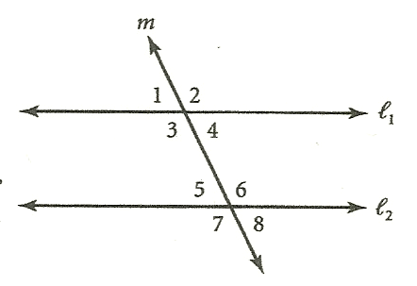_____ 6. What type of angles are ∡3 and ∡6?

1. alternate interior
2. alternate exterior
3. same-side interior
4. corresponding

Items 6 through 9

_____ 7. If || and m∡1 = 110°, then m∡6=

a. 35° b. 55° c. 70° d. 110°

_____ 8. If || and m∡5=75°, then m∡3 =

a. 15° b. 75° c. 90° d. 105°

_____ 9. If m∡5 = 55° and m∡4 = 35° , then $l_{1}$ and $l_{2}$_______.

a. are perpendicular b. are parallel

c. intersect at an acute angle d. intersect at an obtuse angle

_____ 10. Suppose ∡1 and ∡2 are alternate interior angles formed by parallel lines n and p and transversal t. Which of the following must be true?

a. ∡1 and ∡2 are complementary

b. ∡1 and ∡2 are congruent

c. ∡1 and ∡2 are supplementary

d. ∡1 and ∡2 have a common vertex

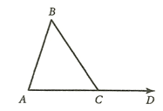_____ 11. If $m∡A = x + 5$, $m∡B = x$, and $m∡BCD = 125$ °, then $m∡A$ =

a. 55° b. 60° c. 65° d. 185°

_____ 12. If $\overline{AC}≅\overline{BC}$ and $m∡BCD$ = 108°, then $m∡A$ =

a. 54° b. 72° c. 36° d. 90°

_____ 13. What is the sum of the measures of the interior angles of a hexagon?

a. 180° b. 360° c. 540° d. 720°

_____ 14. What is the measure of an interior angle of a regular pentagon?

a. 60° b. 72° c. 108° d. 120°

_____ 15. If the measure of an exterior angle of a regular polygon is 18°, how many sides does the polygon have?

a. 6 b. 8 c. 15 d. 20

_____ 16. If the measure of an interior angle of a regular polygon is 140°, how many sides does the polygon have?

a. 10 b. 9 c. 8 d. 5

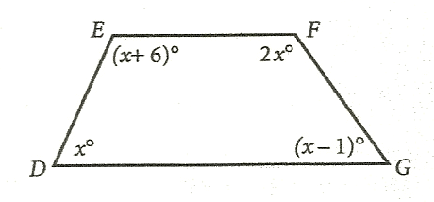_____ 17. The measure of an interior angle of a regular polygon is four times the measure of its exterior angle. How many sides does the polygon have?

a. 15 b. 12 c. 10 d. 8

_____ 18. What is mG in quadrilateral DEFG?

a. 35° b. 70° c. 71° d. 77°

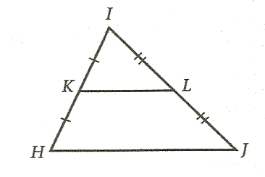_____ 19. If HJ = 26, then KL =

a. 13 b. 26 c. 30 d. 52

_____ 20. If $HJ = 3x – 1$ and $KL = x + 1$, then HJ =

a. 3 b. 4 c. 8 d. 10

_____ 21. Determine a value of **r** so that a line through (r, 3) and (7, 4) has a slope of ½.

a. 7 b. 5 c. -1 d. 2

_____ 22. Find the slope of any line perpendicular to the line through (-1, 5) and (0, -3)

a. 1/8 b. -8 c. -1/8 d. 8

***Classify each statement as true or false.***

_____ 23. Two lines that are not parallel must intersect.

_____ 24. Two noncoplanar lines cannot be parallel.

_____ 25. A line and plane must either be parallel or intersect.

_____ 26. If two parallel planes are cut by a third plane, then the lines of intersection cannot intersect one another.

_____ 27. If P, Q, and R are noncollinear, only one line can be drawn through P parallel to $\overline{QR}$.

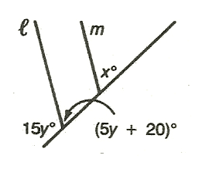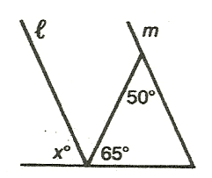**Find the value of $x$ for which ||.**

28. 29.

_____________________________ _______________________

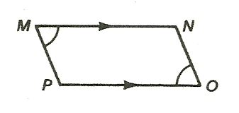30. Write a two-column proof.

Given: ||; ∡M ≌ ∡O

Prove: ||

|  |  |
| --- | --- |
| **Statements** | **Reasons** |
|  |  |

***Part 4***

***Solve for the missing variable(s).***



1. 2.

3. Given ΔWXY ≌ ΔMNO, find the values of $a$ and $b$*.*



***Decide whether there is enough information to prove the triangles are congruent. State the postulate or theorem that you would use to prove the triangles congruent.***

4. 5. 6

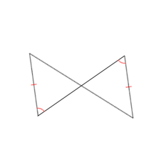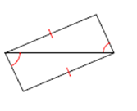

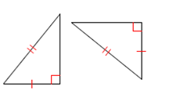

7. 8. 9.

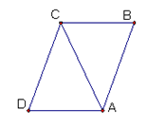***Prove the following***:

10. Given: ∡D≌∡B; ||

Prove:

11. Given:

Prove: ΔBDE is isosceles

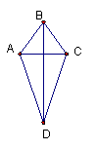

12. Given: ABCD is a kite with $\overline{AB }$ ≌ $\overline{BC}$; $\overline{AD}$ ≌ $\overline{ CD}$

Prove: $\overline{BD }$ bisects

13. *ABCD* is a parallelogram with diagonals $\overline{AC}$ and $\overline{BD}$.

a.) If $m∡CBD=26°, m∡DCA=60°, m∡DEC=100°. Find m∡BAD.$

b.) If

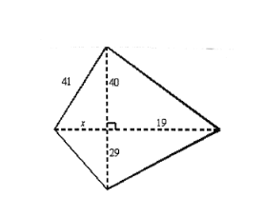***Part 5***

1. Find the area of the quadrilateral.

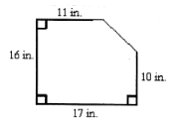2. What is the area of the figure?

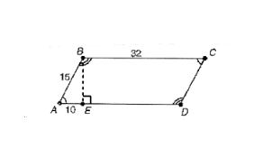

3. Find the area of the parallelogram ABCD. Leave answer in exact form (simplified square root).

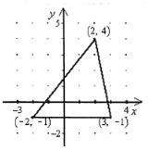

4. Find the area of the triangle to the nearest tenth.

5. In rhombus ABCD, $AB = 16$ and $AC = 28$. Find the area of the rhombus to the nearest tenth.

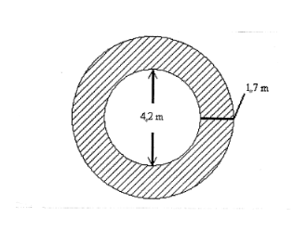

6. The figure below is an overhead view of a deck surrounding a hot tub.

What is the area of the deck to the nearest tenth?

7. Given A( 1, 3) B (6, 3) C (3, -1) D (-2, -1).

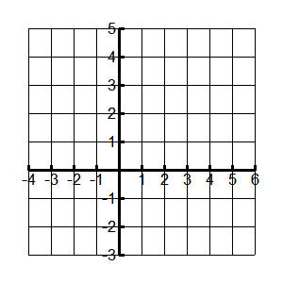Plot the points on the grid provided. Label your points, including coordinates.

a) Find the slopes of the segments (in the subscripts). Show your work.

$m_{AB}=$ $m_{BC}=$

$m_{CD}=$ $m_{DA}=$

b) Find the length of the segments indicated. Show your calculations.

AB= BC=

CD= AD=

c) ABCD is a quadrilateral. How would you classify it? (What name would you give it?) Be as exact as you can.

d) Find the Area of quadrilateral ABCD

8. Each of the following triples represents sides of a triangle. Determine whether the triangle is right, acute or obtuse.

a. 14, 48, 50 _____________________________________

b. 4, 8, 9 _______________________________________

c. 2√3, 4, 6 _______________________________________

9. Determine the area of an equilateral triangle whose side length is 14 in. Leave answer in simplified square roots if necessary.

10. A regular hexagon has an apothem of 2cm and a side length of $\frac{4\sqrt{3}}{3}$ cm. Determine its area exactly.

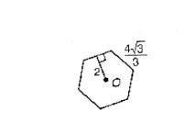

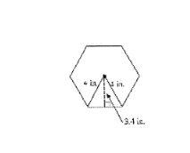

11. What is the perimeter of the regular hexagon to the nearest inch? (Radius is 4 in, apothem is 3.4 in)

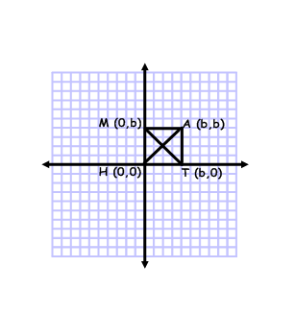

*M(0,b) MATH is a square with diagonals $\overline{AH}$ and $\overline{MT}$. Use distance, slope and/or midpoint formulas to prove each statement: Show all work*

12. Diagonals are congruent.

13. Diagonals bisect each other.

14. Diagonals are perpendicular to each other.

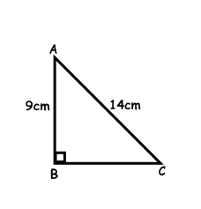15. In the triangle below, find BC when AB = 9cm and AC = 14. Leave answer to the nearest tenth.

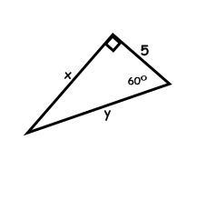16. In the triangle below, find $x$ and $y$. Leave answers as simplified square roots when necessary.

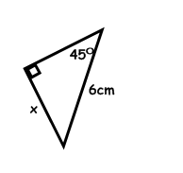

17. Find . Leave answers as simplified square roots when necessary.

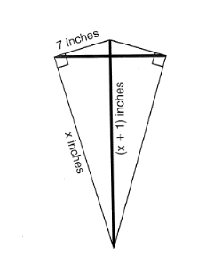18. A kite needs a vertical and a horizontal support bar attached at opposite corners. The upper edges of the kite are 7 inches, the side edges are $x$ inches and the vertical support bar is $(x + 1)$ inches. What is the measure of the vertical support bar in inches?

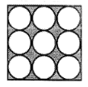19. In the figure, each circle has a radius of 2 inches. What is the area of the shaded region rounded to the nearest hundredth?

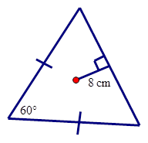20. Find the area of the triangle if the length of the apothem is 8 cm.

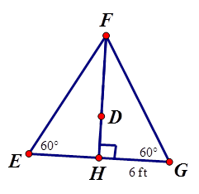

21. Find the area of the triangle if HW=6 ft and $\overline{DH}$ is the apothem.

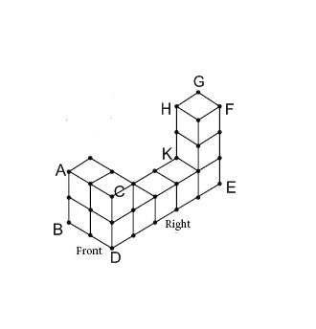***Part 6***

Use the diagram to answer the questions #1-5:

1) Name 2 pairs of skew lines ______________________________________

2) Name a plane that is perpendicular to line DE _____________________________

3) Name 2 pairs of parallel planes __________________________________

***Part 7- Surface Area and Volume***

**Determine the surface area and volume of a right prism with the given base shape, base dimensions, and prism height, h. Round to the nearest tenth, if necessary.**

1. Square base whose side measures 3 meters; h = 14 meters

_______________________

2. Regular hexagon base whose sides measure 10 cm; h = 4 cm

_______________________

3. Equilateral triangle base whose sides measure 6 inches; h = 8 in

_______________________

4. A right triangle base whose hypotenuse is 17in and one leg is 15 in; h = 5 in

_______________________

**Use the pyramid at the right. The base of the pyramid is an equilateral triangle whose perimeter is 120 in. The volume of the pyramid is 3464.1 in3.**

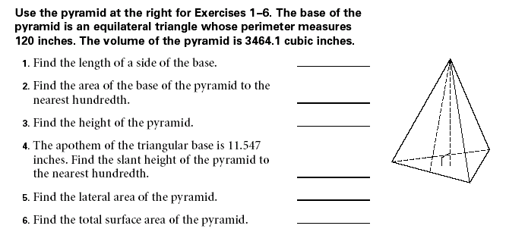

5. Determine the length of a side of the base ________________________

6. Determine the area of the base of the pyramid _______________________

7. Determine the height of the pyramid ________________________

8. The apothem of the triangular base is 11.547 in. Determine the slant height of the pyramid.

________________________

9. Determine the total surface area

________________________

**Determine the unknown value for a right cylinder with the given radius, r, height, h, surface area SA, and volume, V.**

10. r = 26’, h = 16’ SA = _______________ 11. SA= 98 in2, h = 14 in, r = ______________

12. V = 144 cm3, r = 12 cm h = ________________ 13. V = 80 in3, h = 16 in r = ______________

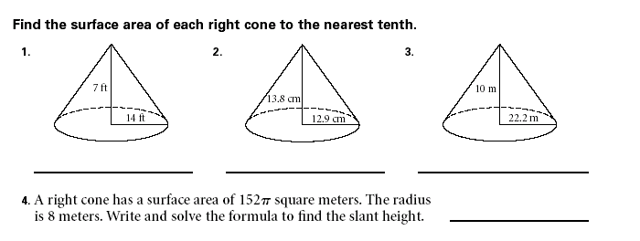**Determine the surface area of each right cone.**

14. 15.

______________________ _______________________

16. A right cone has a surface area of 152π square meters. The radius is 8 meters. Determine the slant height.

_______________________

**Determine the volume of each right cone.**

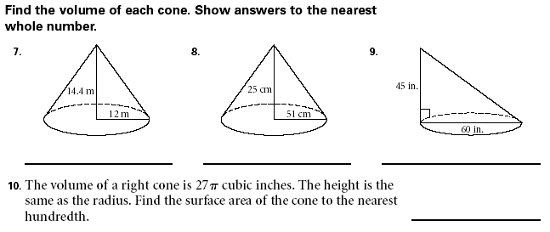17. 18.

______________________ _______________________

19. The volume of a right cone is 27π cubic inches. The height is the same as the radius. Determine the surface area of the cone to the nearest hundredth.

_______________________

20. Determine the surface area of a sphere with a diameter of 4”. Leave answer in terms of π.

_______________________

21. Determine the length of a radius if the surface area of a sphere is 36π cm2.

_______________________

22. Determine the volume of a sphere with a radius of 14 cm.

_______________________

23. Determine the volume of a sphere if the surface area is 100 cm2.

_______________________

24. Determine the volume of a sphere if the surface area is 100π cm2

_______________________

**Determine the surface area and volume of each composite.**

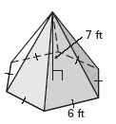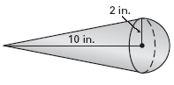25. 26.

SA = ________________________ SA = ______________________

Volume = ____________________ Volume = __________________

***Part 8***

*Multiple-Choice*

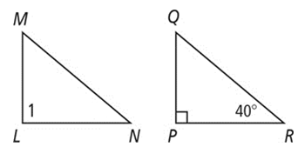______ 1. The pair of polygons below are similar. Determine the measure of angle 1.

a. 90° b. 40° c. 50° d. 95°

______ 2. Which of the following theorems/postulates is NOT a way to determine if triangles are similar?

a. SAS b. ASA c. $AA$ d. SAA

______ 3. On a map of Florida, one-fourth of an inch represents 10 miles. If it is approximately 2 inches from

Orlando to Ocala on the map, what is the actual distance in miles?

a. 16 b. 64 c. 80 d. 20

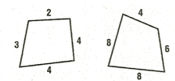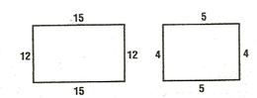______ 4. Which pair of polygons are definitely **not** similar?

a. b.

c. 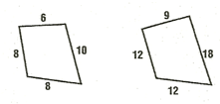 d. 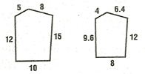

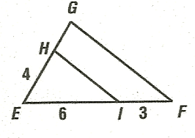

______ 5. Given ΔEGF with || , EI = 6, IF = 3, and EH = 4, find HG.

a. 2 b. 3 c. 6 d. 10

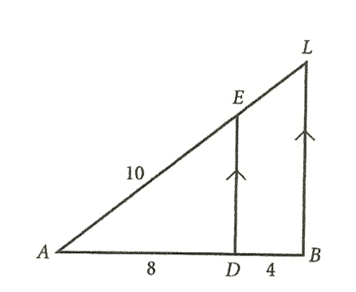

______ 6. Which proportion illustrates the Side-Splitting Theorem?

1. $\frac{AD}{AB}=\frac{AL}{AE}$ b. $\frac{AD}{EL}=\frac{AB}{AL}$

c. $\frac{AD}{AE}=\frac{AL}{AB}$ d. $\frac{AD}{DB}=\frac{AE}{EL}$

______ 7. In ΔADE, if ED = 6 what is BL?

a. 3 b. 5 c. 9 d. 12

______ 8. The perimeter of ΔGHI is 18, the perimeter of ΔPQR is 30, and ΔGHI~ΔPQR. If GH is 10, what is PQ?

a. 3.6 b. 6 c. 16.67 d. 27.78

______ 9. Suppose ΔABC is similar to a triangle whose sides have lengths 3, 7, and 6. Which of the following

could be the perimeter of ΔABC?

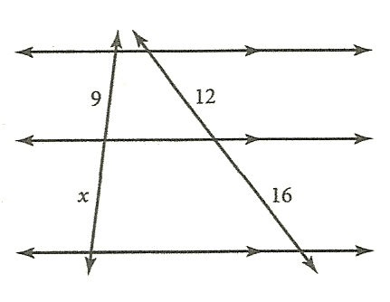 a. 8 b. 16 c. 32 d. any of these

______ 10. What is the value of $x$ in the figure at the right?

a. 8 b. 12 c. 14 d. 16

______ 11. The shadow of a man 6 feet tall is 30 inches long. At the same time of day, a building casts a shadow 125 inches long. How tall is the building?

a. 15 ft b. 25 ft c. 30 ft d. 50 ft

______ 12. It costs $144 to refinish a floor that is 9 feet by 12 feet. At the same rate, how much will it cost to

refinish a floor that is 12 feet by 16 feet?

a. $81 b. $108 c. $256 d. $576

______ 13. Two spheres have radii of 3 cm and 5 cm. What is the ratio between the areas of their great circles?

a. 3:5 b. 6:10 c. 9:25 d. 27: 125

______ 14. The area of one side of a cube is 36 ft2. If the edges of the cube are tripled, what is the volume of the new

cube?

a. 36 ft3  b. 196 ft3 c. 324 ft3 d. 5832 ft3

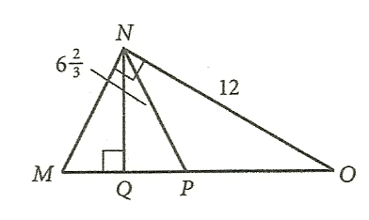______ 15. In the figure at the right, ΔMNO~ΔHIJ. What is the length of $\overline{NQ}$?

a. 6 b. 10 c. 12 d. 15

______ 16. MN =

a. $6\sqrt{7}$ b. $4\sqrt{7}$ c. $4\sqrt{3}$ d. $6\sqrt{3}$

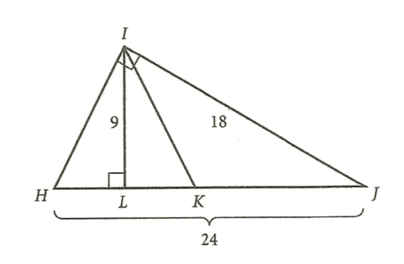

______ 17. What is the length of $\overline{IK}$?

a. 9 b. 10 c. 12 d. 15

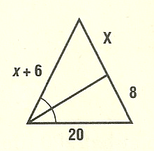______ 18. For the figure at the right, find the value of $x$.

a. 3 b. 4 c. 5 d. 6

______ 19. Which polygon is similar to other polygons of its classification?

a. rectangle b. rhombus

c. regular octagon d. isosceles triangle

______ 20. The measures of the angles of a triangle are in the extended ratio 2:4:9. Which is a measure of one of the angles?

a. 12 b. 36 c. 48 d. 105

*Complete each statement with the word* ***always****,* ***sometimes,***  *or* ***never.***

21. Two equilateral triangles are ___________________ similar.

22. Two similar triangles are __________________ congruent.

23. Two congruent triangles are ___________________ similar.

24. Two isosceles right triangles are ___________________ similar.

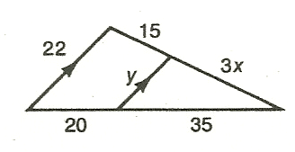25. Find the values of x and y.

= _____________________

= _____________________

26. Using the given information, tell which triangles are similar. The diagram is not drawn to scale.

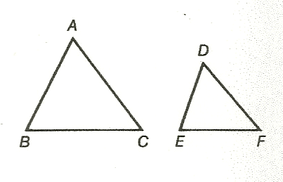 a. $\frac{AB}{DF}=\frac{AC}{DE}; ∡A≌∡D$

______________________

b. $\frac{AB}{FD}=\frac{BC}{DE}=\frac{AC}{FE}$

_______________________

c. $∡A≌∡E; ∡B≌∡F$

_______________________

d. $AB=AC;DE=DF; ∡A≌∡D$

_______________________

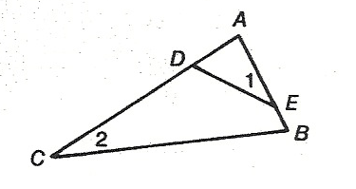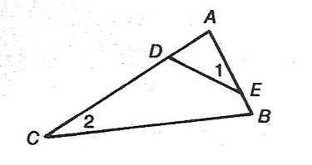27. Given: $∡1≌∡2$

Prove: $\frac{AD}{AB}=\frac{AE}{AC}$

|  |  |
| --- | --- |
| **Statements** | **Reasons** |
|  |  |

***Part 9:***

Given ⨀Q, m∡ABC=72° and m $\hat{CD}=46°$. $\overline{BD}$ is a diameter. Find the indicated measures.





In the circle to the right, . Find each of the following measures:



12. If the length of an arc on a circle is 26 cm and the radius of that circle is 10 cm, what is the degree measure of the arc? Leave your answer in exact, simplified terms.

13. If the radius of a circle is 22 mm and the degree measure of one of the arcs on the circle is 160°, find the length of the arc.

For each of the following problems, find the m∡1.



14. 15. 16.

17. 18.  19.

***Part 10***

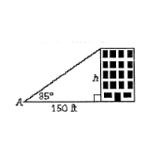1. Determine the height of the building, to the nearest tenth, when ∡A = 35°

2. A slide 4.1 m long makes an angle of 27° with the ground. How high is the top of the slide above the ground? Round your answer to the nearest tenth.

3. Tom drives 16 km up a hill that is at a grade of 10°. What horizontal distance, to the nearest tenth of a kilometer, has he covered?

4. Find the area of an octagon whose side length is 14 in.

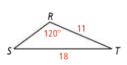5. In triangle RST, what is the measure of angle S to the nearest tenth?

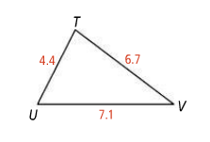6. Find the measure of angle V to the nearest tenth.

***Part 11***

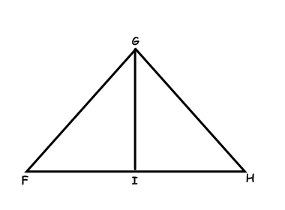1. Prove Indirectly:

Given: ΔGHF is not isosceles; ∡GIF ≅ ∡GIH

Prove: $\overline{GI}$ is not a median

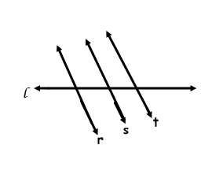

2. Prove indirectly.

Given: r ll s, s ∦ t

Prove: r ∦ t